UNITED STATES
SECURITIES AND EXCHANGE COMMISSION
Washington, D.C. 20549

FORM 6-K

REPORT OF FOREIGN PRIVATE ISSUER PURSUANT TO RULE 13a-16 OR 15d-16 UNDER THE
SECURITIES EXCHANGE ACT OF 1934

For the Month of April 2026

Commission File Number: 001-40377

Valneva SE
(Translation of registrant's name into English)

Îlot Saint-Joseph, Bureaux Convergence
12ter Quai Perrache
69002 Lyon, France
(Address of principal executive office)

Indicate by check mark whether the registrant files or will file annual reports under cover of Form 20-F or Form 40-F.

Form 20-F ☒ Form 40-F ☐

INFORMATION CONTAINED IN THIS REPORT ON FORM 6-K

Securities Purchase Agreement

On April 29, 2026, Valneva SE (the “Company”) entered into a securities purchase agreement (the “Securities Purchase Agreement”) with the investors named therein (each an “Investor,” and together, the “Investors”), pursuant to which the Company agreed to issue and sell to the Investors in a private placement (the “Private Placement”) 15,893,817 new ordinary shares of the Company (the “New Shares”), nominal value €0.15 per share (“Ordinary Share”), each New Share with a warrant attached (a “Warrant” and, together with the New Share to which it is attached, an “ABSA”, or Actions à Bons de Souscription d'Actions) exercisable for one Ordinary Share at a subscription price of €2.33 per ABSA, as part of a share capital increase for an amount of €37 million. If all the Warrants attached to the New Shares are exercised, up to 15,893,817 additional new ordinary shares (the “Warrant Shares”) will be issued by the Company for an aggregate capital increase amount of approximately €47 million.

Each Warrant entitles its holder to subscribe to one Warrant Share at an exercise price of €2.96 per Warrant Share, representing a premium of 25% to the volume-weighted average price of the Ordinary Shares on the regulated market of Euronext Paris over the three trading days preceding the setting of such issue price, i.e. April 27, 28 and 29, 2026 (i.e. €2.37), subject to standard adjustments. The Warrants may be exercised, in whole or in part, for cash, at any time from the business day immediately following their issuance to the earlier of (i) the 30th calendar day following receipt by the Company of the FDA regulatory approval for its investigational 6-valent OspA-based Lyme disease vaccine candidate (LB6V, formerly known as VLA15) (the “FDA Approval”) and (ii) the third business day (included) prior to March 31, 2028 (the “Maturity Date” and such period, the “Exercise Period”). If, as of March 1, 2028, the FDA Approval has not been obtained by the Company, the Maturity Date shall automatically be extended to September 30, 2028 and the Exercise Period shall be correspondingly extended.

The Warrants provide that the holder will not have the right to exercise any portion of its Warrants if such holder, together with its affiliates, would beneficially own in excess of 9.99% of the number of Ordinary Shares outstanding immediately after giving effect to such exercise (the “Beneficial Ownership Limitation”). The holder may increase or decrease the Beneficial Ownership Limitation, provided that (i) to the extent required by the French foreign direct investment regime (“French FDI Regime”), the holder may only increase the Beneficial Ownership Limitation above 9.99% if the holder has obtained from the French Ministry of Economy through an authorization request or prior notification, in accordance with the French FDI Regime and (ii) in no event will the Beneficial Ownership Limitation exceed 19.99%. Any increase in the Beneficial Ownership Limitation will not be effective until the 61st day after such notice is delivered to the Company.

Jefferies LLC, Jefferies GmbH, TD Securities (USA) LLC, Stifel, Nicolaus & Company, Incorporated, Stifel Europe Securities SAS, acted as Global Coordinators, Van Lanschot Kempen (USA) Inc. and Van Lanschot Kempen N.V., together with the Global Coordinators, acted as Joint Bookrunnners and placement agents in connection with the Private Placement. The Company has agreed to pay the placement agents customary placement fees. Jefferies GmbH acted as settlement agent in connection with the Private Placement.

The Private Placement is expected to close on May 5, 2026 (the “Closing Date”). The Company intends to use the net proceeds from the Private Placement, together with its existing cash, to (i) advance its existing pipeline of differentiated vaccine candidates, maximize growth of its cash-generating commercial business and (ii) for working capital and general corporate purposes.

The securities to be issued by the Company in the Private Placement have not been registered under the Securities Act of 1933, as amended (the “Securities Act”), and may not be offered or sold in the United States absent effective registration or an applicable exemption from registration requirements. The securities to be issued by the Company in the Private Placement have been, or will be, issued in reliance on the exemption from registration provided by Section 4(a)(2) of the Securities Act and/or Regulation S promulgated thereunder.

The foregoing descriptions of the Securities Purchase Agreement and the Warrants do not purport to be complete and are qualified in their entirety by reference to the form of Securities Purchase Agreement (including the terms and conditions of the Warrants included as Exhibit B thereto), a copy of which is filed as Exhibit 99.1 hereto, and incorporated by reference herein.

Registration Rights Agreement

On April 29, 2026, the Company also entered into a registration rights agreement (the “Registration Rights Agreement”) with the Investors, pursuant to which the Company agreed to register the New Shares and Warrant Shares for resale (together, the “Registrable Securities”). Under the Registration Rights Agreement, the Company has agreed to file a registration statement covering the resale of the Registrable Securities by no later than 30 days after the Closing Date (the “Filing Deadline”) and to use reasonable best efforts to cause such registration statement to be declared effective as soon as practicable, but no later than the earlier of (a) the 60th calendar day following the initial filing date of the registration statement if the U.S. Securities and Exchange Commission (the “SEC”) notifies the Company that it will “review” the registration statement and (b) the 10th business day after the date the Company is notified (orally or in writing, whichever is earlier) by the SEC that the initial registration statement will not be “reviewed” or will not be subject to further review(the “Effectiveness Deadline”). The Company also agreed to use reasonable efforts to keep such registration statement continuously effective until the date the Registrable Securities covered by such registration statement have been sold or may be resold pursuant to Rule 144 without restriction. The Company has agreed to be responsible for all reasonable fees and expenses incurred in connection with the registration of the Registrable Securities.

In the event (i) the registration statement has not been filed by the Filing Deadline, (ii) the registration statement has not been declared effective by the Effectiveness Deadline, (iii) a new registration statement has not been timely filed or declare effective pursuant to the Registration Rights Agreement or (iv) after the registration statement has been declared effective by the SEC, sales cannot be made pursuant to the registration statement for any reason (including by reason of a stop order or the Company’s failure to update such registration statement), subject to certain limited exceptions, then the Company has agreed to make pro rata payments to the Investor as liquidated damages in an amount equal to 1% of the aggregate amount paid by the Investors pursuant to the Securities Purchase Agreement per 30-day period or pro rata for any portion thereof following the date by which such registration statement should have been filed or effective, as applicable, subject to certain caps set forth in the Registration Rights Agreement.

The Company has granted the Investors customary indemnification rights in connection with the registration statement. The Investors have also granted the Company customary indemnification rights in connection with the registration statement.

The foregoing description of the Registration Rights Agreement does not purport to be complete and is qualified in its entirety by reference to the form of Registration Rights Agreement, a copy of which is filed as Exhibit 99.2 hereto and incorporated by reference herein.

Press Release

On April 30, 2026, the Company issued a press release announcing the Private Placement. A copy of the press release is attached hereto as Exhibit 99.3 and is incorporated herein by reference.

The information contained in this Form 6-K, excluding Exhibit 99.3, is hereby incorporated by reference into the Company’s registration Statement on Form F-3 (File No. 333-268071).

Exhibits

Exhibit 99.1 Form of Securities Purchase Agreement
Exhibit 99.2 Form of Registration Rights Agreement
Exhibit 99.3 Press release dated April 30, 2026

SIGNATURES

Pursuant to the requirements of the Securities Exchange Act of 1934, the registrant has duly caused this report to be signed on its behalf by the undersigned, thereunto duly authorized.

 |  |  |  |  |  |  |  |  |  |  |  |  |  |  | Valneva SE (Registrant)
Date: April 30, 2026 |  |  |  |  |  |  |  |  |  |  |  |  |  |  | /s/ Thomas Lingelbach
 |  |  |  |  |  |  |  |  |  |  |  |  |  |  | Thomas Lingelbach
 |  |  |  |  |  |  |  |  |  |  |  |  |  |  | Chief Executive Officer and President

Exhibit 99.1

FORM OF

SECURITIES PURCHASE AGREEMENT

This SECURITIES PURCHASE AGREEMENT (this “Agreement”) is dated as of April 29, 2026, by and among Valneva SE, a Societas Europaea incorporated under the laws of France (the “Company”), and each of the entities listed on Exhibit A attached to this Agreement (each, an “Investor” and together, the “Investors”).
WHEREAS, the Company and the Investors are executing and delivering this Agreement in reliance upon the exemption from securities registration afforded by Section 4(a)(2) of the Securities Act and/or Regulation S promulgated thereunder;
WHEREAS, the Company desires to sell to the Investors, and each Investor desires to purchase from the Company, severally and not jointly, upon the terms and subject to the conditions stated in this Agreement, without preferential subscription rights (sans droit préférentiel de souscription) to specified categories of investors (the “Reserved Offering”), units (actions avec bons de souscription d’actions, the “ABSAs”) each consisting of (i) one ordinary shares (the “Ordinary Shares”), nominal value €0.15 per share, of the Company (the “Offered Shares”) and (ii) an accompanying warrant (bons de souscription d’actions) to subscribe for one Ordinary Share (the “Warrant Shares”) at the Exercise Price substantially in accordance with the terms and conditions attached hereto as Exhibit B (the “Warrants” and, together with the ABSAs and the Offered Shares, the “Securities”)), pursuant to the 28th resolution of the combined general meeting of the shareholders of the Company held on June 25, 2025 (the “28th Resolution”); and
WHEREAS, contemporaneously with the sale of the ABSAs, the parties hereto will execute and deliver a Registration Rights Agreement, substantially in the form attached hereto as Exhibit C, pursuant to which the Company will agree to provide certain registration rights in respect of the Offered Shares and the Warrant Shares under the Securities Act and applicable state securities laws.
NOW THEREFORE, in consideration of the mutual agreements, representations, warranties and covenants herein contained, the Company and each Investor, severally and not jointly, agree as follows:
1.Definitions. As used in this Agreement, the following terms shall have the following respective meanings:
“ABSA” has the meaning set forth in the recitals.
“ABSA Price” means €2.33.
“ADSs” means the Company’s American Depositary Shares, each representing two Ordinary Shares.
“Affiliate” means, with respect to any Person, any other Person that, directly or indirectly through one or more intermediates, controls, is controlled by or is under common control with such Person.

“Agreement” has the meaning set forth in the recitals.
“AMF” means the French Autorité des marchés financiers.
“Board of Directors” means the board of directors of the Company.
“Business Day” means any day except any Saturday, any Sunday, any day which is a federal legal holiday in the United States, or a legal holiday in France, or any day on which banking institutions in the State of New York or in France are authorized or required by law or other governmental action to close.
“Closing” has the meaning set forth in Section 2.2.
“Closing Date” has the meaning set forth in Section 2.2.
“Code” means the U.S. Internal Revenue Code of 1986, as amended.
“Company” has the meaning set forth in the recitals.
“Company Intellectual Property” has the meaning set forth in Section 3.14.
“Deposit Agreement” means the Deposit Agreement, dated as of May 10, 2021, by and among the Company, the Depositary and all holders and beneficial owners of ADSs issued thereunder, as such agreement may be amended or supplemented.
“Depositary” means Citibank, N.A., and any successor depositary of the Company.
“Disclosure Document” has the meaning set forth in Section 5.4.
“Drug Regulatory Agency” means the U.S. Food and Drug Administration (“FDA”) or other foreign, state, local or comparable governmental authority responsible for regulation of the research, development, testing, manufacturing, processing, storage, labeling, sale, marketing, advertising, distribution and importation or exportation of drug or biological products and drug or biological product candidates.
“ERISA” means the U.S. Employee Retirement Income Security Act of 1974, as amended.
“Euronext Paris” has the meaning set forth in Section 4.4.
“Exchange Act” means the U.S. Securities Exchange Act of 1934, as amended, and all of the rules and regulations promulgated thereunder.
“Exercise Price” means the subscription price per Warrant Share payable upon exercise of the Warrants, as set forth in the Warrants.
“Financial Statements” has the meaning set forth in Section 3.8(a).
“GDPR” has the meaning set forth in Section 3.34.
“Governmental Authorizations” has the meaning set forth in Section 3.11.
2
“Health Care Laws” has the meaning set forth in Section 3.22.
“HIPAA” has the meaning set forth in Section 3.33.
“IFRS” has the meaning set forth in Section 3.8(a).
“Indemnified Person” has the meaning set forth in Section 5.11.
“Investor” and “Investors” have the meanings set forth in the recitals.
“Material Adverse Effect” means any change, event, circumstance, development, condition, occurrence or effect that, individually or in the aggregate, (a) was, is, or would reasonably be expected to be, materially adverse to the business, financial condition, properties, assets, liabilities, shareholders’ equity, prospects or results of operations of the Company and its subsidiaries, taken as a whole, or (b) materially delays or materially impairs the ability of the Company to comply, or prevents the Company from complying, with its obligations under this Agreement, the other Transaction Agreements, or with respect to the Closing, or would reasonably be expected to do so.
“Nasdaq” means the Nasdaq Stock Market LLC.
“National Exchange” means any of the following markets or exchanges on which the ADSs are listed or quoted for trading on the date in question, together with any successor thereto: the NYSE American, The New York Stock Exchange, The Nasdaq Global Market, The Nasdaq Global Select Market and The Nasdaq Capital Market.
“Offered Shares” has the meaning set forth in the recitals.
“Ordinary Share Equivalents” means any securities of the Company that would entitle the holder thereof to acquire at any time Ordinary Shares (including those represented by ADSs), including, without limitation, any debt, preferred share, rights, options, warrants or other instrument that is at any time convertible into or exchangeable for, or otherwise entitles the holder thereof to receive, Ordinary Shares.
“Ordinary Shares” has the meaning set forth in the recitals.
“Organizational Documents” means the articles of association (statuts) and other organizational or charter documents of the Company, as currently in effect.
“Person” means an individual, partnership, corporation, limited liability company, business trust, joint stock company, trust, unincorporated association, joint venture or any other entity or organization.
“Placement Agent(s)” means Jefferies LLC, Jefferies GmbH (together with Jefferies LLC, “Jefferies”), TD Securities (USA) LLC (“TD Cowen”), Stifel, Nicolaus & Company, Incorporated, Stifel Europe Securities SAS (together with Stifel, Nicolaus & Company, Incorporated, “Stifel”), Van Lanschot Kempen (USA) Inc. and Van Lanschot Kempen N.V. (together with Van Lanschot Kempen (USA) Inc., “Van Lanschot Kempen”).
“Registrar” means Uptevia or such other financial institution that provides transfer agent services as the Company may engage from time to time.
3
“Registration Rights Agreement” has the meaning set forth in Section 6.1(i).
“Regulation S” means Regulation S under the Securities Act.
“Regulatory Agencies” has the meaning set forth in Section 3.11.
“Reserved Offering” has the meaning set forth in the recitals.
“Rule 144” means Rule 144 promulgated by the SEC pursuant to the Securities Act, as such Rule may be amended from time to time, or any similar rule or regulation hereafter adopted by the SEC having substantially the same effect as such Rule.
“SEC” means the U.S. Securities and Exchange Commission.
“SEC Reports” means (a) the Company’s most recently filed Annual Report on Form 20-F and (b) all Reports on Form 6-K furnished by the Company following the end of the most recent fiscal year for which an Annual Report on Form 20-F has been filed and prior to the execution of this Agreement, together in each case with any documents incorporated by reference therein or exhibits thereto.
“Securities” has the meaning set forth in the recitals.
“Securities Act” means the U.S. Securities Act of 1933, as amended, and all of the rules and regulations promulgated thereunder.
“Settlement Agent” has the meaning set forth in Section 2.2.
“Short Sales” include, without limitation, (a) all “short sales” as defined in Rule 200 promulgated under Regulation SHO under the Exchange Act, whether or not against the box, and all types of direct and indirect stock pledges, forward sale contracts, options, puts, calls, short sales, swaps, “put equivalent positions” (as defined in Rule 16a-1(h) under the Exchange Act) and similar arrangements (including on a total return basis), and (b) sales and other transactions through non-U.S. broker dealers or non-U.S. regulated brokers (but shall not be deemed to include the location and/or reservation of borrowable Ordinary Shares or ADSs).
“Tax” or “Taxes” means any and all U.S. federal, state, local, foreign and other taxes, levies, fees, imposts, duties and charges of whatever kind (including any interest, penalties or additions to the tax imposed in connection therewith or with respect thereto), whether or not imposed on the Company or its subsidiaries (if any) including, without limitation, taxes imposed on, or measured by, income, franchise, profits or gross receipts, and also ad valorem, value added, sales, use, service, real or personal property, share capital, license, payroll, withholding, employment, social security, workers’ compensation, unemployment compensation, utility, severance, production, excise, stamp, occupation, premium, windfall profits, transfer and gains taxes and customs duties.
“Tax Returns” means returns, reports, information statements and other documentation (including any additional or supporting material) filed or maintained, or required to be filed or maintained, in connection with the calculation, determination, assessment or collection of any Tax and shall include any amended returns required as a
4
result of examination adjustments made by the Internal Revenue Service or other Tax authority.
“Trading Market” means any of the following markets or exchanges on which the Ordinary Shares or ADSs are listed or quoted for trading on the date in question: the NYSE American, the Nasdaq Capital Market, the Nasdaq Global Market, the Nasdaq Global Select Market, the New York Stock Exchange or the regulated market of Euronext Paris (or any successors to any of the foregoing).
“Transaction Agreements” means this Agreement, the Warrants and the Registration Rights Agreement.
“Transfer Taxes” means any and all transfer, documentary, sales, use, stamp, registration, value added, recording, filing, conveyance, securities transaction and other similar taxes, duties, fees, levies or charges (including any interest, penalties or additions thereto) imposed by any governmental authority in connection with, arising out of, or attributable to, the issuance, transfer, sale or delivery of the Securities or any other transaction contemplated by this Agreement or any of the other Transaction Agreements.
“URD” means the universal registration document for the year 2025 filed with the AMF on March 17, 2026 under number D. 26-0102.
“Warrant Shares” has the meaning set forth in the recitals.
“Warrants” has the meaning set forth in the recitals.
2.Purchase and Sale of Securities.
2.1Purchase and Sale. On the Closing Date, upon the terms and subject to the conditions set forth herein, the Company agrees to sell, and the Investors, severally and not jointly, agree to purchase, the number of ABSAs, for the aggregate purchase price, set forth opposite the Investor’s name on Exhibit A. The purchase price per ABSA is equal to the ABSA Price. Each Warrant shall be exercisable for Warrant Shares in accordance with the terms of the Warrants, subject to payment of the Exercise Price.
2.2Closing Subject to the satisfaction or waiver of the conditions set forth in Section 5.7 of this Agreement, the closing of the purchase and sale of the ABSAs shall occur remotely via the exchange of documents and signatures at 11.00 am (Paris time) on May 5, 2026 or such later time as indicated by the Registrar or, as agreed to by the Company and the Investors (the “Closing” and the date on which the Closing occurs, the “Closing Date”) but (i) in no event earlier than the second Business Day after the date of the press release referred to in Section 5.4(a) and (ii) in no event later than the fifth Business Day after such date. The Company and the Placement Agents have appointed Jefferies GmbH as settlement agent (the “Settlement Agent”).
2.3Delivery of the funds Payment of the aggregate purchase price for the Units (the “Aggregate Purchase Amount”) shall be received no later than 10:00 a.m. (CET) on the Closing Date by Uptevia from Jefferies, on behalf of the Investors, on a delivery versus payment basis.
2.4Delivery of the ABSAs. On the Closing Date, subject to and upon receipt of the Aggregate Purchase Amount of the Reserved Offering from the Settlement Agent on the Closing Date and the issuance of the depositary certificate (certificat du dépositaire des fonds) required by Article L. 225-146 of the French Commercial Code by the Registrar, the ABSAs shall be issued and registered in the name of the Settlement Agent,
5
representing the number of ABSAs to be purchased by the Investors at such Closing as set forth in Exhibit A.
(a)On the Closing Date, the Registrar shall: (i) send to Euroclear France, in the name and on behalf of the Company, (a) a lettre comptable for the creation of the Offered Shares and (b) a lettre comptable for the creation of the Warrants, each for credit thereof no later than on the Closing Date in a securities account opened in the name and on behalf of the Company in the books of the Registrar; (ii) transfer and credit the Offered Shares to a securities account opened in the books of the Settlement Agent for purposes of settlement and delivery of the Offered Shares; and (iii) transfer and credit the Warrants to the securities account opened in the books of the Settlement Agent for purposes of settlement and delivery of the Warrants in accordance with Euroclear France procedures. Prior to the Closing Date, the Company shall have taken all actions and made all necessary filings with Euronext and Euroclear France to facilitate the transfer of the Offered Shares through Euroclear France.]
(b)In the event that the Closing has not occurred within one Business Day after the expected Closing Date, unless otherwise agreed by the Company and the Settlement Agent, the Company shall promptly (but no later than one Business Day thereafter) return or cause the Registrar, to return the previously wired Aggregate Purchase Amount to the Settlement Agent by wire transfer of Euros in immediately available funds to the account specified by the Settlement Agent, and any book entries for the ABSAs or Offered Shares shall be deemed cancelled; provided that, unless this Agreement has been terminated pursuant to Section 7, such return of funds shall not terminate this Agreement or relieve such Investor of its obligation to purchase, or the Company of its obligation to issue and sell, the Securities at the Closing.
2.5Fee. Each of the Investors acknowledges that the Company intends to pay the Placement Agents a fee in connection with the Reserved Issuance, pursuant to an engagement letter entered into by the Company and the Placement Agents.
2.6Placement Agents’ Reliance. All representations and warranties, covenants and agreements made or given by the Company to the Investors herein, and specifically as made or given in Section 3 and Section 5, are also irrevocably made and given for the benefit of the Placement Agents and that the Placement Agents are entitled to rely on the same in connection with the Reserved Offering.
3.Representations and Warranties of the Company. The Company hereby represents and warrants to each of the Investors and the Placement Agents that the statements contained in this Section 3 are true and correct as of the date of this Agreement and as of the Closing Date (except for the representations and warranties that speak as of a specific date, which shall be made as of such date).
3.1Organization and Power. The Company is a Societas Europaea, duly incorporated, validly existing and in good standing (to the extent such concept exists in the Company’s home jurisdiction) under the laws of France and registered at the Lyon Trade and Companies Registry under the number 422 497 560, has the requisite power and authority to own, lease and operate its properties and to carry on its business as now conducted and described in the SEC Reports and is qualified to do business in each jurisdiction in which the character of its properties or the nature of its business requires such qualification, except where such failure to be in good standing (to the extent such concept exists in the Company’s home jurisdiction) or to have such power and authority or to so qualify would not reasonably be expected to have a Material Adverse Effect. Each of the Company’s subsidiaries is (i) duly incorporated or organized, as the case may be, and validly existing and in good standing
6
(to the extent such concept exists in such subsidiary’s home jurisdiction) under the laws of the jurisdiction of its incorporation or organization, as the case may be, and has the requisite power and authority to carry on its business as now conducted and to own or lease its properties and (ii) qualified to do business as a foreign corporation and in good standing (to the extent such concept exists in such jurisdiction) in each jurisdiction in which such qualification is required, except in each case as would not reasonably be expected to have a Material Adverse Effect. Each member of the Board of Directors (Conseil d’administration), the Chairman of the Board of Directors (Président du Conseil d’administration) and the Chief Executive Officer (Directeur Général) have been lawfully appointed or elected and are validly in office in accordance with the law and, to the Company’s knowledge, perform their respective duties in compliance with French law and the Company’s by-laws (statuts) and internal regulations.
3.2Capitalization. The Company’s disclosure of its authorized, issued and outstanding share capital in the URD and the SEC Reports containing such disclosure was accurate in all material respects as of the date indicated in such documents. All of the issued and outstanding Ordinary Shares have been duly authorized and validly issued in compliance with French law and are fully paid and non-assessable, and will not be subject to any call for further capital. None of the outstanding share capital of the Company was issued in violation of any preemptive or other similar rights of any securityholder of the Company which have not been waived, and all such share capital was issued in compliance in all material respects with applicable state and federal securities law and any rights of third parties. Except as described in the URD and the SEC Reports, there are no outstanding rights (including, without limitation, pre-emptive rights), warrants or options to acquire, or instruments convertible into or exchangeable for, any share capital or other equity interest in the Company or any of its subsidiaries, or any contract, commitment, agreement, understanding or arrangement of any kind relating to the issuance of any share capital of the Company or any such subsidiary, any such convertible or exchangeable securities or any such rights, warrants or options; the share capital of the Company conforms in all material respects to the description thereof contained in the URD and the SEC Reports; and all the outstanding share capital or other equity interests of each subsidiary owned, directly or indirectly, by the Company have been duly and validly authorized and issued, are fully paid and non-assessable (except, in the case of any foreign subsidiary, for directors’ qualifying shares), are not subject to any call for further capital and are owned directly or indirectly by the Company, free and clear of any lien, charge, encumbrance, security interest, restriction on voting or transfer or any other claim of any third party.
3.3Registration Rights. Except as set forth in the Transaction Agreements, the Company is presently not under any obligation, and has not granted any rights, to register under the Securities Act any of the Company’s presently outstanding securities or any of its securities that may hereafter be issued, other than such rights and obligations that have expired or been satisfied or waived.
3.4Authorization. The Company has all requisite power and authority to enter into the Transaction Agreements and to carry out and perform its obligations under the terms of the Transaction Agreements, including the issuance and sale of the ABSAs, including the Offered Shares and Warrants, and the issuance of the Warrant Shares upon exercise of the Warrants. All action on the part of the Company, its officers, directors and shareholders necessary for the authorization of the Offered Shares, Warrants and the Warrant Shares, the authorization, execution, delivery and performance of the Transaction Agreements and the consummation of the transactions contemplated herein, including the issuance and sale of the Securities, has been taken. This Agreement has been duly executed and delivered by the Company and, assuming the due authorization, execution and delivery by each Investor of this Agreement and that this Agreement constitutes the legal, valid and binding agreement of each Investor, this Agreement and each of the Warrants constitutes a legal, valid and binding obligation of the Company, enforceable against the Company in accordance with its terms, except as such enforceability may be limited by bankruptcy, insolvency, reorganization, moratorium and similar laws relating to or affecting creditors generally or by general equity principles (regardless of whether such enforceability is considered in a proceeding in equity or at law). Upon its execution by the Company and the other parties thereto and assuming that it constitutes legal, valid and binding agreements of
7
the other parties thereto, the Registration Rights Agreement will constitute a legal, valid and binding obligation of the Company, enforceable against the Company in accordance with its terms, except as such enforceability may be limited by bankruptcy, insolvency, reorganization, moratorium and similar laws relating to or affecting creditors generally or by general equity principles (regardless of whether such enforceability is considered in a proceeding in equity or at law). The execution and the completion of the transactions described in this Agreement, and the issuance of the Offered Shares and Warrants have been validly authorized pursuant to applicable French law, the 28th Resolution and the appropriate decisions of the Board of Directors (Conseil d’administration) dated April 28, 2026 and has been validly authorized by the Chief Executive Officer (Directeur Général) of the Company on or about the date hereof and all ceilings applicable to these authorizations have been respected; the ABSA Price is at least equal to the minimum subscription price determined in accordance with the 28th Resolution, including any pricing formula or minimum discount threshold set forth therein; all the notices, authorizations and approvals necessary to proceed with the valid issuance of the Offered Shares and Warrants, and those necessary for execution by the Company of its obligations hereunder have been duly obtained and will remain in force on the Closing Date.
3.5Valid Issuance. The ABSAs, including the Offered Shares and Warrants, being purchased by the Investors hereunder have been duly and validly authorized and, upon issuance pursuant to the terms of this Agreement against full payment therefor in accordance with the terms of this Agreement, and issuance of a depositary certificate (certificat du dépositaire) by the Registrar in accordance with Article L. 225-146 of the French Commercial Code with respect to the Offered Shares, will be duly and validly issued, fully paid and non-assessable and will be issued free and clear of any liens or other restrictions (other than those as provided in the Transaction Agreements, any lock-up provisions applicable to the ABSAs, or restrictions on transfer under applicable state and federal securities laws), and a holder of the Offered Shares shall be entitled to all rights accorded to a holder of Ordinary Shares. The Warrant Shares have been duly and validly authorized and reserved for issuance and, upon issuance pursuant to the terms of the Warrants against full payment therefor in accordance with the terms of the Warrants, will be duly and validly issued, fully paid and non-assessable and will be issued free and clear of any liens or other restrictions (other than those as provided in the Transaction Agreements, any lock-up provisions applicable to the ABSAs, or restrictions on transfer under applicable state and federal securities laws), and the holder of the Warrant Shares shall be entitled to all rights accorded to a holder of Ordinary Shares. The Warrants are detachable from the Offered Shares upon issuance and shall not be admitted to trading on any stock exchange or trading market. The Warrants shall be admitted to the operations of Euroclear France SA. The issuance and delivery of the ABSAs, including the Offered Shares and the Warrants, does not, and the exercise in full of the Warrants and the issuance and delivery of the Warrant Shares (as applicable) thereupon will not, (a) obligate the Company to offer to issue, or issue, Ordinary Shares, ADSs or other securities to any Person (other than the Investors) pursuant to any preemptive rights, rights of first refusal, rights of participation or similar rights, or (b) result in any adjustment (automatic, at the election of any Person or otherwise) of the exercise, conversion, exchange or reset price under, or any other anti-dilution adjustment pursuant to, any outstanding securities of the Company. Subject to the accuracy of the representations and warranties made by the Investors in Section 4, the offer and sale of the Securities to the Investors is, and will be, (i) exempt from the registration and prospectus delivery requirements of the Securities Act, (ii) exempt from (or otherwise not subject to) the registration, qualification and prospectus delivery requirements of applicable securities laws of the states of the United States, and (iii) exempt from the obligation to publish a prospectus in France under Regulation (EU) 2017/1129, as amended (the “Prospectus Regulation”), it being specified that, where such exemption requires it, a document containing the information set out in Annex IX of the Prospectus Regulation shall be filed with the competent authority and made available to the public in accordance with said applicable laws and regulations (including the Prospectus Regulation and the AMF general regulation).
3.6No Conflict. The execution, delivery and performance of the Transaction Agreements by the Company, the issuance and sale of the Securities and the consummation of the other transactions contemplated by the Transaction Agreements will not
8
(i) violate any provision of the Organizational Documents of the Company, (ii) conflict with or result in a violation of or default (with or without notice or lapse of time, or both) under, or give rise to a right of termination, cancellation or acceleration of any obligation, a change of control right or to a loss of a benefit under any material agreement or instrument, credit facility, franchise, license, judgment, order, statute, law, ordinance, rule or regulations, applicable to the Company or any of its subsidiaries or their respective properties or assets, or (iii) result in a violation of any law, rule, regulation, order, judgment, injunction, decree or other restriction of any court or governmental authority to which the Company or any of its subsidiaries is subject, or by which any property or asset of the Company or any of its subsidiaries is bound or affected, in each case assuming the correctness of the representations and warranties made by the Investors herein and except, in the case of clauses (ii) and (iii), as would not, individually or in the aggregate, be reasonably expected to have a Material Adverse Effect.
3.7Consents. Assuming the accuracy of the representations and warranties of each Investor set forth in Section 4 hereof, no consent, approval, authorization, filing with or order of or registration with, any court or governmental agency or body is required in connection with the authorization, execution or delivery by the Company of the Transaction Agreements, the issuance and sale of the Securities and the performance by the Company of its other obligations under the Transaction Agreements, except (a) as have been or will be obtained or made under the Securities Act or the Exchange Act and under the securities laws of France, (b) the filing of any requisite notices and/or application(s) to the Trading Markets for the issuance and sale of the Offered Shares or the Warrant Shares and the listing of the Offered Shares or the Warrant Shares for trading or quotation, as the case may be, thereon in the time and manner required thereby, (c) customary post-closing filings with the SEC or pursuant to state securities laws in connection with the offer and sale of the Offered Shares or the Warrant Shares by the Company in the manner contemplated herein, which will be filed on a timely basis, (d) the filing of the registration statement required to be filed by the Registration Rights Agreement, or (e) such that the failure of which to obtain would not have a Material Adverse Effect. All material notices, consents, authorizations, orders, filings and registrations which the Company is required to deliver or obtain prior to the Closing pursuant to the preceding sentence have been obtained or made or will be delivered or obtained or effected, and shall remain in full force and effect, on or prior to the Closing, except as would not, individually or in the aggregate, reasonably be expected to have a Material Adverse Effect..
3.8SEC Filings; AMF Filings; Financial Statements.
(a)Financial Statements. The financial statements of the Company included in the URD and the SEC Reports, together with the related schedules and notes (collectively, the “Financial Statements”), present fairly in all material respects the financial position of the Company and its consolidated subsidiaries at the dates indicated and the statement of operations, shareholders’ equity and cash flows of the Company and its consolidated subsidiaries for the periods specified; said financial statements have been prepared in conformity with International Financing Reporting Standard (“IFRS”) as issued by the International Accounting Standards Board (“IASB”) applied on a consistent basis throughout the periods involved. The supporting schedules, if any, present fairly in all material respects in accordance with the information required to be stated therein. The financial data included in the URD and the SEC Reports present fairly in all material respects the information shown therein and have been compiled on a basis consistent with that of the audited financial statements included therein. The interactive data in eXtensible Business Reporting Language included or incorporated by reference in the URD and the SEC Reports fairly presents the information called for in all material respects and has been prepared in accordance with the Commission’s rules and guidelines applicable thereto. No other financial statements or supporting schedules are required to be included in the URD and the SEC Reports. The financial data set forth in the URD and the SEC Reports fairly present the information set forth therein on a basis consistent with that of the audited financial statements contained in such URD and SEC Reports. To the Company’s knowledge, no person who has been suspended or barred from being associated with a registered public accounting firm, or who has failed to comply with any sanction pursuant to Rule 5300 promulgated by the PCAOB, has participated in or otherwise aided the preparation of, or audited, the financial
9
statements, supporting schedules or other financial data filed with the Commission as a part of the SEC Reports. In connection with the filing of the URD, the Company’s statutory auditors have submitted a letter of completion of work (lettre de fin de travaux) that showed no reservation, observation or warning; this letter of completion of work will not be altered or replaced. To the Company’s knowledge, no challenge to the filing with the AMF or the use of the URD has been filed with any court.
(b)The consolidated Financial Statements included in the URD and the SEC Reports comply in all material respects with applicable accounting requirements and the rules and regulations of the AMF and the SEC with respect thereto as in effect at the time of filing (or to the extent corrected by a subsequent restatement) and fairly present in all material respects the consolidated financial position of the Company and its subsidiaries as of the dates indicated, and the results of its operations and cash flows for the periods therein specified, and have been prepared in accordance with IFRS as issued by the IASB applied on a consistent basis throughout the periods therein specified (except as otherwise noted therein, and except that any unaudited financial statements may not contain certain footnotes and are subject to normal and recurring year-end adjustments). Except as set forth in the Financial Statements filed prior to the date of this Agreement, the Company has not incurred any liabilities, contingent or otherwise, except (i) those incurred in the ordinary course of business, consistent with past practices since the date of such financial statements or (ii) liabilities not required under IFRS to be reflected in the Financial Statements, in either case, none of which, individually or in the aggregate, have had or would reasonably be expected to have a Material Adverse Effect.
3.9Absence of Changes. Since December 31, 2025 and except as described in the SEC Reports, (a) the Company has conducted its business only in the ordinary course of business and there have been no material transactions entered into by the Company or any of its subsidiaries (except for the execution and performance of this Agreement and the discussions, negotiations and transactions related thereto); (b) no material change to any material contract or arrangement by which the Company or any of its subsidiaries is bound or to which any of its assets or properties is subject has been entered into; and (c) there has not been any other event or condition of any character that has had or would reasonably be expected to have a Material Adverse Effect; provided, however, that none of the following will be deemed in themselves, either alone or in combination, to constitute, and that none of the following will be taken into account in determining whether there has been or will be, a Material Adverse Effect under this Section 3.9:
(i) any change generally affecting the economy, financial markets or political, economic or regulatory conditions in the United States, France, or any other geographic region in which the Company conducts business, provided that the Company is not disproportionately affected thereby;
(ii) general financial, credit or capital market conditions, including interest rates or exchange rates, or any changes therein, provided that the Company is not disproportionately affected thereby;
(iii) any change that generally affects industries in which the Company and its subsidiaries conduct business, provided that the Company is not disproportionately affected thereby;
(iv) earthquakes, hurricanes, tsunamis, tornadoes, floods, mudslides, fires or other natural disasters, weather conditions, global pandemics and related strains, global conflicts, including the ongoing conflict in Ukraine and the Middle East, epidemic or similar health emergency, and other force majeure events in the United States, France or any other location, provided that the Company is not disproportionately affected thereby;
10
(v) national or international political or social conditions (or changes in such conditions), whether or not pursuant to the declaration of a national emergency or war, or the occurrence of any military or terrorist attack, provided that the Company is not disproportionately affected thereby;
(vi) material changes in laws after the date of this Agreement; and
(vii) in and of itself, any material failure by the Company to meet any published or internally prepared estimates of revenues, expenses, earnings or other economic performance for any period ending on or after the date of this Agreement (it being understood that the facts and circumstances giving rise to such failure may be deemed to constitute, and may be taken into account in determining whether there has been, a Material Adverse Effect to the extent that such facts and circumstances are not otherwise described in clauses (i)-(v) of this definition).
3.10Absence of Litigation. There is no action, suit, proceeding, arbitration, claim, investigation, charge, complaint or inquiry pending or, to the Company’s knowledge, threatened against the Company or any of its subsidiaries which, individually or in the aggregate, has had or would reasonably be expected to have a Material Adverse Effect, nor are there any orders, writs, injunctions, judgments or decrees outstanding of any court or government agency or instrumentality and binding upon the Company or any of its subsidiaries that have had or would reasonably be expected to have a Material Adverse Effect or would be expected to have a Material Adverse Effect on the performance of this Agreement or the consummation of any of the transactions contemplated hereby.
3.11Compliance with Law; Permits. The Company and its subsidiaries have been and are in compliance with all applicable laws, rules and regulations governing the respective businesses, except where failure to be so in compliance could not be expected, individually or in the aggregate, to result in a Material Adverse Effect. Each of the Company and its subsidiaries has possessed and currently possesses, and is in material compliance with the terms of, all applications, certificates, approvals, clearances, registrations, exemptions, franchises, licenses, permits, consents and other authorizations necessary to conduct their respective businesses (collectively, “Licenses”), issued by governmental authorities, including, without limitation, all Licenses required by the FDA, or any component thereof, the National Institutes of Health (“NIH”) and/or by any other U.S., state, local or foreign government or drug regulatory agency (collectively, the “Regulatory Agencies”). All Licenses are in full force and effect and neither the Company nor any of its subsidiaries is in violation of any term or conditions of any License. Each of the Company and its subsidiaries has fulfilled and performed all of its respective obligations with respect to the Licenses and, to the Company’s knowledge, no event has occurred which allows, or after notice or lapse of time would allow, revocation or termination thereof or results in any other impairment of the rights of the holder of any License. Except as set forth in the SEC Reports and the URD, neither the Company nor any of its subsidiaries has received any written notice of proceedings relating to the revocation or modification of any Licenses and, to the Company’s knowledge, no Regulatory Agency has taken any action to limit, suspend or revoke any License possessed by the Company.
3.12Insolvency. With respect to the Company or to its subsidiaries (a) no application for the appointment of an ad hoc representative (mandataire ad hoc) has been made, (b) no application to enter into a safeguard procedure (procédure de sauvegarde) has been made, (c) no application to enter into an accelerated safeguard procedure (procédure de sauvegarde accelérée) has been made, (d) no application to enter into a conciliation procedure (procédure de conciliation) has been made, (e) no application for the transfer of whole of the business (cession totale de l’entreprise) has been made, (f) no notice of judicial reorganisation (redressement judiciaire), judicial liquidation (liquidation judiciaire) or voluntary liquidation has been filed, (g) no conveyance, assignment or other arrangement for the benefit of, or enters into a composition with, its creditors has been made and (h) no
11
proceedings under any applicable laws before a court having competent jurisdiction over the Company or such subsidiaries which has analogous effect to any of the proceedings referred to in this Section 3.12 is commenced, threatened or pending.
3.13Use of Proceeds. The Company confirms that the funds to come from the sale of the Securities will be used as described in the Disclosure Document.
3.14Intellectual Property. Except in each case as would not, individually or in the aggregate, reasonably be expected to have a Material Adverse Effect, the Company owns or has valid, binding and enforceable licenses or other rights to practice and use all patents and patent applications, copyrights, trademarks, trademark registrations, service marks, service mark registrations, trade names, service names and know-how (including trade secrets and other unpatented and/or unpatentable proprietary or confidential information, systems or procedures) and all other technology and intellectual property rights necessary for, or used in the conduct, or the proposed conduct, of the business of the Company in the manner described in URD and the SEC Reports (collectively, the “Company Intellectual Property”), and, to the Company’s knowledge, the conduct of its and its subsidiaries’ respective business (including the development and commercialization of the product candidates described in URD and SEC Reports) has not and will not infringe or misappropriate any intellectual property rights of others; other than as disclosed in SEC Reports, to the knowledge of the Company there are no rights of third parties to any of the intellectual property owned by the Company, and such intellectual property is owned by the Company free and clear of all material liens, security interests, or encumbrances; other than as disclosed in SEC Reports, to the knowledge of the Company, the patents, trademarks and copyrights held or licensed by the Company included within the Company Intellectual Property are valid, enforceable and subsisting; to the Company’s knowledge, there is no infringement by third parties of any of the Company Intellectual Property; other than as disclosed in SEC Reports, (i) neither the Company nor its subsidiaries, to the knowledge of the Company, is obligated to pay a material royalty, grant a license, or provide other material consideration to any third party in connection with the Company Intellectual Property, (ii) no action, suit, claim or other proceeding is pending or, to the knowledge of the Company, is threatened, alleging that the Company or its subsidiaries is infringing, misappropriating, diluting or otherwise violating any rights of others with respect to any of the Company’s product candidates, processes or intellectual property, and the Company is unaware of any facts which, in the Company’s view, could form a reasonable basis for any such action, suit, proceeding or claim, (iii) no action, suit, claim or other proceeding is pending or, to the knowledge of the Company, is threatened, challenging the validity, enforceability, scope, registration, ownership or use of any of the Company’s Intellectual Property, and the Company is unaware of any facts which, in the Company’s view, could form a reasonable basis for any such action, suit, proceeding or claim, (iv) no action, suit, claim or other proceeding is pending or, to the knowledge of the Company, is threatened, challenging the Company’s rights in or to any Company Intellectual Property, and the Company is unaware of any facts which, in the Company’s view, could form a reasonable basis for any such action, suit, proceeding or claim, (v) the Company has not received written notice of any claim of infringement, misappropriation or conflict with any asserted rights of others with respect to any of the Company’s products, proposed products, processes or Company Intellectual Property, (vi) to the knowledge of the Company, the development, manufacture, sale, and any currently proposed use of any of the products, proposed products or processes of the Company referred to in SEC Reports, in the current or proposed conduct of the business of the Company, do not currently, and will not upon commercialization infringe any right or valid patent claim of any third party, (vii) to the knowledge of the Company, no third party has any ownership right in or to any Company Intellectual Property in any field of use that is exclusively licensed to the Company, other than any licensor to the Company of such Company Intellectual Property, (viii) to the knowledge of the Company, no employee, consultant or independent contractor of the Company or any of its subsidiaries is in or has ever been in violation in any material respect of any term of any employment contract, patent disclosure agreement, invention assignment agreement, non-competition agreement, non-solicitation agreement nondisclosure agreement or any restrictive covenant to or with a
12
former employer or independent contractor where the basis of such violation relates to such employee’s employment or independent contractor’s engagement with the Company or actions undertaken while employed or engaged with the Company, (ix) the Company has taken reasonable measures to protect its confidential information and trade secrets and to maintain and safeguard the Company’s Intellectual Property, including the execution of appropriate nondisclosure and confidentiality agreements, and to the Company’s knowledge, no employee of the Company is in or has been in violation of any term of any employment contract, patent disclosure agreement, invention assignment agreement, non-competition agreement, non-solicitation agreement, nondisclosure agreement, or any restrictive covenant to or with a former employer where the basis of such violation relates to such employee’s employment with the Company, and (x) the Company has taken reasonable measures to comply with the terms of each agreement pursuant to which the Company’s Intellectual Property has been licensed to the Company, and, to the Company’s knowledge, all such agreements are in full force and effect.
3.15Employee Benefits. The Company and its subsidiaries are in compliance with all applicable federal, state, local and foreign laws, rules and regulations regarding employment, except for any failures to comply that are not reasonably likely, individually or in the aggregate, to have a Material Adverse Effect. There is no labor dispute, strike or work stoppage against the Company or its subsidiaries pending or, to the knowledge of the Company, threatened which may interfere with the business activities of the Company, except where such dispute, strike or work stoppage is not reasonably likely, individually or in the aggregate, to have a Material Adverse Effect.
3.16Taxes. All tax returns of the Company and its subsidiaries required by law to be filed have been filed (except in any case in which the failure so to file would not, individually or in the aggregate, have a Material Adverse Effect) and all taxes shown as due on such returns or that otherwise have been assessed, which are due and payable, have been paid, except assessments against which appeals have been or will be promptly taken and as to which adequate reserves have been provided. The Company and its Subsidiaries have filed all other tax returns that are required to have been filed by them pursuant to applicable French, United States federal, state or local or other law except insofar as the failure to file such returns would not, individually or in the aggregate, reasonably be expected to have a Material Adverse Effect, and has paid all taxes due pursuant to such returns or pursuant to any assessment received by the Company and its Subsidiaries, except for such taxes, if any, as are being contested in good faith and as to which adequate reserves have been provided or which would not, individually or in the aggregate, reasonably be expected to have a Material Adverse Effect.
3.17Title. Company and its subsidiaries have good and marketable title in fee simple to all real property and good and marketable title to all personal property owned by them, in each case free and clear of all liens, encumbrances and defects except such as are described in the SEC Reports and URD or such as do not materially affect the value of such property in the aggregate and do not materially interfere with the use made and proposed to be made of such property by the Company and its subsidiaries; and any real property and buildings held under lease by the Company and its subsidiaries are, to the Company’s knowledge, held by them under valid, subsisting and enforceable leases with such exceptions as are not material and do not materially interfere with the use made and proposed to be made of such property and buildings by the Company and its subsidiaries.
3.18Insurance. The Company and its subsidiaries have insurance covering their respective properties, operations, personnel and businesses, including business interruption insurance, which insurance is in amounts and insures against such losses and risks as the Company believes are reasonable and as the Company reasonably believes is necessary for its business as conducted and as proposed to be conducted or required by applicable rules, laws and regulations; and neither the Company nor any of its subsidiaries has (i) received notice from any insurer or agent of such insurer that capital improvements or other expenditures are required or necessary to be made in order to continue such insurance or (ii) any reason to believe that it will not be able to renew its existing insurance coverage as and when such coverage expires or to obtain similar coverage at reasonable cost from similar insurers as may be necessary to continue its business
13
3.19Trading Markets. The ADSs are registered pursuant to Section 12(b) or 12(g) of the Exchange Act and are listed on The NASDAQ Global Select Market (the “NASDAQ”), and the Company has taken no action designed to, or likely to have the effect of, terminating the registration of the Offered Securities under the Exchange Act or delisting the Offered Securities from NASDAQ, nor has the Company received any notification that the Commission or NASDAQ is contemplating terminating such registration or listing. The Company is in compliance with all applicable listing requirements of NASDAQ and of Euronext.
3.20Sarbanes-Oxley Act. The Company and each member of the board of directors or officer of the Company, in their capacities as such, are in compliance, to the extent required, with all provisions of the Sarbanes-Oxley Act, and all rules and regulations promulgated thereunder applicable to, and the Company at such time, and is taking steps designed to ensure that it will be in compliance, at all times, with the other provisions of the Sarbanes-Oxley Act when they become applicable to the Company.
3.21Clinical Data and Regulatory Compliance. The pre-clinical studies and clinical trials conducted by or on behalf of the Company or its subsidiaries that are described in the URD and SEC Reports were and, if still pending, are being, conducted in all material respects in accordance with the protocols submitted to the Institutional Review Board, FDA, or any foreign governmental body exercising comparable authority, procedures and controls pursuant to, where applicable, accepted professional and scientific standards, and all applicable laws and regulations; the descriptions of the pre-clinical studies and clinical trials conducted by or, to the Company’s knowledge, on behalf of the Company or its subsidiaries, and the results thereof, contained in the URD and SEC are accurate and complete in all material respects and fairly present the data derived from such pre-clinical studies and clinical trials; the Company is not aware of any other pre-clinical studies or clinical trials, the results of which reasonably call into question the results described in the URD and SEC Reports; and except as set forth the SEC Reports, neither the Company nor any of its subsidiaries have received any written notice or correspondence from the FDA, EMA, any foreign, state or local governmental body exercising comparable authority or any Institutional Review Board requiring the termination, suspension, material modification or clinical hold of any pre-clinical studies or clinical trials conducted by or on behalf of the Company or its subsidiaries.
3.22Compliance with Health Care Laws. The Company and its subsidiaries and its and their respective directors, supervisory board members, management board members, officers and employees, and to the Company’s knowledge, its and their respective agents, affiliates and representatives, are, and for the past five years, have been, in material compliance with all applicable Health Care Laws (defined herein), including, but not limited to, the rules and regulations of the FDA, the U.S. Department of Health and Human Services Office of Inspector General, the Centers for Medicare & Medicaid Services, the Office for Civil Rights, the Department of Justice and any other national, supranational or foreign governmental agency or body having jurisdiction over the Company or any of its properties, and has not engaged in any activities which are, as applicable, cause for false claims liability, civil penalties, or mandatory or permissive exclusion from Medicare, Medicaid, or any other local, state or federal or foreign equivalent healthcare programs. For purposes of this Agreement, “Health Care Laws” shall mean the federal Anti-kickback Statute (42 U.S.C. § 1320a-7b(b)), the Physician Payments Sunshine Act (42 U.S.C. § 1320a-7h), the civil False Claims Act (31 U.S.C. §§.3729 et seq.), the criminal False Claims Act (42 U.S.C. § 1320a-7b(a)), all criminal laws relating to health care fraud and abuse, including but not limited to 18 U.S.C. Sections 286 and 287, and the health care fraud criminal provisions under the Health Insurance Portability and Accountability Act of 1996 (42 U.S.C. §§ 1320d et seq.) (“HIPAA”), the exclusions law (42 U.S.C. § 1320a-7), the civil monetary penalties law (42 U.S.C. § 1320a-7a), the Stark Law (42 U.S.C. § 1395nn), HIPAA, as amended by the Health Information Technology for Economic and Clinical Health Act (42 U.S.C. §§ 17921 et seq.), the Federal Food, Drug, and Cosmetic Act (21 U.S.C. §§ 301 et seq.), Medicare (Title XVIII of the Social Security Act), Medicaid (Title XIX of the Social Security Act), the Public Health Service Act (42 U.S.C. §§ 201 et seq.), or the rules and regulations of any other national, federal, state or local governmental or regulatory body or authority. For the past five years, the Company and its subsidiaries have filed, maintained or submitted all reports, documents, forms, notices, applications, records, claims, submissions and supplements or
14
amendments as required by any Health Care Laws, and all such reports, documents, forms, notices, applications, records, claims, submissions and supplements or amendments were complete and accurate on the date filed in all material respects (or were corrected or supplemented by a subsequent submission). Neither the Company nor any of its subsidiaries is a party to or has any ongoing reporting obligations pursuant to any corporate integrity agreement, deferred prosecution agreement, monitoring agreement, consent decree, settlement order, plan of correction or similar agreement imposed by any governmental authority. Except as set forth in the SEC Reports, neither the Company nor any of its subsidiaries has received any notification, correspondence or any other written communication, including, without limitation, any FDA Form 483, notice of adverse finding, warning letter, untitled letter or other correspondence or notice from the FDA or any similar regulatory authority, or any notification of any pending or threatened claim, suit, proceeding, hearing, enforcement, investigation, arbitration or other action, from any arbitrator or regulatory or governmental authority or third party alleging actual non-compliance by, or liability of, the Company or its subsidiaries under any Health Care Laws.
3.23Company’s Accounting System. The Company and each of its subsidiaries make and keep accurate books and records and maintain a system of internal accounting controls sufficient to provide reasonable assurance that (i) transactions are executed in accordance with management’s general or specific authorization; (ii) transactions are recorded as necessary to permit preparation of financial statements in conformity with IFRS as issued by the IASB and to maintain accountability for assets; (iii) access to assets is permitted only in accordance with management’s general or specific authorization; (iv) the recorded accountability for assets is compared with existing assets at reasonable intervals and appropriate action is taken with respect to any differences; and (v) the interactive data in eXtensible Business Reporting Language included or incorporated by reference in the SEC Reports fairly presents the information called for in all material respects and is prepared in accordance with the Commission’s rules and guidelines applicable thereto.
3.24Price Stabilization of Ordinary Shares. The Company and each of its subsidiaries has not taken and will not take, directly or indirectly, any action that is designed to or that has constituted or might reasonably be expected to cause or result in stabilization in violation of applicable European Union or French laws or manipulation of the price of the Offered Shares to facilitate the sale or resale of the Securities. The Company has not taken or omitted to take any action nor will take any action or omit to take any action which may result in the loss by any of the Investors of the ability to rely on any stabilization safe harbor provided under the Commission Delegated Regulation (EU) 2016/1052 of 8 March 2016 supplementing Regulation (EU) No 596/2014 of the European Parliament and of the Council with regard to regulatory technical standards for the conditions applicable to buy-back programs and stabilization measures.
3.25No Market Abuse. The sale of the Offered Shares and the consummation of the transactions contemplated by this Agreement will not constitute a violation by the Company of applicable rules relating to market abuse (including provisions of EU Regulation n° 596/2014, as amended and delegated EU regulations adopted thereunder and the equivalent French laws and regulations).
3.26Investment Company Act; Not a Passive Foreign Investment Company.
(a) The Company is not, and immediately after receipt of payment for the Securities will not be, an “investment company” within the meaning of the U.S. Investment Company Act of 1940, as amended. The Company was not classified as a “passive foreign investment company” (“PFIC”) as defined in Section 1297 of the Internal Revenue Code of 1986, as amended (the “Code”), for its taxable year ended December 31, 2025, and it is not yet known whether the Company will be a PFIC for the taxable year that includes the offering and sale of the Securities.
15
(b) If the Company reasonably determines that it is a PFIC for any taxable year, at the request of an Investor, the Company will consider in good faith making publicly available a “PFIC Annual Information Statement” (within the meaning of Treasury Regulations Section 1.1295-1(g)) following the end of such taxable year.
3.27General Solicitation; No Integration or Aggregation. Neither the Company nor any other person or entity authorized by the Company to act on its behalf has engaged in a general solicitation or general advertising (within the meaning of Regulation D of the Securities Act) of investors with respect to offers or sales of Securities pursuant to this Agreement. The Company has not, directly or indirectly, sold, offered for sale, solicited offers to buy or otherwise negotiated in respect of, any security (as defined in the Securities Act) which, to its knowledge, is or will be (i) integrated with the offer and sale of the Securities pursuant to this Agreement for purposes of the Securities Act or (ii) aggregated with prior offerings by the Company for the purposes of the rules and regulations of the Nasdaq Global Select Market. Assuming the accuracy of the representations and warranties of the Investors set forth in Section 4, neither the Company nor any of its Affiliates, its subsidiaries nor any Person acting on their behalf has, directly or indirectly, made any offers or sales of any Company security or solicited any offers to buy any Company security, under circumstances that would adversely affect reliance by the Company on Section 4(a)(2) for the exemption from registration for the transactions contemplated hereby. With respect to those Securities sold in reliance upon Regulation S, (x) none of the Company, its Affiliates or any person acting on its or their behalf has engaged in any directed selling efforts within the meaning of Regulation S and (y) each of the Company and its Affiliates and any person acting on its or their behalf has complied with the offering restrictions set forth in Regulation S.
3.28Brokers and Finders. Other than the Placement Agents, neither the Company nor any of its subsidiaries is a party to any contract, agreement or understanding with any person (other than this Agreement) that would give rise to a valid claim against the Company or the Investors for a brokerage commission, finder’s fee or other like payment in connection with this Offering.
3.29Reliance by the Investors. The Company has a reasonable basis for making each of the representations set forth in this Section 3. The Company acknowledges that each of the Investors will rely upon the truth and accuracy of, and the Company’s compliance with, the representations, warranties, agreements, acknowledgements and understandings of the Company set forth herein.
3.30No Additional Agreements. To the Company’s knowledge, there are no agreements or understandings between the Company and any Investor with respect to the transactions contemplated by the Transaction Agreements other than (i) as specified in the Transaction Agreements and (ii) any side letter agreements with any of the Investors containing material financial or governance rights, which side letters the Company has shared with all Investors.
3.31Anti-Corruption and Anti-Bribery Laws. None of the Company or any of its subsidiaries nor, to the knowledge of the Company, any supervisory board member or management board member, officer, agent, employee, affiliate or other person associated with or acting on behalf of the Company or any of its subsidiaries has (i) made, offered, promised or authorized any unlawful contribution, gift, entertainment or other unlawful expense (or taken any act in furtherance thereof); (ii) made, offered, promised or authorized any direct or indirect unlawful payment; or (iii) violated or is in violation of any provision of the Foreign Corrupt Practices Act of 1977, as amended (the “FCPA”), the UK Bribery Act 2010, Articles 432-11 et seq., 433-1 and 433-2, 433-22 to 433-25, 435-1 et seq. and 445-1 et seq. of the French Criminal Code or any other applicable national or foreign anti-bribery or anti-corruption law. The Company and its subsidiaries and, to the knowledge of the Company, the Company’s affiliates have conducted their respective businesses in compliance with the FCPA and have instituted and maintain policies and procedures designed to ensure, and which are reasonably expected to continue to ensure, continued compliance therewith.
3.32Money-Laundering Law.The operations of the Company and its subsidiaries are and have been conducted at all times in compliance with the requirements of
16
applicable anti-money laundering laws, including, but not limited to, the Bank Secrecy Act of 1970, as amended by the USA PATRIOT ACT of 2001, and the rules and regulations promulgated thereunder, and the applicable anti-money laundering laws of the various jurisdictions in which the Company and its subsidiaries conduct business including but not limited to, the Cellule française de lutte contre le blanchiment de capitaux et le financement du terrorisme (TRACFIN) and the Office central pour la répression de la grande délinquance financière (OCRGDF) (collectively, the “Money Laundering Laws”) and no action, suit or proceeding by or before any court or governmental agency, authority or body or any arbitrator involving the Company or any of its subsidiaries with respect to the Money Laundering Laws is pending or, to the best knowledge of the Company, threatened.
3.33Cybersecurity. The Company and each of its subsidiaries have taken technical and organizational measures reasonably designed to protect the information technology systems and Data used in connection with the operation of the Company’s and its subsidiaries’ businesses. Without limiting the foregoing, the Company and its subsidiaries have used commercially reasonable efforts to establish, implement, and maintain reasonable information technology, information security, cyber security and data protection controls, policies and procedures, including technical and physical safeguards that are designed to protect against security breaches, and unauthorized destruction, loss, use, access, modification, or other compromise or misuse of any information technology system or Data used in connection with the operation of the Company’s and its subsidiaries’ businesses (“Data Breach”). There has been no material Data Breach, and the Company and its subsidiaries have not been notified of and have no knowledge of any event or condition that would reasonably be expected to result in, any such material Data Breach
3.34Compliance with Data Privacy Laws. (i) The Company and each of its subsidiaries have for the past five years complied and are presently in compliance, in all material respects, with all internal and external privacy policies, contractual obligations, industry standards by which the Company is legally or contractually bound, applicable laws, statutes, judgments, orders, rules and regulations of any court or arbitrator or other governmental or regulatory authority, in each case, relating to the privacy and security of its information technology Systems and the collection, processing, use, transfer, import, export, storage, protection, disposal and disclosure by the Company or any of its subsidiaries of personal data as defined in applicable privacy laws, including Regulation No.2016/679 of 27 April 2016 on the protection of natural persons with regard to the processing of personal data and on the free movement of such data (“GDPR”) or the United Kingdom General Data Protection Regulation (“UK GDPR”), the United Kingdom Data Protection Act 2018 (“UK DPA 2018”) (“Data Security Obligations”, and such data, “Data”); (ii) the Company has not received any written notification of or written complaint regarding alleged non-compliance with any Data Security Obligation by the Company or any of its subsidiaries; and (iii) to the knowledge of the Company, there is no action, suit or proceeding by or before any court or governmental agency, authority or body pending or threatened alleging non-compliance with any Data Security Obligation by the Company or any of its subsidiaries.
3.35Transactions with Affiliates and Employees. No relationship, direct or indirect, exists between or among the Company or any of its subsidiaries, on the one hand, and the directors, officers, shareholders, customers or suppliers of the Company or any of its subsidiaries, on the other, that is required by the Act to be described in the URD, SEC Reports and the Disclosure Document and that is not so described in such documents. There are no business relationships or related-party transactions, including conventions réglementées under Article L. 225-38 et seq. of the French Commercial Code, involving the Company or any of its subsidiaries or any other person required to be described in the SEC Reports or the Disclosure Documents that have not been described as required.
3.36Submission to Jurisdiction. The Company and any holder of the Securities and each Investor are each entitled to sue as plaintiff in the court of the jurisdiction of formation and domicile of the Company for the enforcement of their respective rights under this Agreement and the Securities and such access to such courts will not be subject to any conditions which are not applicable to residents of such jurisdiction or a company incorporated in such jurisdiction except that plaintiffs not residing in France may be required to guarantee payment of a possible order for payment of costs or damages at the request of the defendant.
17
3.37Choice of Law. The choice of the law of the State of New York as the governing law of this Agreement is a valid choice of law under French law and will be honored by French courts. The Company has the power to submit, and pursuant to Section 8.4 of this Agreement, has legally, validly, effectively and irrevocably submitted, to the personal jurisdiction of (i) the federal courts of the United States located in the City and County of New York, Borough of Manhattan or (ii) the courts of the State of New York located in the City and County of New York, Borough of Manhattan (collectively, the “Specified Courts”), and the Company has legally, validly, effectively and irrevocably designated, appointed and authorized an agent for service of process in any action arising out of or relating to this Agreement or the Securities in any Specified Court. Neither the Company nor any of its subsidiaries or their properties or assets has immunity under the laws of France, U.S. federal or New York state law from any legal action, suit or proceeding, from the giving of any relief in any such legal action, suit or proceeding, from set-off or counterclaim, from the jurisdiction of any French, U.S. federal or New York state court, from service of process, attachment upon or prior to judgment, or attachment in aid of execution of judgment, or from execution of a judgment, or other legal process or proceeding for the giving of any relief or for the enforcement of a judgment, in any such court with respect to their respective obligations, liabilities or any other matter under or arising out of or in connection herewith; and, to the extent that the Company or any of its subsidiaries or any of its properties, assets or revenues may have or may hereafter become entitled to any such right of immunity in any such court in which proceedings arising out of, or relating to the transactions contemplated by this Agreement, may at any time be commenced, the Company has, pursuant to Section 8.4 of this Agreement, waived, and it will waive, or will cause its subsidiaries to waive, such right to the extent permitted by law. The indemnification provision set forth in Section 5.11 hereof do not contravene French law or public policy.
3.38Enforceability of Judgments. Any final judgment for a fixed or determined sum of money rendered by any U.S. federal or New York state court located in the State of New York having jurisdiction under its own laws in respect of any suit, action or proceeding against the Company based upon this Agreement would be enforceable against the Company by the courts of France, without reconsideration or reexamination of the merits provided it meets the conditions established by French case law, in particular that (i) the court having rendered the judgement is materially connected to the dispute, (ii) the judgement does not contravene French public policy, and (iii) the judgement is not tainted with fraud.
3.39Foreign Private Issuer. The Company is a “foreign private issuer” within the meaning of Rule 405 under the Securities Act and a “foreign issuer” (as defined in Rule 902(e) of Regulation S) and reasonably believes that there is no “substantial U.S. market interest” (as defined in Rule 902(j) of Regulation S) in any of the Securities. The Company agrees to notify the Placement Agents as soon as practicable upon the Company ceasing to be a foreign private issuer.
3.40 No Reliance. The Company has not relied upon the Placement Agents or the legal counsel of the Placement Agents for any legal, tax or accounting advice in connection with the offering and sale of the Securities.
3.41Form F-3 Eligibility. As of the date of this Agreement and the Closing Date, the Company meets the registration and transaction requirements for use of Form F-3 for the registration of the resale of the Offered Shares and the Warrant Shares.
4.Representations and Warranties of Each Investor. Each Investor, severally for itself and not jointly with any other Investor, represents and warrants to the Company and the Placement Agents that the statements contained in this Section 4 are true and correct as of the date of this Agreement and the Closing Date:
4.1Organization. The Investor is duly organized, validly existing and in good standing under the laws of the jurisdiction of its organization and has the requisite power and authority to own, lease and operate its properties and to carry on its business as now conducted.
4.2Authorization. The Investor has all requisite corporate or similar power and authority to enter into this Agreement and the other Transaction Agreements to which it
18
will be a party and to carry out and perform its obligations hereunder and thereunder. All corporate, member or partnership action on the part of such Investor or its stockholders, members or partners necessary for the authorization, execution, delivery and performance of this Agreement and the other Transaction Agreements to which it will be a party and the consummation of the other transactions contemplated in this Agreement has been taken. The execution, delivery and performance by such Investor of the Transaction Agreements to which such Investor is a party has been duly authorized and each has been duly executed. Assuming this Agreement constitutes the legal and binding agreement of the Company, this Agreement constitutes a legal, valid and binding obligation of such Investor, enforceable against such Investor in accordance with its respective terms, except as such enforceability may be limited or otherwise affected by bankruptcy, insolvency, fraudulent conveyance, reorganization, moratorium and/or similar laws relating to or affecting the rights of creditors generally or by general equity principles (regardless of whether such enforceability is considered in a proceeding in equity or at law).
4.3No Conflicts. The execution, delivery and performance of the Transaction Agreements by the Investor, the purchase of the Securities in accordance with their terms and the consummation by the Investor of the other transactions contemplated hereby will not conflict with or result in any violation of, breach or default by such Investor (with or without notice or lapse of time, or both) under, conflict with, or give rise to a right of termination, cancellation or acceleration of any obligation, a change of control right or to a loss of a material benefit under (i) any provision of the organizational documents of the Investor, including, without limitation, its incorporation or formation papers, bylaws, indenture of trust or partnership or operating agreement, as may be applicable or (ii) any agreement or instrument, undertaking, credit facility, franchise, license, judgment, order, ruling, statute, law, ordinance, rule or regulations, applicable to such Investor or its respective properties or assets, except, in the case of clause (ii), as would not, individually or in the aggregate, be reasonably expected to materially delay or hinder the ability of the Investor to perform its obligations under the Transaction Agreements.
4.4Residency; Use of Information. The Investor’s residence (if an individual) or offices in which its investment decision with respect to the Securities was made (if an entity) are located at the address immediately below the Investor’s name on the pertinent signature page of this Agreement, except as otherwise communicated by the Investor to the Company. The Investor agrees that all of the Investor’s information on the pertinent signature page of this agreement may be used in connection with the admission to trading and listing of the Shares on the regulated market of Euronext Paris (“Euronext Paris”), and the information thereon is true and correct as of the date hereof and will be true and correct as of the Closing Date.
4.5Brokers and Finders. The Investor has not retained, utilized or been represented by any broker or finder in connection with the transactions contemplated by this Agreement whose fees the Company would be required to pay.
4.6Investment Representations and Warranties. The Investor hereby represents and warrants that, it (i) as of the date of this Agreement is, if an entity, a “qualified institutional buyer” (as defined in Rule 144A under the Securities Act) or an institutional “accredited investor” as that term is defined in Rule 501(a) under Regulation D promulgated pursuant to the Securities Act; or (ii) if an individual, is an “accredited investor” as that term is defined in Rule 501(a) of Regulation D of the Securities Act and has such knowledge and experience in financial and business matters as to be able to protect its own interests in connection with an investment in the Securities. The Investor further represents and warrants that (x) it is capable of evaluating the merits and risk of such investment, and (y) that it has not been organized for the purpose of acquiring the Securities and is an “institutional account” as defined by FINRA Rule 4512(c). The Investor understands and agrees that the offering and sale of the Securities has not been registered under the Securities Act or any applicable state securities laws and is being made in reliance upon federal and state exemptions for transactions not involving a public offering which depend upon, among other things, the bona fide nature of the investment intent and the accuracy of the Investor’s representations as expressed herein. With respect to any Investor purchasing those Securities sold in reliance upon Regulation S, such Investor represents and warrants that it (I) is acquiring the Securities outside the United States in an offshore transaction meeting the
19
requirements of Regulation S; (II) is not acquiring, has not offered, and will not offer prior to the expiration of the applicable compliance period pursuant to Rule 903 of Regulation S, the Securities for the account or benefit of any U.S. Person; (III) did not become aware of the Company or the Securities through any form of “directed selling efforts” (as defined in Rule 902 of Regulation S); (IV) was outside the United States at the time of the origination of contact concerning the transactions contemplated by this Agreement and on the date of execution and delivery of this Agreement by such Investor; (V) is not acquiring the Securities in a transaction or part of series of transactions that, although in technical compliance with Regulation S, is part of a plan or scheme to evade the registration provisions of the Securities Act; (VI) is neither a U.S. Person nor a Distributor (in each case, as defined in Rule 902 of Regulation S) and (VII) is the sole beneficial owner of the Securities specified on signature pages hereto and has not pre-arranged any sale with a purchaser in the United States.
4.7Intent. The Investor is purchasing the Securities solely for the Investor’s own account and not for the account of others, and not with a view to the resale or distribution of any part thereof in violation of the Securities Act, and the Investor has no present intention of selling, granting any participation in, or otherwise distributing the same in violation of the Securities Act without prejudice, however, to the Investor’s right at all times to sell or otherwise dispose of all or any part of such Securities in compliance with applicable federal and state securities laws. Notwithstanding the foregoing, if the Investor is purchasing the Securities as a fiduciary or agent for one or more investor accounts, the Investor has full investment discretion with respect to each such account, and the full power and authority to make the acknowledgements, representations and agreements herein on behalf of each owner of each such account. The Investor has no present arrangement to sell the Securities to or through any person or entity. The Investor understands that the Securities must be held indefinitely unless such Securities are resold pursuant to a registration statement under the Securities Act or an exemption from registration is available. Nothing contained herein shall be deemed a representation or warranty by the Investor to hold the Securities for any period of time.
4.8Investment Experience; Ability to Protect Its Own Interests and Bear Economic Risks. The Investor acknowledges that it can bear the economic risk and complete loss of its investment in the Securities and has knowledge and experience in finance, securities, taxation, investments and other business matters as to be capable of evaluating the merits and risks of investments of the kind described in this Agreement and contemplated hereby, and the Investor has had an opportunity to seek, and has sought, such accounting, legal, business and tax advice as the Investor has considered necessary to make an informed investment decision. The Investor acknowledges that the Investor (i) is a sophisticated investor, experienced in investing in private placements of equity securities and capable of evaluating investment risks independently, both in general and with regard to all transactions and investment strategies involving a security or securities and (ii) has exercised independent judgment in evaluating its participation in the purchase of the Securities. The Investor acknowledges that the Investor is aware that there are substantial risks incident to the purchase and ownership of the Securities, including those set forth in the Company’s filings with the SEC. Alone, or together with any professional advisor(s), the Investor has adequately analyzed and fully considered the risks of an investment in the Securities and determined that the Securities are a suitable investment for the Investor. The Investor is, at this time and in the foreseeable future, able to afford the loss of the Investor’s entire investment in the Securities and the Investor acknowledges specifically that a possibility of total loss exists.
4.9Independent Investment Decision. The Investor understands that nothing in the Transaction Agreements or any other materials presented by or on behalf of the Company to the Investor in connection with the purchase of the Securities constitutes legal, tax or investment advice. The Investor has consulted such legal, tax and investment advisors as it, in such Investor’s sole discretion, has deemed necessary or appropriate in connection with its purchase of the Securities.
4.10Securities Not Registered. The Investor acknowledges and agrees that the Securities are being offered in a transaction not involving any public offering within the meaning of the Securities Act, and the Investor understands that the Securities have not been registered under the Securities Act, by reason of their issuance by the Company in a
20
transaction exempt from the registration requirements of the Securities Act, and that the Securities must continue to be held and may not be offered, resold, transferred, pledged or otherwise disposed of by the Investor unless a subsequent disposition thereof is registered under the Securities Act or is exempt from such registration and in each case in accordance with any applicable securities laws of any state of the United States. The Investor understands that the exemptions from registration afforded by Rule 144 or Regulation S (the provisions of which are known to it) promulgated under the Securities Act depend on the satisfaction of various conditions including, but not limited to, the time and manner of sale, the holding period and on requirements relating to the Company which are outside of the Investor’s control and which the Company may not be able to satisfy, and that, if applicable, Rule 144 may afford the basis for sales only in limited amounts. The Investor acknowledges and agrees that it has been advised to consult legal counsel prior to making any offer, resale, transfer, pledge or disposition of any of the Securities. The Investor acknowledges that no federal or state agency has passed upon or endorsed the merits of the offering of the Securities or made any findings or determination as to the fairness of this investment.
The Investor acknowledges that the Securities are “restricted securities” within the meaning of Rule 144(a)(3) and that any subsequent transfer of the Securities (or beneficial interests therein) is subject to certain restrictions and conditions of the Securities and the undersigned agrees to be bound by, and not to resell, pledge or otherwise transfer the Securities (or beneficial interests therein) except in compliance with, such restrictions and conditions, the Securities Act. The Investor agrees that, for so long as the Securities remain “restricted securities” within the meaning of Rule 144 under the Securities Act, the Offered Shares and Warrant Shares may not be deposited in any unrestricted depositary receipt facility for the Shares established or maintained by a depositary bank.
4.11No General Solicitation. The Investor acknowledges and agrees that the Investor is purchasing the Securities directly from the Company. Investor became aware of this offering of the Securities solely by means of direct contact from the Placement Agents or directly from the Company as a result of a pre-existing, substantive relationship with the Company or the Placement Agents, and/or their respective advisors (including, without limitation, attorneys, accountants, bankers, consultants and financial advisors), agents, control persons, representatives, Affiliates, directors, officers, managers, members, and/or employees, and/or the representatives of such persons. The Securities were offered to Investor solely by direct contact between Investor and the Company, the Placement Agents and/or their respective representatives. Investor did not become aware of this offering of the Securities, nor were the Securities offered to Investor, by any other means, and none of the Company, the Placement Agents and/or their respective representatives acted as investment advisor, broker or dealer to Investor. The Investor is not purchasing the Securities as a result of any general or public solicitation or general advertising, or publicly disseminated advertisement, article, notice or other communication regarding the Securities published in any newspaper, magazine or similar media or broadcast over television, radio or the internet or presented at any seminar or any other general solicitation or general advertisement, including any of the methods described in Section 502(c) of Regulation D under the Securities Act.
4.12Access to Information. In making its decision to purchase the Securities, such Investor has relied solely upon independent investigation made by such Investor, upon the URD and the SEC Reports and upon the representations, warranties and covenants set forth herein. Such Investor acknowledges and agrees that such Investor and the Investor’s professional advisor(s), if any, have had the opportunity to ask such questions, receive such answers and obtain such information from the Company regarding the Company, its business and the terms and conditions of the offering of the Securities as the Investor and the Investor’s professional advisor(s), if any, have deemed necessary to make an investment decision with respect to the Securities and that the Investor has independently made its own analysis and decision to invest in the Company. Such Investor has relied on its own independent examination and due diligence of the Company and its subsidiaries, the
21
terms of the transactions contemplated hereby, and the representations and warranties of the Company contained in this Agreement, in making its decision to purchase the ABSAs.
4.13Certain Trading Activities. Other than consummating the transaction contemplated hereby, the Investor has not, nor has any Person acting on behalf of or pursuant to any understanding with the Investor, directly or indirectly executed any purchases or sales, including Short Sales, of the securities of the Company during the period commencing as of the time that the Investor was first contacted by the Company or any other Person regarding the transaction contemplated hereby and ending immediately prior to the date of this Agreement. Notwithstanding the foregoing, in the case of an Investor that is a multi-managed investment vehicle whereby separate portfolio managers manage separate portions of such Investor’s assets and the portfolio managers have no direct knowledge of the investment decisions made by the portfolio managers managing other portions of such Investor’s assets, the representation set forth above shall only apply with respect to the portion of the assets managed by the portfolio manager that made the investment decision to purchase the Securities covered by this Agreement. Furthermore, in the case of an Investor whose investment advisor utilized an information barrier with respect to the information regarding the transactions contemplated hereunder after first being contacted by the Company or its representatives, the representation set forth above shall only apply after the point in time when the portfolio manager who manages such Investor’s assets was informed of the information regarding the transactions contemplated hereunder and, with respect to the Investor’s investment advisor, the representation set forth above shall only apply with respect to any purchases or sales, including Short Sales, of the securities of the Company on behalf of other funds or investment vehicles for which the Investor’s investment advisor is also an investment advisor or sub-advisor after the point in time when the portfolio manager who manages the assets of such other funds or investment vehicles for which the Investor’s investment advisor is also an investment advisor or sub-advisor was informed of the information regarding the transactions contemplated hereunder. Other than to other Persons party to this Agreement and to its advisors and agents who had a need to know such information, the Investor has maintained the confidentiality of all disclosures made to it in connection with this transaction (including the existence and terms of this transaction). Notwithstanding the foregoing, for avoidance of doubt, nothing contained herein shall constitute a representation or warranty, or preclude any actions, with respect to the identification of the availability of, or securing of, available shares to borrow in order to effect Short Sales or similar transactions in the future.
4.14Qualified Investor. The Investor (a) belongs to one of the following categories: (i) natural persons and legal entities, including companies, trusts or investment funds, organized under French or foreign law, that routinely invest in the pharmaceutical, biotechnological or medical technology sector; and/or (ii) companies, institutions or entities of any type, French or foreign, that do a significant part of their business in the pharmaceutical, cosmetic, chemical or medical devices and/or technologies or research in these sectors and (b) is, at the date hereof, and will remain until the completion of the Closing a qualified investor pursuant to the 28th resolution of the Annual General Meeting of the Shareholders of the Company held on June 25, 2025 and Article L.411-2 1° of the Code monétaire et financier.
4.15Sanctions. The Subscriber represents and warrants that the proceeds funds will not be derived from sources prohibited under any sanctions programs administered by the U.S. Treasury Department’s Office of Foreign Assets Control, or the sanctions under any program of the European Union.
4.16No Concert. The Investor does not act “in concert” (within the meaning of Article L.233-10 of the French Commercial Code) with any shareholder of the Company or any third party.
4.17Foreign Direct Investment. The Investor undertakes to comply with any notification or authorization requirements that may be required under any applicable law and the Company’s bylaws in connection with foreign direct investment in France pursuant to the French Code monétaire et financier and the French Decree (Décret) no. 2020-892 of July
22
22, 2020 as lastly amended by the French Decree (Décret) no. 2023-1293 of December 28, 2023 and the ministry order (arrêté) of December 28, 2023, as amended from time to time and implementing regulations.
4.18Reliance by the Company and the Placement Agents. The Investor has a reasonable basis for making each of the representations set forth in this Section 4. The Investor acknowledges that the Company and the Placement Agents will rely upon the truth and accuracy of, and the Investor's compliance with, the representations, warranties, agreements, acknowledgements and understandings of the Investor set forth herein.
5.Covenants.
5.1Further Assurances. Each party agrees to cooperate with each other and their respective officers, employees, attorneys, accountants and other agents, and, generally, do such other reasonable acts and things in good faith as may be necessary to effectuate the intents and purposes of this Agreement, subject to the terms and conditions of this Agreement and compliance with applicable law, including taking reasonable action to facilitate the filing of any document or the taking of reasonable action to assist the other parties hereto in complying with the terms of this Agreement. The Investor acknowledges that the Company and the Placement Agents will rely on the acknowledgments, understandings, agreements, representations and warranties contained in this Agreement. Prior to the Closing, the Investor agrees to promptly notify the Company if any of the acknowledgments, understandings, agreements, representations and warranties set forth in Section 4 of this Agreement are no longer accurate.
5.2Listing. The Company will cause the Offered Shares (including the Warrant Shares issuable upon exercise of the Warrants) to be approved for admission to trading and listed on the regulated market of Euronext Paris on or prior to the Closing Date. The Company shall use commercially reasonable efforts to maintain the listing and trading of its ADSs on the Nasdaq Global Select Market and of its Ordinary Shares on the regulated market of Euronext Paris and, in accordance therewith, will use reasonable best efforts to comply in all material respects with the Company’s reporting, filing and other obligations under the rules and regulations of Nasdaq and Euronext Paris.
5.3Lock-Up. From the date hereof until 60 days following the Closing Date, neither the Company nor any of its direct or indirect subsidiaries shall (A) issue, enter into any agreement to issue or announce the issuance or proposed issuance of, any debt or equity securities or any securities convertible, exercisable or exchangeable into debt or equity securities, including, but not limited to, additional Offered Shares and Warrants; (B) effect a reverse stock split, recapitalization, share consolidation, reclassification or similar transaction affecting the outstanding Common Stock or (C) file with the SEC a registration statement under the Securities Act relating to any Ordinary Shares or Ordinary Share Equivalents, except pursuant to the terms of the Registration Rights Agreement; provided, however, that the Company may (X) issue ADSs or Ordinary Shares or options to purchase ADSs or Ordinary Shares, or issue ADSs or Ordinary Shares upon exercise of options, pursuant to any stock option, stock bonus or other stock plan or arrangement described in the SEC Reports, (Y) issue ADSs or Ordinary Shares in connection with sales under its existing “at-the-market offering” program pursuant to that certain Amended and Restated Open Market Sale AgreementSM (the “Sale Agreement”) between the Company and Jefferies LLC dated as of March 24, 2025, provided no sales shall be made pursuant to the Sale Agreement until the thirtieth (30th) day following the date of this Agreement, and (Z) issue ADSs, Ordinary Shares or Related Securities in connection with (i) a commercial relationship, license or other strategic corporate transaction or alliance and (ii) the acquisition of the assets of, or a majority or controlling portion of the equity of, or a joint venture with another entity in connection with its acquisition by the Company of such entity, provided, however, that in the case of clause (Z), such ADSs, Ordinary Shares or Related Securities shall not in the aggregate exceed 5% of the Company’s outstanding Ordinary Shares immediately following the Closing. For purposes of the foregoing, “Related Securities” shall mean any options or warrants or other rights to acquire ADSs or Ordinary Shares or any securities exchangeable or exercisable for or convertible into ADSs or Ordinary Shares, or to acquire other securities
23
or rights ultimately exchangeable or exercisable for, or convertible into, ADSs or Ordinary Shares.
5.4Disclosure of Transactions.
(a)The Company shall, by 8:00 a.m., Paris time, on the first (1st) Business Day immediately following the date of this Agreement, issue a press release and/or file with the SEC a Report on Form 6-K (including, if applicable, all exhibits thereto, the “Disclosure Document”) disclosing all material terms of the transactions contemplated hereby and by the other Transaction Agreements and any other material nonpublic information or insider information that the Company may have provided any Investor at any time prior to the filing of such press release and, if the Disclosure Document is a Report on Form 6-K, attaching this Agreement and the other Transaction Documents as exhibits to such Disclosure Document. In addition, unless it has already done so by filing the Disclosure Document, on or before the fourth (4th) Business Day following the date of this Agreement, the Company shall file with the SEC a Report on Form 6-K disclosing all material terms of the transactions contemplated by this Agreement. Notwithstanding anything in this Agreement to the contrary, the Company shall not publicly disclose the name of any Investor or any of its Affiliates or advisors, or include the name of any Investor or any of its Affiliates or advisors in any press release or filing with the SEC (other than any registration statement contemplated by the Registration Rights Agreement), the AMF, Euronext or any regulatory agency, without the prior written consent of the Investor, except (i) as required by the federal securities law in connection with (A) any registration statement contemplated by the Registration Rights Agreement and (B) the filing of final Transaction Agreements with the SEC or pursuant to other routine proceedings of regulatory authorities, or (ii) to the extent such disclosure is required by law, at the request of the staff of the SEC, the AMF or any other regulatory agency or under the regulations of the Nasdaq Global Select Market or of the regulated market of Euronext Paris. Following the issuance and/or filing of the Disclosure Document, no Investor shall be in possession of any material non-public information received from the Company nor any other Person acting on its behalf. The Company covenants and agrees that neither it, nor any other Person acting on its behalf will provide any Purchaser or its agents or counsel, in their respective capacities as such, with any information following the date of the Agreement that constitutes, or the Company reasonably believes constitutes, material non-public information, unless prior thereto such Investor has consented to the receipt of such information and agreed with the Company to keep such information confidential.
5.5[Reserved].
5.6Regulation S Compliance. The Company shall not, and shall use its commercially reasonable efforts to ensure that no Affiliate of the Company shall, sell, offer for sale or solicit offers to buy or otherwise negotiate in respect of any security (as defined in Section 2 of the Securities Act) that will be integrated with the offer or sale of the Securities in a manner that would require the registration under the Securities Act of the sale of the Securities to the Investors, or that will be integrated with the offer or sale of the Securities for purposes of the rules and regulations of any Trading Market such that it would require shareholder approval prior to the closing of such other transaction unless shareholder approval is obtained before the closing of such subsequent transaction. With respect to those Securities sold in reliance upon Regulation S, (i) none of the Company, its Affiliates or any person acting on its or their behalf will engage in any directed selling efforts within the meaning of Regulation S and (ii) each of the Company and its Affiliates and any person acting on its or their behalf will comply with the offering restrictions set forth in Regulation S.
5.7Withholding Taxes. Each Investor agrees to furnish the Company with any information, representations and forms as shall reasonably be requested by the Company from time to time to assist the Company in complying with any applicable tax law (including any withholding obligations).
24
5.8Tax Indemnity. The Company will indemnify and hold harmless each Investor against any Transfer Taxes (including any interest and penalties) payable in France by such Investor in connection with the sale and delivery of the Securities to or for the account of such Investor in the manner contemplated by this Agreement or the execution and delivery of the Transaction Agreements.
5.9Fees and Commissions. The Company shall be solely responsible for the payment of any issuance fees of the Depositary, placement agent’s fees, financial advisory fees, or broker’s commissions (other than for Persons engaged by an Investor) relating to or arising out of the transactions contemplated hereby, including, without limitation, any fees or commissions payable to the Placement Agents.
5.10No Conflicting Agreements. The Company will not take any action, enter into any agreement or make any commitment that would conflict or interfere in any material respect with the Company’s obligations to the Investors under the Transaction Agreements.
5.11Indemnification.
(a)The Company agrees to indemnify and hold harmless each Investor and its Affiliates, and their respective directors, officers, trustees, members, managers, employees, investment advisors and agents (collectively, the “Indemnified Persons”), from and against any and all losses, claims, damages, liabilities and expenses (including without limitation reasonable and documented attorney fees and disbursements and other documented out-of-pocket expenses reasonably incurred in connection with investigating, preparing or defending any action, claim or proceeding, pending or threatened and the costs of enforcement thereof) to which such Person may become subject as a result of any breach of representation, warranty, covenant or agreement made by or to be performed on the part of the Company under the Transaction Agreements, and will reimburse any such Person for all such amounts as they are incurred by such Person solely to the extent such amounts have been finally judicially determined (décision judiciaire exécutoire) not to have resulted from such Person’s fraud (fraude) or willful misconduct (faute intentionnelle).
(b)Any person entitled to indemnification hereunder shall (i) give prompt written notice to the indemnifying party of any claim with respect to which it seeks indemnification and (ii) permit such indemnifying party to assume the defense of such claim with counsel reasonably satisfactory to the indemnified party; provided that any person entitled to indemnification hereunder shall have the right to employ separate counsel and to participate in the defense of such claim, but the fees and expenses of such counsel shall be at the expense of such person unless (a) the indemnifying party has agreed in writing to pay such fees or expenses, (b) the indemnifying party shall have failed to assume the defense of such claim and employ counsel reasonably satisfactory to such person or (c) in the reasonable judgment of any such person, based upon written advice of its counsel, a conflict of interest exists between such person and the indemnifying party with respect to such claims (in which case, if the person notifies the indemnifying party in writing that such person elects to employ separate counsel at the expense of the indemnifying party, the indemnifying party shall not have the right to assume the defense of such claim on behalf of such person); and provided, further, that the failure of any indemnified party to give written notice as provided herein shall not relieve the indemnifying party of its obligations hereunder, except to the extent that such failure to give notice shall materially adversely affect the indemnifying party in the defense of any such claim or litigation. It is understood that the indemnifying party shall not, in connection with any proceeding in the same jurisdiction, be liable for fees or expenses of more than one separate firm of attorneys at any time for all such indemnified parties. No indemnifying party will, except with the consent of the indemnified party, which consent shall not be unreasonably withheld, conditioned or delayed, consent to entry of any judgment or enter into any settlement unless such judgment or settlement (i) imposes no liability or obligation on, (ii) includes as an unconditional term thereof the giving of a complete, explicit and unconditional release from the party bringing such indemnified claims of all liability of the indemnified party in respect of such claim or litigation in favor of, and (iii) does not include any admission of fault, culpability, wrongdoing, or wrongdoing or malfeasance by or
25
on behalf of, the indemnified party. No indemnified party will, except with the consent of the indemnifying party, which consent shall not be unreasonably withheld, conditioned or delayed, consent to entry of any judgment or enter into any settlement.
5.12Reservation and Deposit of Ordinary Shares. The Company shall pay all applicable fees and expenses of the Depositary in connection with the deposit by the Investor of any Offered Shares or Warrant Shares for the creation of new ADSs.

6.Conditions of Closing.
6.1Conditions to the Obligation of the Investors. The several obligations of each Investor to consummate the transactions to be consummated at the Closing, and to purchase and pay for the Securities being purchased by it at the Closing pursuant to this Agreement, are subject to the satisfaction or waiver in writing of the following conditions precedent:
(a)Representations and Warranties. The representations and warranties of the Company contained herein shall be true and correct in all material respects, except for those representation and warranties qualified by materiality or Material Adverse Effect, which shall be true and correct in all respects, as of the date of this Agreement and as of the Closing Date, as though made on and as of such date, except to the extent any such representation or warranty expressly speaks as of an earlier date, in which case such representation or warranty shall be true and correct in all material respects as of such earlier date, except for those representations and warranties qualified by materiality or Material Adverse Effect, which shall be true and correct in all respects as of such earlier date.
(b)Performance. The Company shall have performed in all material respects the obligations and conditions herein required to be performed or observed by the Company on or prior to the Closing Date.
(c)No Injunction. The purchase of and payment for the Securities by each Investor shall not be prohibited or enjoined by any law or governmental or court order or regulation and no such prohibition shall have been threatened in writing.
(d)Consents. The Company shall have obtained any and all consents, permits, approvals, registrations and waivers necessary for the consummation of the purchase and sale of the Securities, all of which shall be in full force and effect.
(e)Registrar. The Company shall have furnished all required materials to the Registrar to reflect the issuance of the Offered Shares, at the Closing.
(f)Adverse Changes. Since the date of this Agreement, no event or series of events shall have occurred that has had or would reasonably be expected to have a Material Adverse Effect.
(g)Compliance Certificate. An authorized officer of the Company shall have delivered to the Investors at the Closing Date a certificate certifying that the conditions specified in Sections 6.1(a) (Representations and Warranties), 6.1(b) (Performance), 6.1(c) (No Injunction), 6.1(d) (Consents), 6.1(e) (Registrar), 6.1(f) (Adverse Changes), 6.1(j) (Listing Requirements) and 6.1(k) (No Injunction) of this Agreement have been fulfilled.
(h)Officer’s Certificate. An authorized officer or representative (mandataire) of the Company shall have delivered to the Investors at the Closing Date a certificate certifying (i) the Organizational Documents and (ii) resolutions of the Company’s Board of Directors and the Company’s Chief Executive Officer approving this Agreement, the other Transaction Agreements, the transactions contemplated by this Agreement and the issuance of the Securities and the Warrant Shares.
26
(i)Registration Rights Agreement. The Company shall have executed and delivered the Registration Rights Agreement in the form attached hereto as Exhibit B (the “Registration Rights Agreement”) to the Investors.
(j)Listing Requirements. No stop order or suspension of trading shall have been imposed by Nasdaq, Euronext Paris, the SEC, the AMF or any other governmental or regulatory body with respect to public trading in the Ordinary Shares and ADSs. The Ordinary Shares and ADSs shall be listed on a National Exchange and shall not have been suspended, as of the Closing Date, by the SEC, the AMF or the National Exchange from trading thereon nor shall suspension by the SEC, the AMF or the National Exchange have been threatened, as of the Closing Date, in writing by the SEC, the AMF or the National Exchange and received by the Company.
(k)No Injunction. No judgment, writ, order, injunction, award or decree of or by any court, or judge, justice or magistrate, including any bankruptcy court or judge, or any order of or by any Governmental Entity, shall have been issued, and no action or proceeding shall have been instituted by any Governmental Entity, enjoining or preventing the consummation of the transactions contemplated hereby or in the other Transaction Agreements.
(l)Payment. Except as may be agreed to among the Company and one or more Investors in accordance with Section 2.2, the Company shall have received payment, by wire transfer of immediately available funds, in the full amount of the purchase price for the number of Securities being purchased by each other Investor at the Closing as set forth in Exhibit A.
6.2Conditions to the Obligation of the Company. The obligation of the Company to consummate the transactions to be consummated at the Closing, and to issue and sell to each Investor the Securities to be purchased by it at the Closing pursuant to this Agreement, is subject to the satisfaction or waiver in writing of the following conditions precedent:
(a)Representations and Warranties. The representations and warranties of each Investor in Section 4 hereto shall be true and correct on and as of the Closing Date, with the same force and effect as though made on and as of the Closing Date and consummation of the Closing shall constitute a reaffirmation by the Investor of each of the representations, warranties, covenants and agreements of the Investor contained in this Agreement as of the Closing Date.
(b)Performance. Each Investor shall have performed or complied with in all material respects all obligations and conditions herein required to be performed or observed by such Investor on or prior to the Closing Date.
(c)Injunction. The purchase of and payment for the Securities by each Investor shall not be prohibited or enjoined by any law or governmental or court order or regulation and no such prohibition shall have been threatened in writing.
(d)Registration Rights Agreement. Each Investor shall have executed and delivered the Registration Rights Agreement to the Company in the form attached as Exhibit B.
(e)Payment. Except as may be agreed to among the Company and such Investor in accordance with Section 2.2, the Company shall have received payment, by wire transfer of immediately available funds, in the full amount of the purchase price for the number of Securities being purchased by each Investor at the Closing as set forth in Exhibit A.
27
7.Termination.
7.1Termination. The obligations of the Company, on the one hand, and the Investors, on the other hand, to effect the Closing shall terminate as follows:
(i)Upon the mutual written consent of the Company and the Investors that agreed to purchase a majority of the Securities prior to the Closing;
(ii)By the Company if any of the conditions set forth in Section 6.2 shall have become incapable of fulfillment, and shall not have been waived by the Company;
(iii)By an Investor (with respect to itself only) if any of the conditions set forth in Section 6.1 shall have become incapable of fulfillment, and shall not have been waived by such Investor; or
(iv)By either the Company or an Investor (with respect to itself only) if the Closing has not occurred on or prior to the fifth Business Day following the date of this Agreement;
provided, however, that, in the case of clauses (ii) and (iii) above, the party seeking to terminate its obligation to effect the Closing shall not then be in breach of any of its representations, warranties, covenants or agreements contained in the Transaction Agreements if such breach has resulted in the circumstances giving rise to such party’s seeking to terminate its obligation to effect the Closing.
7.2Notice. In the event of termination by the Company or the Investor of its obligations to effect the Closing pursuant to Section 7.1, written notice thereof shall be given to the other Investors by the Company. Nothing in this Section 7 shall be deemed to release any party from any liability for any breach by such party of the other terms and provisions of the Transaction Agreements or to impair the right of any party to compel specific performance by any other party of its other obligations under the Transaction Agreements.
8.Miscellaneous Provisions.
8.1Public Statements or Releases. Except as set forth in Section 5.4, neither the Company nor any Investor shall make any public announcement with respect to the existence or terms of this Agreement or the transactions provided for herein without the prior consent of the other party (which consent shall not be unreasonably withheld). Notwithstanding the foregoing, and subject to compliance with Section 5.4, nothing in this Section 8.1 shall prevent any party from making any public announcement it considers necessary in order to satisfy its obligations under the law, including applicable securities laws, or under the rules of any national securities exchange or securities market, in which case the Company shall allow the Investors reasonable time to comment on such release or announcement in advance of such issuance, and the Company will consider in good faith any Investor comments. The Company shall not include the name of the Investor in any press release or public announcement (which, for the avoidance of doubt, shall not include any filing with the SEC if so required by the applicable rules of the SEC) without the prior written consent of the Investors, except as otherwise required by law or the applicable rules or regulations of any securities exchange or securities market, in which case the Company shall allow the Investors, to the extent reasonably practicable in the circumstances, reasonable time to comment on such release or announcement in advance of such issuance.
8.2Notices. Any notices or other communications required or permitted to be given hereunder shall be in writing and shall be deemed to be given (a) when delivered if personally delivered to the party for whom it is intended, (b) when delivered, if sent by electronic mail during normal business hours of the recipient, and if not sent during normal business hours, then on the recipient’s next Business Day, (c) three (3) days after having been sent by certified or registered mail, return-receipt requested and postage prepaid, or (d) one (1) Business Day after deposit with a nationally recognized overnight courier, freight prepaid, specifying next business day delivery, with written verification of receipt:
28
(a)If to the Company, addressed as follows:
Valneva SE
Îlot Saint Joseph Bureaux Convergence
12T Quai Perrache
69002 Lyon, France
Attention: [***]

with a copy (which shall not constitute notice):
Cooley LLP
500 Boylston St., 14th
Boston, Massachusetts 02116
Attention: Marc Recht; Courtney T. Thorne
Email: mrecht@cooley.com; cthorne@cooley.com

(b)If to any Investor, at its address or e-mail address set forth on Exhibit A, or such address as subsequently modified by written notice given in accordance with this Section 8.2.
Any Person may change the address to which notices and communications to it are to be addressed by notification as provided for herein.
8.3Severability. If any part or provision of this Agreement is held unenforceable or in conflict with the applicable laws or regulations of any jurisdiction, the invalid or unenforceable part or provisions shall be replaced with a provision which accomplishes, to the extent possible, the original business purpose of such part or provision in a valid and enforceable manner, and the remainder of this Agreement shall remain binding upon the parties hereto.
8.4Governing Law; Submission to Jurisdiction; Venue; Waiver of Trial by Jury.
(a)This Agreement shall be governed by, and construed in accordance with, the laws of the State of New York without regard to choice of laws or conflicts of laws provisions thereof that would require the application of the laws of any other jurisdiction.
(b)The Company and each of the Investors hereby irrevocably and unconditionally:
(i)submits for itself and its property in any legal action or proceeding relating solely to this Agreement or the transactions contemplated hereby, to the general jurisdiction of the any state court or United States Federal court sitting in the Borough of Manhattan, City of New York in the State of New York;
(ii)consents that any such action or proceeding may be brought in such courts, and waives any objection that it may now or hereafter have to the venue of any such action or proceeding in any such court or that such action or proceeding was brought in an inconvenient court and agrees not to plead or claim the same to the extent permitted by applicable law;
(iii)agrees that service of process in any such action or proceeding may be effected by mailing a copy thereof by registered or certified mail (or any substantially similar form of mail), postage prepaid, to the party, as the case may be, at its address set forth in Section 8.2 or at such other address of which the other party shall have been notified
29
pursuant thereto, provided that the Company has irrevocably appointed Valneva USA, Inc. which currently maintains an office at 4550 Montgomery Avenue, Suite 460, Bethesda MD 20878], United States of America, as its agent to receive service of process or other legal summons for purposes of any such suit, action or proceeding that may be instituted in any state or federal court in the Borough of Manhattan, City of New York in the State of New York;
(iv)agrees that nothing herein shall affect the right to effect service of process in any other manner permitted by law or shall limit the right to sue in any other jurisdiction for recognition and enforcement of any judgment or if jurisdiction in the courts referenced in the foregoing clause (i) are not available despite the intentions of the parties hereto;
(v)agrees that final judgment in any such suit, action or proceeding brought in such a court may be enforced in the courts of any jurisdiction to which such party is subject by a suit upon such judgment, provided that service of process is effected upon such party in the manner specified herein or as otherwise permitted by law;
(vi)agrees that to the extent that such party has or hereafter may acquire any immunity (whether on the basis of sovereignty or otherwise) from jurisdiction of any court or from any legal process with respect to itself or its property, such party hereby irrevocably waives such immunity in respect of its obligations under this Agreement, to the extent permitted by law including, without limitation, any immunity pursuant to the United States Foreign Sovereign Immunities Act of 1976, as amended; and
(vii)irrevocably and unconditionally waives trial by jury in any legal action or proceeding in relation to this Agreement.
8.5Waiver. No waiver of any term, provision or condition of this Agreement, whether by conduct or otherwise, in any one or more instances, shall be deemed to be, or be construed as, a further or continuing waiver of any such term, provision or condition or as a waiver of any other term, provision or condition of this Agreement.
8.6Expenses. Except as expressly set forth in the Transaction Agreements to the contrary, each party shall pay its own out-of-pocket fees and expenses, including the fees and expenses of attorneys, accountants and consultants employed by such party, incurred in connection with the proposed investment in the Securities and the consummation of the transactions contemplated thereby; provided, however, that the Company shall pay all Registrar and Depositary fees (including, without limitation, any fees required for same-day processing of any instruction letter delivered by the Company), stamp taxes and other taxes (other than income taxes) and duties levied in connection with the delivery of any Securities to the Investors, and provided further, the Company shall pay the reasonable fees and disbursements of counsel for certain Investors, Latham & Watkins LLP, up to an aggregate amount of $[***]. The Company shall pay all Placement Agents fees relating to or arising out of the transactions contemplated by this Agreement.
8.7Assignment. None of the parties may assign its rights or obligations under this Agreement or designate another person (i) to perform all or part of its obligations under this Agreement or (ii) to have all or part of its rights and benefits under this Agreement, in each case without the prior written consent of (x) the Company, in the case of an Investor, and (y) the Investors, in the case of the Company, provided that an Investor may, without the prior consent of the Company, assign its rights to purchase the Securities hereunder to any of its Affiliates or to any other investment funds or accounts managed or advised by the investment manager who acts on behalf of such Investor (provided each such assignee agrees to be bound by the terms of this Agreement and makes the same representations and warranties set forth in Section 4 ). In the event of any assignment in accordance with the terms of this Agreement, the assignee shall specifically assume and be bound by the provisions of this Agreement by executing a writing agreeing to be bound by and subject to the provisions of this Agreement and shall deliver an executed counterpart signature page to this Agreement and, notwithstanding such assumption or agreement to be bound hereby by an
30
assignee, no such assignment shall relieve any party assigning any interest hereunder from its obligations or liability pursuant to this Agreement.
8.8Confidential Information.
(a)Each Investor covenants that until such time as the transactions contemplated by this Agreement and any material non-public information provided to such Investor are publicly disclosed by the Company, such Investor will maintain the confidentiality of all disclosures made to it in connection with this transaction (including the existence and terms of this transaction), other than to such Investor’s outside attorney, accountant, auditor or investment advisor only to the extent necessary to permit evaluation of the investment, and the performance of the necessary or required tax, accounting, financial, legal, or administrative tasks and services and other than as may be required by law.
(b)The Company may request from the Investors such reasonable and customary additional information as the Company may deem necessary to evaluate the eligibility of the Investor to acquire the Securities, and the Investor shall promptly provide such information as may reasonably be requested to the extent readily available; provided, that the Company agrees to keep any such information provided by the Investor confidential, except (i) as required by the federal securities laws, rules or regulations and (ii) to the extent such disclosure is required by other laws, rules or regulations, at the request of the staff of the SEC or regulatory agency or under the regulations of Nasdaq. The Investor acknowledges that the Company may file a copy of this Agreement and the Registration Rights Agreement with the SEC as exhibit to a periodic report or a registration statement of the Company.
8.9Reliance by and Exculpation of Placement Agents.
(a)Each Investor agrees for the express benefit of the Placement Agents, its affiliates and its representatives that (i) it is not relying upon, and has not relied upon, any statement, representation or warranty made by the Placement Agents, any of its Affiliates or any of its or its representatives, in making its investment or decision to invest in the Company, (ii) the Placement Agents are acting solely as placement agents in connection with the transactions contemplated hereby and is not acting as an underwriter, initial purchaser, dealer or in any other such capacity and is not and shall not be construed as a fiduciary for such Investor, (iii) the Placement Agents, their affiliates and representatives have not made, and will not make any representations or warranties with respect to the Company or the offer and sale of the Securities or any other matter concerning the Company or the transactions contemplated hereby, and the Investor will not rely on any statements made by the Placement Agents, orally or in writing, to the contrary, (iv) the Investor will be responsible for conducting its own due diligence investigation with respect to the Company and the offer and sale of the Securities, (v) the Investor will be purchasing Securities based on the results of its own due diligence investigation of the Company and the Placement Agents and each of its directors, officers, employees, representatives, and controlling persons have made no independent investigation with respect to the Company, the Securities, or the accuracy, completeness, or adequacy of any information supplied to the Investor by the Company, (vi) the Investor has negotiated the offer and sale of the Securities directly with the Company, and the Placement Agents will not be responsible for the ultimate success of any such investment and (vii) the decision to invest in the Company will involve a significant degree of risk, including a risk of total loss of such investment. Each Investor further represents and warrants to the Placement Agents that it, including any fund or funds that it manages or advises that participates in the offer and sale of the Securities, is permitted under its constitutive documents (including, without limitation, all limited partnership agreements, charters, bylaws, limited liability company agreements, all applicable side letters with investors, and similar documents) to make investments of the type contemplated by this Agreement. This Section 8.9 shall survive any termination of this Agreement.
(b)The Company agrees and acknowledges that the Placement Agents may rely on its representations, warranties, agreements and covenants contained in this Agreement and each Investor agrees that the Placement Agents may rely on such Investor’s representations and warranties contained in this Agreement as if such representations and warranties, as applicable, were made directly to the Placement Agents.
31
(c)Neither the Placement Agents nor any of their Affiliates or representatives (1) shall be liable for any improper payment made in accordance with the information provided by the Company; (2) makes any representation or warranty, or has any responsibilities as to the validity, enforceability, accuracy, value or genuineness of any information, certificates or documentation delivered by or on behalf of the Company pursuant to the Transaction Agreements or in connection with any of the transactions contemplated therein; or (3) shall be liable (x) for any action taken, suffered or omitted by any of them in good faith and reasonably believed to be authorized or within the discretion or rights or powers conferred upon it by the Transaction Agreements or (y) for anything which any of them may do or refrain from doing in connection with the Transaction Agreements, except in each case for such party’s own gross negligence or willful misconduct.
(d)The Company agrees that the Placement Agents, their affiliates and representatives shall be entitled to (1) rely on, and shall be protected in acting upon, any certificate, instrument, notice, letter or any other document or security delivered to any of them by or on behalf of the Company, and (2) be indemnified by the Company for acting as the Placement Agents hereunder pursuant to the indemnification provisions set forth in the applicable letter agreement between the Company and the Placement Agents.
8.10Third Parties. Nothing in this Agreement, express or implied, is intended to confer on any Person other than the parties to this Agreement any rights, remedies, claims, benefits, obligations or liabilities under or by reason of this Agreement, and no Person that is not a party to this Agreement (including, without limitation, any partner, member, shareholder, director, officer, employee or other beneficial owner of any party to this Agreement, in its own capacity as such or in bringing a derivative action on behalf of a party to this Agreement) shall have any standing as a third party beneficiary with respect to this Agreement or the transactions contemplated hereby. Notwithstanding the foregoing, (i) each of the Placement Agents is an intended third-party beneficiary of the representations and warranties of the Company and of each Investor set forth in Section 3, Section 4 and Section 6.1(g) and Section 8.9 respectively, of this Agreement and (ii) the Indemnified Persons are intended third-party beneficiaries of Section 5.11.
8.11Independent Nature of Investors’ Obligations and Right. The obligations of each Investor under this Agreement are several and not joint with the obligations of any other Investor, and no Investor shall be responsible in any way for the performance obligations of any other Investor under this Agreement. Nothing contained herein, and no action taken by any Investor pursuant hereto, shall be deemed to constitute the Investors as, and the Company acknowledges that the Investors do not so constitute, a partnership, an association, a joint venture or any other kind of entity, or create a presumption that the Investors are in any way acting in concert or as a group, and the Company will not assert any such claim with respect to such obligations or the transactions contemplated by this Agreement. The Company acknowledges and each Investor confirms that it has independently participated in the negotiation of the transaction contemplated hereby with the advice of its own counsel and advisors. Each Investor shall be entitled to independently protect and enforce its rights, including, without limitation, the rights arising out of this Agreement, and it shall not be necessary for any other Investor to be joined as an additional party in any proceeding for such purpose. The Company has elected to provide all Investors with the same terms and Transaction Agreements for the convenience of the Company and not because it was required or requested to do so by any Investor.
8.12Headings. The titles, subtitles and headings in this Agreement are for convenience of reference and shall not form part of, or affect the interpretation of, this Agreement.
8.13Counterparts. This Agreement may be executed in two or more identical counterparts, all of which shall be considered one and the same agreement and shall become effective when counterparts have been signed by each party and delivered to the other party; provided that a facsimile or pdf signature including any electronic signatures complying with the U.S. federal ESIGN Act of 2000, e.g., www.docusign.com shall be considered due execution and shall be binding upon the signatory thereto with the same force
32
and effect as if the signature were an original, not a facsimile or pdf (or other electronic reproduction of a) signature.
8.14Entire Agreement; Amendments. This Agreement and the other Transaction Agreements (including all schedules and exhibits hereto and thereto), together with any side letter agreements with any of the Investors, constitute the entire agreement between the parties hereto respecting the subject matter of this Agreement and supersedes all prior agreements, negotiations, understandings, representations and statements respecting the subject matter of this Agreement, whether written or oral. No amendment, modification, alteration, or change in any of the terms of this Agreement shall be valid or binding upon the parties hereto unless made in writing and duly executed by the Company and the Investors of at least a majority in interest of the Securities then held by the Investors, provided that prior to the Closing the consent of all Investors shall be required. Notwithstanding the foregoing, this Agreement may not be amended and the observance of any term of this Agreement may not be waived with respect to any Investor without the written consent of such Investor unless such amendment or waiver applies to all Investors in the same fashion. The Company, on the one hand, and each Investor, on the other hand, may by an instrument signed in writing by such parties waive the performance, compliance or satisfaction by such Investor or the Company, respectively, with any term or provision of this Agreement or any condition hereto to be performed, complied with or satisfied by such Investor or the Company, respectively. Notwithstanding the foregoing or anything else herein to the contrary, no amendment, modification, alteration, change or waiver of this Section 8.14 shall be valid without the prior written consent of the Placement Agents, which consent may be granted or withheld in the sole discretion of the Placement Agents.
8.15Survival. The covenants, representations and warranties made by each party hereto contained in this Agreement shall survive the Closing and the delivery of the Securities in accordance with their respective terms. Each Investor shall be responsible only for its own representations, warranties, agreements and covenants hereunder.
8.16Contract Interpretation. This Agreement is the joint product of each Investor and the Company and each provision of this Agreement has been subject to the mutual consultation, negotiation and agreement of such parties and shall not be construed for or against any party hereto.
8.17Arm’s Length Negotiations. For the avoidance of doubt, the parties acknowledge and confirm that the terms and conditions of the Securities were determined as a result of arm’s-length negotiations.
[Remainder of Page Intentionally Left Blank.]

33
IN WITNESS WHEREOF, the parties hereto have executed this Agreement as of the day and year first above written.
COMPANY:
VALNEVA SE

By:
Name:
Title:

IN WITNESS WHEREOF, the parties hereto have executed this Agreement as of the day and year first above written.
INVESTOR:
[NAME]
By:
Name:
Title:
Address:
[●]
Email: [●]

EXHIBIT A
INVESTORS

1

EXHIBIT B
EXHIBIT CTERMS AND CONDITIONS OF THE WARRANT

THESE TERMS AND CONDITIONS OF THE WARRANTS DO NOT CONSTITUTE A CERTIFICATE REPRESENTING THE WARRANTS

TERMS AND CONDITIONS OF THE WARRANTS
The Company’s general meeting held on June 25, 2025, under its 28th resolution (the “Resolution”), delegated to the Board of Directors the authority to issue the ABSAs (ordinary shares with warrants attached or “actions à bons de souscription d’actions”). The Board of Directors, during its meeting of April 28, 2026, decided to authorize the issue of the ABSAs and to grant power to the Chief Executive Officer (Directeur Général) of the Company to issue the ABSAs and determine the terms and conditions of the ABSAs. On April 29, 2026, the Chief Executive Officer (Directeur Général) of the Company decided to issue an aggregate of 15,893,817 units (the “ABSAs”), at a subscription price per unit of €2.33, each consisting of (i) one ordinary share of the Company, nominal value €0.15 per share (each, a “New Share”) and (ii) one warrant initially attached to each New Share with a maturity of March 31, 2028 to purchase a number of ordinary shares as determined pursuant to the Exercise Ratio (each, a “Warrant Share”), at a subscription price of €2.96 per new ordinary share (each, a “Warrant” and collectively, the “Warrants”). Warrant Shares will be issued upon exercise and full payment by the Holder of the Exercise Price (as defined below).
The Warrants are issued on the terms and conditions herein (the “Terms and Conditions” or the “Conditions”). The Warrants will be detached from the New Shares upon issuance and shall not be admitted to trading on any stock exchange or Trading Market. The Warrants shall be admitted to the operations of Euroclear France SA (ISIN: FR00140188J5). Each Warrant is exercisable for one Warrant Share (the “Exercise Ratio”) for a price per share equal to the Exercise Price.
1.Interpretation
For the purposes of these Terms and Conditions, unless the context otherwise requires, the following words shall have the meaning set out opposite them:
“Affiliate” |  |  | means any Person that, directly or indirectly through one or more intermediaries, controls, is controlled by or is under common control with such Person, as such terms are used in and construed under Article L. 233-3 of the French Commercial Code;
“Aggregate Exercise Price” |  |  | has the meaning given in Condition 2(d);

“Attribution Parties” |  |  | means, collectively, the following Persons and entities: (i) any investment vehicle, including any funds, feeder funds or managed accounts, currently, or from time to time after the Issue Date, directly or indirectly managed or advised by the Holder’s investment manager or any of its Affiliates or principals, (ii) any direct or indirect Affiliates of the Holder or any of the foregoing, (iii) any Person acting or who could be deemed to be acting as a group together with the Holder or any of the foregoing and (iv) any other Persons whose beneficial ownership of Shares would or could be aggregated with the Holder’s and the other Attribution Parties for purposes of Section 13(d) or Section 16 of the Exchange Act, or, with respect to the French FDI Regime, as defined therein. For clarity, the purpose of the foregoing is to subject collectively the Holder and all other Attribution Parties to the Beneficial Ownership Limitation (as defined in Condition 2(g));
“Business Day” |  |  | means a day, other than a Saturday, Sunday, U.S. federal holiday or a weekday on which banks are open for general banking business in the United States and France;
“Closing Date” |  |  | means May 5, 2026
“Company” |  |  | means Valneva, a European Company organized under the laws of France and registered with the Register of Commerce and Companies (Registre du Commerce et des Sociétés) of Lyon under number 422 497 560, with a registered capital of €26,081,613.00 and having its registered office at Ilôt Saint-Joseph, Bureaux Convergence Bât. A, 12 ter Quai Perrache, 69002 Lyon, France;
“Crossing Event” |  |  | has the meaning given in Condition 2(g);
“Euroclear France” |  |  | has the meaning given in Condition 6;
“Euronext” |  |  | means the regulated market of Euronext in Paris;
“Exchange Act” |  |  | means the United States Securities Exchange Act of 1934, as amended;
“Exercise Date” |  |  | means, in relation to any exercise of the Warrants, the date on which the Aggregate Exercise Price for such Warrants is received by the Registrar, together with a copy of a duly completed Exercise Notice in accordance with Conditions 2(d) and 2(e);
“Exercise Notice” |  |  | has the meaning given in Condition 2(d);
“Exercise Period” |  |  | has the meaning given in Condition 2(a);
“Exercise Price” |  |  | has the meaning given in Condition 2(c);
“Exercise Ratio” |  |  | has the meaning given in the introduction;
“Exercised Shares” |  |  | has the meaning given in Appendix A;
3

“Exercised Shares Delivery Date” |  |  | has the meaning given in Condition 2(f);
“Extended Maturity Date” |  |  | has the meaning given in Condition 2(a);
“FDA Approval” |  |  | means, in the context of LB6V, the receipt by the Company of an approval letter issued by the United States Food and Drug Administration authorizing the marketing of the vaccine in the United States;
“FDA Review” |  |  | has the meaning given in Condition 2(a);
“French Commercial Code” |  |  | means the French code de commerce;
“French FDI Regime” |  |  | means Articles L. 151-3 et seq. and R. 151-3 et seq. of the French Monetary and Financial Code and Decree no. 2020-892 of July 22, 2020, as amended by Decree no. 2023-1293 of December 28, 2023, as amended from time to time;
“French Monetary and Financial Code” |  |  | means the French code monétaire et financier;
“Holder” |  |  | means any holder of Warrant(s) from time to time;
“Issue Date” |  |  | means April 29, 2026;
“LB6V” |  |  | means the investigational 6-valent OspA-based vaccine candidate PF-07307405 for the prevention of Lyme disease;
“Maturity Date” |  |  | March 31, 2028 (subject to extension pursuant to Condition 8) or if such date is not a Business Day, the following Business Day;
“New Shares” |  |  | has the meaning given in the introduction;
“Person(s)” |  |  | means an individual or a corporation, a general or limited partnership, a trust, an incorporated or unincorporated association, a joint venture, a limited liability company, a limited liability partnership, a joint stock company, a government (or any agency or political subdivision thereof) or any other entity of any kind;
“Registrar” |  |  | means the registrar of the Warrant Shares and the registrar of the Warrants on behalf of the Company from time to time as specified in writing by the Company to the Holders of the Warrants pursuant to Condition 12 which, as of the Issue Date, is Uptevia;
“Securities Act” |  |  | means the United States Securities Act of 1933, as amended;
“Shares” |  |  | means the ordinary shares, nominal value €0.15 per share, of the Company;
“Securities Purchase Agreement” |  |  | means the securities purchase agreement pursuant to which the ABSAs are issued by the Company and purchased by the Holders;
“Terms and Conditions” |  |  | has the meaning given in the introduction;
4

“Trading Market” |  |  | means Euronext or any stock exchange on which the Shares (and, as applicable, any of the Securities referred to in Condition 5) are admitted to trading;
“Transaction” |  |  | has the meaning given in Condition 5;
“VWAP” |  |  | means, for any date, the price determined by the following: the daily volume weighted average price of the Shares for such date (or the nearest preceding date) on the Trading Market on which the Shares are then listed or quoted as reported by Bloomberg L.P. (based on a trading day from 9:00 a.m. (Paris time) to 5.30 p.m. (Paris time));
“Warrant Shares” |  |  | has the meaning given in the introduction; and
“Warrants” |  |  | has the meaning given in the introduction.

-Condition headings are included for the convenience of the parties only and do not affect the interpretation of the Warrants.
2.Exercise
(a)Exercise Period
Subject to the conditions and limitations specifically provided herein, each Holder may exercise the Warrants owned by it, in whole or in part, in one or more instances, for cash during the period starting from (and including) the Business Day immediately following the Issue Date and ending on the earlier of (x) the 30th calendar day following the date of occurrence of FDA Approval and (y) the third Business Day (included) prior to the Maturity Date (included) (as may be extended pursuant to this Condition 2(a) or Condition 8, the “Exercise Period”). If, as of March 1, 2028, (i) the FDA has already determined that the application for the FDA Approval was sufficiently complete to permit a substantive review (the “FDA Review”) and (ii) the FDA Approval has not yet been obtained, the Maturity Date shall automatically be extended to September 30, 2028 (or, if such date is not a Business Day, the following Business Day) (the “Extended Maturity Date”) and the Exercise Period shall be correspondingly extended.
The Company shall notify the Holders in accordance with Condition 12 upon the occurrence of (i) the FDA Review, (ii) the FDA Approval, (iii) any FDA final decision other than an FDA Approval with respect to LB6V that requires to publish a press release pursuant to applicable law (including Market Abuse Regulation (EU) No 596/2014 (MAR)), or (iv), subject to the conditions of the extension of the Maturity Date being met pursuant to this Condition 2(a), the Extended Maturity Date.
Any Warrant that has not been exercised in accordance with these Terms and Conditions shall become null and void on the expiry of the Exercise Period or, as applicable, on the Maturity Date (or, if applicable, the Extended Maturity Date).
The Company will give notice of the FDA Approval in accordance with Condition 12.
5

(b)Conditions for exercise
The exercise of the Warrants by each Holder is subject to (i) all the New Shares to be subscribed by the relevant Holder in accordance with the Securities Purchase Agreement having been duly subscribed by such Holder (or any transferee thereof in accordance with the Securities Purchase Agreement) on the Closing Date, (ii) the execution by the Holder of such documents referred to in Condition 2(d) and payment of the Exercise Price, and (iii) the limitations set forth in Condition 2(g).
(c)Exercise Price
Subject to any adjustment to the Exercise Ratio as provided in Condition 5 (or, as the case may be, Condition 9), each one (1) Warrant is exercisable for a number of Warrant Shares as determined pursuant to the Exercise Ratio, at a price equal to, in respect of each Warrant Share, €2,96, which is equal to the VWAP of the Shares over the three trading days preceding the setting of the subscription price of the ABSAs (i.e. April 27, 28 and 29, 2026), with a premium of 25% (the “Exercise Price”).
(d)Terms of exercise
In order to exercise the Warrants, the Holder shall (i) send to the Registrar, through their secured platform, or by email, to OSTCENTRAPRIMAIRE@uptevia.com, at any time prior to 5.00 p.m., Paris time, on any Business Day during the Exercise Period, a notice, with a copy to the Company, to the attention of Kendra Wergin ([***]) and Peter Bühler ([***]), in the form of the exercise notice (bulletin de souscription) set forth in Appendix A (each an “Exercise Notice”), of the Holder’s election to exercise the Warrants, which Exercise Notice shall specify the number of Warrants to be exercised and the number of Warrant Shares to be subscribed for, and (ii) within two (2) Business Days of the sending of the Exercise Notice, make payment to the Registrar for the account of the Company of an amount equal to the Exercise Price multiplied by the number of Exercised Shares in respect of which the Warrants are being exercised (the “Aggregate Exercise Price”) by wire transfer of immediately available funds in euros as set forth in Condition 2(f) below. For the avoidance of doubt the Holder may exercise all or parts of its Warrants in one or several times within the Exercise Period, it being specified that each Warrant shall be exercised only once. No ink-original Exercise Notice shall be required, nor shall or any type of guarantee or notarization of any Exercise Notice be required. The Aggregate Exercise Price shall be received no later than two (2) Business Days of the sending of the Exercise Notice.
Once the Exercise Notice is sent as provided above, such Exercise Notice shall be irrevocable.
(e)Confirmation of Exercise
Upon receipt by the Registrar of an Exercise Notice and the corresponding Aggregate Exercise Price in accordance with Condition 2(d), the Registrar shall, as soon as practicable but in no event later than 5:00 p.m. Paris time, on the second Business Day immediately following the Exercise Date, send by email, with a copy to the Company, a confirmation of receipt of such Aggregate Exercise Price and Exercise Notice in the form of the notice at Appendix B to the Holder.
(f)Issue of Warrant Shares Upon Exercise
In the event of the exercise of the Warrants in accordance with Condition 2(d), the Company shall allot and issue to the Holder the Warrant Shares to which the Holder
6

thereby becomes entitled on or with effect from the Exercise Date. In such event the Company shall cause the Registrar to, on or before the second Business Day (the “Exercised Shares Delivery Date”) following the Exercise Date, credit such aggregate number of Warrant Shares to which the Holder shall be entitled to and as stated in the Exercise Notice (i) to the Holder’s securities account opened in the name of the Holder with the Registrar, or (ii) to the Holder’s securities account opened in the name of the Holder with any other financial intermediary and indicated in the Exercise Notice.
The Company’s obligation to issue Warrant Shares upon exercise of the Warrants shall not be subject to (i) any set-off or defense or (ii) any claims relating to the ownership of the Warrants against any holder of Warrants however arising.
(g)Holder’s Exercise Limitations
The Holder shall not have the right to exercise any portion of the Warrants, pursuant to Condition 2 or otherwise, to the extent that after giving effect to such issuance after exercise as set forth on the applicable Exercise Notice, the Holder (together with its Attribution Parties (as defined below)) would beneficially own in excess of the Beneficial Ownership Limitation (as defined below). For purposes of the foregoing sentence, the number of Shares beneficially owned by the Holder and its Attribution Parties shall include the number of Shares held by the Holder and its Attribution Parties plus the number of Warrant Shares issued upon exercise of the Warrants with respect to which such determination is being made, but shall exclude the number of Shares which would be issuable upon (i) exercise of the remaining, unexercised portion of the Warrants beneficially owned by the Holder or any of its Attribution Parties and (ii) exercise or conversion of the unexercised or nonconverted portion of any other securities of the Company subject to a limitation on conversion or exercise analogous to the limitation contained herein that are beneficially owned by the Holder or any of its Attribution Parties.
Except as set forth in the preceding sentence, for purposes of this Condition 2(g), beneficial ownership shall be calculated in accordance with Section 13(d) of the Exchange Act and the rules and regulations promulgated thereunder or, with respect to the French FDI Regime, in accordance therewith, it being acknowledged by the Holder that the Company is not representing to the Holder that such calculation is in compliance with Section 13(d) of the Exchange Act or the French FDI Regime and the Holder is solely responsible for any schedules required to be filed in accordance therewith.
To the extent that the limitation contained in this Condition 2(g) applies, the determination of whether the Warrants are exercisable (in relation to other securities owned by the Holder together with any Attribution Parties) and of which portion of the Warrants is exercisable shall be in the sole discretion of the Holder, and the submission of an Exercise Notice shall be deemed to be the Holder’s determination of whether the Warrants are exercisable (in relation to other securities owned by the Holder together with any Attribution Parties) and of which portion of the Warrants is exercisable, in each case subject to the Beneficial Ownership Limitation, and the Company shall have no obligation to verify or confirm the accuracy of such determination and shall have no liability for exercises of the Warrants that are not in compliance with the Beneficial Ownership Limitation. In addition, a determination as to any group status as contemplated above shall be determined by the Holder in accordance with Section 13(d) of the Exchange Act and the rules and regulations promulgated thereunder, and the Company shall have no obligation to verify or confirm the
7

accuracy of such determination and shall have no liability for exercises of the Warrants that are not in compliance with the Beneficial Ownership Limitation.
For purposes of this Condition 2(g), in determining the number of outstanding Shares the Holder may acquire upon exercise of the Warrants without exceeding the Beneficial Ownership Limitation, the Holder may rely on the number of outstanding Shares as reflected in (x) the Company’s most recent Annual Report on Form 20-F, Interim Report on Form 6-K or other public filing with the U.S. Securities and Exchange Commission, as the case may be, (y) a more recent public announcement by the Company or (z) any other written notice by the Company setting forth the number of Shares outstanding. Upon the written request of the Holder, the Company shall within two (2) Business Days confirm in writing or by electronic mail to the Holder the number of Shares then outstanding. In any case, the number of outstanding Shares shall be determined after giving effect to the conversion or exercise of securities of the Company, including the Warrants, by the Holder or its Attribution Parties since the date as of which such number of outstanding Shares was reported. The “Beneficial Ownership Limitation” shall initially be 9.99% of the number of Shares outstanding immediately after giving effect to the issuance of Shares issuable upon exercise of the Warrants.
The Holder, upon notice to the Company, may increase or decrease the Beneficial Ownership Limitation provisions of this Condition 2(g), provided that (a) to the extent required by the French FDI Regime, in the cases of Beneficial Ownership Limitation increased above 9.99% of the voting rights of the Company (the “Crossing Event”), the Holder has obtained from the French Ministry of Economy through an authorization request or prior notification, in accordance with the French FDI Regime, either (i) a written response from the French Ministry of Economy confirming that the exercise of the Warrants and, therefore, the acquisition of Warrant Shares that would cause the Crossing Event is not subject to the prior authorization procedure or (ii) the authorization (express or tacit) to proceed with the Crossing Event, and (b) the Beneficial Ownership Limitation in no event exceeds 19.99% of the number of Shares outstanding immediately after giving effect to the issuance of Shares upon exercise of the Warrants held by the Holder, and the provisions of this Condition 2(g) shall continue to apply (provided that, with respect to the French FDI Regime, the applicable percentage will be 24.99% of the voting rights of the Company). Any increase in the Beneficial Ownership Limitation will not be effective until the sixty-first (61st) day after such notice is delivered to the Company. Notwithstanding the foregoing, at any time as from the date of announcement of any cash tender offer, exchange offer or any combination thereof (including any offre publique d’achat, offre publique d’échange, offre alternative, offre mixte) regarding the Company or in case of a reduction of capital not motivated by losses, any Holder may increase, waive or amend the Beneficial Ownership Limitation effective two (2) Business Days upon written notice to the Company.
Any decrease in the Beneficial Ownership Limitation will not be effective until two (2) Business Days after such notice is delivered to the Company. The provisions of this paragraph shall be construed and implemented in a manner otherwise than in strict conformity with the terms of this Condition 2(g) to correct this paragraph (or any portion hereof) which may be defective or inconsistent with the intended Beneficial Ownership Limitation herein contained or to make changes or supplements necessary or desirable to properly give effect to such limitation. The limitations contained in this paragraph shall apply to a successor holder of the Warrants.
8

3.Warrant Shares
(a)Form of Warrant Shares
The Warrant Shares will be, at the option of the Holder, delivered (i) in registered form (au nominatif) (including administered registered form (nominatif administré)) in the securities account opened in the name of the Holder in the books of the Registrar (and, if held in administered registered form, of the Holder’s financial intermediary), or (ii) in bearer form (au porteur), in the securities account opened in the name of the Holder in the books of the Holder’s financial intermediary.
(b)Dividend Due Date and Rights Attached to the Warrant Shares
Upon issuance on the Exercise Date, the Warrant Shares will grant the same rights, including, as from their date of issuance, the right to any dividend or any other distribution decided or to be paid, as are granted to holders of the Shares, and will be entirely assimilated to the Shares.
Warrant Shares shall be subject to all the Company’s by-laws’ provisions and to the decisions of the shareholders’ meetings.
The Registrar will submit an application on behalf of the Company for the Warrant Shares to be admitted to trading on Euronext, on the same quotation line as the Shares, as from the Exercise Date. The issuance of the Warrants, the issuance of the Warrant Shares upon exercise of the Warrants and the resale of the Warrants or the Warrant Shares by the Holders have not and will not be registered under the Securities Act.
(c)Transfer of Warrant Shares
Subject to compliance with any applicable securities laws, the Warrant Shares will, upon issuance, be freely transferable as of the date of their entry in a securities account.
In accordance with the provisions of Articles L. 211-15 and L. 211-17 of the French Monetary and Financial Code, Shares are transferred from account to account and title to the Warrant Shares will be evidenced by book-entries (inscriptions en compte).
Application has been made for all the Warrant Shares to be admitted to Euroclear France SA under ISIN FR00140188J5.
4.Fractional Interests
No fractional Shares shall be issuable upon the exercise of a Warrant.
Any adjustment will be made so that it equalizes, up to the next 1/100th of a Share, the value of Warrant Shares that would have been obtained if Warrants had been exercised immediately before the implementation of one of the Transactions mentioned in Condition 5 and the value of the Warrant Shares that would have been obtained in the event of exercising the Warrants immediately after the implementation of that Transaction.
In case of adjustments made in accordance with paragraphs 1 to 9 mentioned in Condition 5 (or, as the case may be, Condition 9), the new Exercise Ratio will be determined with two decimals rounded to the next 1/100th (0.005 rounded up to the next 1/100th, i.e. 0.01). Possible subsequent adjustments will be effected based on the preceding Exercise Ratio as so calculated and rounded. The Warrant Shares, however, may only be delivered in a whole number of Shares.
9

If the number of Warrant Shares resulting from the Exercise Ratio, be the initial Exercise Ratio or the Exercise Ratio thus calculated in case of adjustment, is not a whole number, the Holder may request delivery of either:
(a)the next lower number of Warrant Shares; in which case the Holder will receive from the Company a cash payment equal to the product of the remaining fractional share multiplied by the value of a Share, equal to the last price quoted on Euronext Paris on the last trading day preceding the Exercise Date;
(b)the next greater number of Warrant Shares, provided that in such case the Holder pays to the Company, together with the Aggregate Exercise Price, an amount equal to the value of the additional fraction of a Share thus delivered, calculated on the basis set out in the preceding paragraph.
If the Holder does not state a choice, it will receive a number of Shares rounded down to the nearest whole number, and the remainder in cash as described above.
The Holder and any assignee, by acceptance of this Warrant, acknowledge and agree that, by reason of the provisions of this Condition, following the purchase of a portion of the Warrant Shares hereunder, the number of Warrant Shares available for purchase hereunder at any given time may be less than the amount stated on the face hereof.
5.Adjustments of Exercise Ratio
Warrants issued by the Company are securities giving access to the share capital of the Company within the meaning of Article L. 228-91 et seq. of the French Commercial Code.
The Exercise Price and/or the number of Warrant Shares will be subject to adjustment from time to time according to mandatory legal requirements imposed by the French Commercial Code and in particular by Articles L. 228-98 to L. 228-101 (with the exception of the provisions of Articles L. 228-99 1°) and L. 228-99 2°)) and Articles R. 228-90 to R. 228-92 of this Code.
In accordance with the provisions of Article R. 228-92 of the French Commercial Code, if the Company decides to issue new Shares or securities giving access to the capital with preferential subscription rights to its shareholders, to distribute reserves (in cash or in kind) and share premiums or to change the allocation of its profits by creating preferred Shares, or to otherwise carry out any of the Transactions listed below, it will inform (as long as the current regulation so requires) the Holders via an announcement in the Bulletin des Annonces Légales Obligatoires and pursuant to Condition 12.
If the Company is absorbed by a company or merges or consolidates with (fusion) one or several other companies to participate in the incorporation of a new entity, or proceed with a split (scission), the Holders shall exercise their rights in the entity(ies) that is/are the beneficiary(ies) of the contributions in accordance with the provisions of Article L. 228-101 of the French Commercial Code.
So long as any Warrants are outstanding and upon contemplation of the following transactions (each, a “Transaction”):
-financial transactions (issuance of Shares or any other securities of any nature) with listed preferential subscription rights or by free allocation of listed subscription warrants;
-free allocation of Shares to shareholders, regrouping or splitting Shares;
10

-incorporation of reserves, profits or premiums into equity, by increasing the nominal value of the Shares;
-distribution of reserves and of any Share premium, in cash or in kind;
-free allocation, to the shareholders of the Company of any securities of the Company (except Shares);
-merger by acquisition (fusion par absorption), merger (fusion par création d’une nouvelle société), spin-off, or division (scission) of the Company;
-buyback of its own Shares at a price higher than the stock market price;
-amortization of the share capital; and
-change in the allocation of profits and/or creation of preferred Shares;
which the Company can effect from the Issue Date, and for which the date on which the holding of Shares is established in order to determine the shareholders benefitting from a Transaction, is before the Exercise Date, the maintenance of the rights of the Holders will be ensured by proceeding to an adjustment of the Exercise Ratio in accordance with the conditions below.
1.
(a)For financial transactions (issuance of Shares or any other securities of any nature) with listed preferential right to subscription, the new Exercise Ratio will equal the product of the Exercise Ratio applicable before the start of the Transaction at issue and the following ratio:
Value of a Share after detachment of the preferential subscription right
+ Value of the preferential subscription right
______________________________________
Value of a Share after detachment of the preferential subscription right
To calculate this ratio, the value of a Share after detachment of the preferential subscription right and the value of the preferential subscription right are equal to the average of the opening prices listed on the Trading Market as reported by Bloomberg L.P. during all trading days included in the subscription period during which the Shares and the subscriptions rights are simultaneously listed.
(b)For financial transactions carried out through the free allocation of listed subscription warrants to shareholders with a correlative ability to sell the securities resulting from subscription warrants not exercised by their holders during the period of subscription which has opened to them, the new Exercise Ratio will be equal to the product of the Exercise Ratio before the start of the Transaction contemplated and of the following ratio:
Value of a Share after detachment of the subscription warrant
+ Value of the subscription warrant
______________________________________________
11

Value of a Share after detachment of the subscription warrant
-the value of a Share after detachment of the subscription warrant will be equal to the VWAP of (i) the prices of the Company's Shares listed on the Trading Market during all trading days included in the subscription period, and, if there is a rump placement, (ii) either (a) the sale price of the Shares sold in the rump placement, or (b) the VWAP of the Shares on the Trading Market on the day the sale price for the securities sold in the rump placement is fixed, if such securities are not fungible with the Shares;
-the value of the subscription warrant will be equal to the VWAP of (i) the prices of the subscription warrants listed on the Trading Market on each trading day included in the subscription period, and (ii) the implicit value of the subscription warrants, being equal to either (a) the difference, if positive, adjusted by the warrant exercise ratio, between the sale price of the securities sold in the rump placement and the subscription price of the securities upon the exercise of the subscription warrants, or (b) if such difference as aforesaid is not positive, zero (0).
2.In case of a free allocation of Shares to shareholders, and also in case of regrouping or splitting of Shares, the new Exercise Ratio will be equal to the product of the Exercise Ratio applicable before the start of the Transaction contemplated and of the following ratio:
Number of Shares forming the share capital after the Transaction
________________________________________
Number of Shares forming the share capital before the Transaction
3.In case of a capital increase by incorporation of reserves, profits or premiums carried out by increasing the nominal value of the Shares, the nominal value of the Warrant Shares the Holders could obtain by exercising their Warrants will be increased in due proportion.
4.In case of a distribution of reserves and of any share premiums, either in cash or in kind (securities in portfolio...), the new Exercise Ratio will be equal to the product of the Exercise Ratio applicable before the start of the Transaction contemplated and of the following ratio:
Value of a Share before distribution
_________________________________________________________________
Value of a Share before distribution
- Amount per Share of the distribution or value of securities or assets distributed per Share.
For the calculation of this ratio:
-the value of a Share before the distribution will be equal to the VWAP of the prices of the Shares listed on the Trading Market during the last three trading days preceding the day the Shares are listed ex-distribution;
-if distribution is made in kind:
oin case of delivery of securities already listed on a Trading Market, the value of the securities will be determined as above,
12

oin case of delivery of securities not yet listed on a Trading Market, the value of securities remitted will be equal, if they should be listed on a Trading Market during the ten trading day period starting from the date on which the Shares are listed ex-distribution, to the VWAP of the Shares listed on such trading Market during the three first trading days included in this period during which the said securities are listed, and
oin all other cases (securities delivered not listed on a Trading Market or listed during less than three trading days within the ten trading day period mentioned above or distribution of assets), the value of the securities or the assets delivered per Share shall be determined by an independent expert of international reputation appointed by the Company.
5.In case of a free allocation to shareholders of securities, other than Shares and subject to paragraph 1 (b) above, the new Exercise Ratio will be equal to:
(a)if the rights to the free allocation of securities were listed on the Trading Market, the product of the Exercise Ratio applicable before the start of the Transaction contemplated and of the following ratio:
Share price ex-right to free allocation + value of the right to free allocation
__________________________________________________________
Share price ex-right to free allocation
For the calculation of this ratio:
-the value of the Share price ex-right of free allocation will be equal to the VWAP of the Shares listed on the Trading Market of the Share ex-right of free allocation during the first ten trading days starting on the date on which the Shares are listed ex-right of free allocation;
-the value of the right to free allocation will be determined as in the above paragraph.
If the right to free allocation is not listed during each of the ten trading days, its value will be determined by an independent expert of international reputation appointed by the Company.
(b)if the right to free allocation of securities were not listed on the Trading Market, the product of the Exercise Ratio applicable before the start of the Transaction contemplated and of the following ratio:
Share price ex-right to free allocation
+ Value of that/those security(ies) allocated per Share
___________________________________
Share price ex-right to free allocation
For the calculation of this ratio:
-the Share price ex-right to allocation will be determined as in paragraph (a) above.
13

-if these securities are listed or can be listed on the Trading Market within ten trading days starting from the day Shares are listed ex-distribution, the value of the securities allocated by Share will be equal to the VWAP of these securities listed on said market during the three first trading days included in this period during which said securities are listed. If the allocated securities are not listed during each of these three market trading days, the value of these securities will be determined by an independent expert of international reputation appointed by the Company.
6.In case of an absorption of the Company by another company (fusion par absorption) or a merger with one or more companies resulting in the incorporation of a new company (fusion par création d’une nouvelle société), a spin-off or division (scission) of the Company, the exercise of the Warrants will allow allocation of shares of the absorbing company or the new company(ies) or the company(ies) resulting from any division or spin-off.
The new Exercise Ratio will be determined by multiplying the Exercise Ratio applicable before the start of the contemplated Transaction by the exchange ratio of the Shares against the shares of the absorbing company or the new company(ies) or the company(ies) resulting from any division or spin-off. These companies will be fully subrogated to the Company’s rights and obligations towards the Holders.
7.In case of a buyback of the Company of its own Shares (except for buyback made pursuant to Article L. 22-10-62 of the French Commercial Code) at a price higher than the stock exchange price, the new Exercise Ratio will be equal to the product of the Exercise Ratio applicable before the buyback and the following ratio:
Share price x (1-Pc%)
________________________________
Share price – Pc% x Buyback price
For the calculation of this ratio:
-Share price means the VWAP of the Shares listed on the Trading Market during the three last trading days preceding the buyback (or the ability of buyback):
-Pc% means the percentage of total share capital repurchased; and
-Buyback price means the effective buyback price.
8.In case of amortization of the share capital of the Company, the new Exercise Ratio will be equal to the product of the Exercise Ratio on the date before the start of the contemplated Transaction and of the following ratio:
Value of a Share before amortization
_____________________________________________________________
Value of a Share before amortization - amount of the amortization per Share
For the calculation of the ratio, the Share value before amortization will be equal to the VWAP of the Shares listed on the Trading Market during the three last trading days preceding the trading day the Shares are listed ex-amortization.
14

9.(a) In case of a change in the allocation of profits and/or creation of new preferred shares resulting in such modification by the Company, the new Exercise Ratio will be equal to the product of the Exercise Ratio before the start of the contemplated Transaction and the following ratio:
Share price before modification
___________________________________________________________
Share price before modification - reduction per Share of the right to profits.
For the calculation of this ratio:
-the Share price before modification means the volume-weighted average of the prices of the Company’s Shares listed on the Trading Market during the last three trading days preceding the date of modification;
-the reduction by Share on the right to profits will be determined by an independent expert of international reputation appointed by the Company and will be submitted to the approval of the Holders’ General Meeting (as defined in Condition 7).
If however these preferred Shares are issued with shareholders’ preferential subscription rights or by free distribution of Warrants to subscribe to such preferred shares, the new Exercise Ratio will be adjusted in accordance to paragraphs 1 or 5 above.
(b) in case of creation of preferred shares without a modification in the distribution of profits, the adjustment of the Exercise Ratio that would be necessary will be determined by an independent expert of international reputation appointed by the Company.
If the Company were to carry out Transactions where an adjustment had not been completed under paragraphs 1 to 9 above, and a later law or regulations require an adjustment, the Company shall undertake such adjustment in accordance with the law or regulations then applicable and the market practice observed in France.
In the event of an adjustment, the new exercise conditions will be brought to the prompt attention of the Holders pursuant to Condition 12 within three Business Days of the effectiveness of the adjustment.
The Company’s Board of Directors will report the calculation and results of any adjustment in the annual report following such adjustment.
6.Form, Title and Transfer of Warrants
The Warrants will be issued in dematerialised form (dématérialisé) and held in bearer form (au porteur).
Subject to compliance with any applicable securities laws, the Warrants are freely negotiable and will be detachable upon issuance.
The Warrants will, upon issue, be inscribed in the books of Euroclear France SA (“Euroclear France”), which shall credit the accounts of the intermediary institution entitled to hold, directly or indirectly, accounts on behalf of its customers with Euroclear France, and includes the depositary bank for Clearstream Banking, S.A. and Euroclear Bank SA/NV.
15

Transfers of the Warrants are subject to any applicable securities laws.
The Warrants shall not be listed on Euronext or on any other stock exchange nor admitted to clearing. The issuance of the Warrants, the issuance of the Warrant Shares upon exercise of the Warrants and the resale of the Warrants or the Warrant Shares by the Holders have not and will not be registered under the Securities Act.
No physical document of title (including certificats représentatifs pursuant to Article R. 211-7 of the French Monetary and Financial Code) will be issued in respect of the Warrants.
In accordance with the provisions of Articles L. 211-15 and L. 211-17 of the French Monetary and Financial Code, title to the Warrants held by the Holders shall be evidenced by entries in the books of the Registrar (inscription en compte), and transfer of the Warrants may only be effected through registration of the transfer in the Registrar’s books.
7.Representation of Holders
The Holders will be grouped automatically in a collective group with legal personality (the “Masse”) to defend their common interests.
The Masse will be governed by the provisions of the French Commercial Code, subject to the following provisions:
The Masse will be a separate legal entity by virtue of Article L.228-103 of the French Commercial Code, acting in part through a representative (the “Representative”) elected by the Holders' General Meeting (as defined hereafter) and in part through a holders’ general meeting (the “Holders’ General Meeting”). In accordance with Articles L. 228-47 and L. 228-51 of the French Commercial Code, the Holders’ General Meeting shall be represented by a representative of the Masse. The representative shall be:
MASSQUOTE
33, rue Anna Jacquin
92100 Boulogne-Billancourt, France
RCS Nanterre 529 065 880
Represented by its Chairman

The Masse alone, to the exclusion of all individual Holders, shall exercise the common rights, actions and benefits which now or in the future may accrue with respect to the Warrants. The Holders’ General Meeting shall be called upon to authorize any changes to the Terms and Conditions and to approve any decision that has an impact on the conditions for subscription of the Warrant Shares determined within the scope of these Terms and Conditions, for the avoidance of doubt, decisions should be approved by the Holders’ General Meeting at the majority provided for in Article L. 228-65 of the French Commercial Code (i.e., two-thirds majority of the votes cast at such meeting).
In accordance with Articles L. 228-59 and R. 228-67 of the French Commercial Code, notice of date, hour, place and agenda of any Holders' General Meeting will be given by way of a press release published by the Company which will also be posted on its website (www.valneva.com) not less than fifteen (15) calendar days prior to the date of such general meeting on first notice, and five (5) calendar days on second notice.
16

Each Holder has the right to participate in a Holders' General Meeting in person, by proxy, by correspondence and, in accordance with Article L. 228-61 of the French Commercial Code by any other means of telecommunication allowing the identification of participating Holders.
Decisions of the Holders' General Meetings once approved will be published by way of a press release posted by the Company on its website (www.valneva.com).
8.Suspension of the ability to exercise the Warrants
In case of a capital increase or issuance of new ordinary shares or securities conferring access to the share capital, or any other financial transaction involving a preferential subscription right or reserving a priority subscription period for the benefit of the Company’s shareholders, or in the event of a merger or a demerger (scission), the Company shall be entitled to suspend the exercise of the Warrants for a period that may not exceed three months or any other period set by the applicable regulations. Notwithstanding anything contained herein, in the case of a suspension under this Condition 8, the Exercise Period shall be automatically extended for a period equal to the duration of such suspension; provided, however, that in no event shall such extension result in the Exercise Period, as defined in Condition 2(a), exceeding the period ending on the third Business Day (included) prior to the Maturity Date (or, if Applicable, the Extended Maturity Date).
The Company's decision to suspend the ability to exercise the Warrants will be published (to the extent that such publication is required under French law or any other form of communication compliant with applicable regulations) in the Bulletin des annonces légales obligatoires. This notice will be published at least seven (7) calendar days (so long as required by French law) before the suspension becomes effective and will indicate the dates on which the suspension of exercise of the Warrants will begin and end. This information will also be the object of a notice published by the Company and put online on its website (www.valneva.com) pursuant to Condition 12 and a notice published by Euronext Paris.
9.Modification of the rules for profit distribution, capital amortization, modification of the legal form or corporate purpose of the Company
Pursuant to the provisions of Article L. 228-98 of the French Commercial Code and to the extent not already covered by the provisions of Condition 5:
(i) the Company may modify its form or corporate purpose without the approval of the Holders’ General Meeting;
(ii) the Company may, without requesting the approval of the Holders’ General Meeting, amortize its share capital, modify the allocation of its profits or issue preferred shares, as long as there are outstanding/unexercised Warrants, provided that it has taken the necessary measures to preserve the rights of the Holders (see Condition 5 above);
(iii) in case of a reduction in the Company's share capital motivated by losses and carried out by reducing the nominal amount or the number of shares making up the share capital, the rights of the Holders will be reduced accordingly, as if they had exercised the Warrants before the date on which the capital reduction became effective. In case of a reduction in the Company's share capital by reducing the number of shares, the new Exercise Ratio will be equal to the product of the Exercise Ratio in force before the reduction in the number of shares and the ratio of the number of shares outstanding to the number of shares and the following ratio:
17

Number of Shares forming the share capital after the transaction
___________________________________________________________
Number of Shares forming the share capital before the transaction
10.New issues and assimilation
The Company may not, unless it requires the consent of the Holders’ General Meeting, issue other warrants fungible with (assimilable) the Warrants. To the extent that these similar (assimilable) warrants and the Warrants will confer identical rights in all respects and that the terms and conditions of these warrants are identical to those of the Warrants, the Holders and the holders of these warrants will be regrouped in a single mass for the defense of their common interests.
11.Absence of restriction on the free negotiability of the Warrants and the Warrant Shares to be issued upon exercise
Nothing in the Company’s by-laws’ provisions restricts the free negotiability of the Warrants and the Warrant Shares.
12.Notices
Any notice to be given by the Company to the Holders in accordance to this Condition shall be deemed to be duly given if:
(a) it has been made available to the Holders on the website of the Company (www.valneva.com); and
(b) delivered by the Company to (as applicable) Euroclear France, Euroclear, Bank SA/NV, Clearstream Banking S.A. and/or any other clearing system through which the Warrants are for the time being cleared for communication by such clearing systems to the Warrant holders;
provided that:
(i) in the case of each of (a) and (b) above, if such notice is so published (or, as the case may be, delivered) more than once, such notice shall be deemed to have been so published (or, as the case may be, delivered) on the date of the first such publication (or, as the case may be, delivery); and
(ii) the date on which any notice is deemed to be validly given in accordance with this Condition 12 shall be the Business Day on which the notice has been both published pursuant to (a) above and delivered pursuant to (b) above.
13.Taxes
The Company shall pay any and all documentary, stamp, transfer and other similar taxes which may be payable under French laws with respect to the issue and delivery of Warrant Shares upon exercise of the Warrants.
14.Successor and Assigns
These Terms and Conditions shall be binding upon and inure to the benefit of the Holders and their assigns, and shall be binding upon any entity succeeding to the Company by consolidation, merger or acquisition of all or substantially all of the Company’s assets. The Company may not
18

assign the Warrants or any rights or obligations hereunder without the prior written consent of each Holder.
15.Third Party Rights
These Warrants confer no right on any person other than the Holder thereof to enforce any of these Terms and Conditions or any other term of these Warrants.
16.Governing Law
These Terms and Conditions shall be interpreted, governed by and construed in accordance with the law of France.
Any suit, action or proceeding arising out of or based upon the Warrants or the transactions contemplated by these Terms and Conditions will be submitted to the exclusive jurisdiction of the Paris commercial court (Tribunal des activités économiques de Paris), and, to the extent permitted by law, the Company and the Holders irrevocably waive any objection it may now or hereafter have to personal jurisdiction the laying of venue of any such suit, action or proceeding, and irrevocably submits to the exclusive jurisdiction of such courts in any such suit, action or proceeding.

19

Appendix A
Form of Exercise Notice
To: [Registrar]
Attention: [●]

Copy to: Company
Attention: Kendra Wergin ([***]) / Peter Bühler ([***])

EXERCISE NOTICE
Reference is made to the Warrants, issued on April 29, 2026, by Valneva, a European Company organized under the laws of France and registered with the Register of Commerce and Companies (Registre du Commerce et des Sociétés) of Lyon under number 422 497 560 having its registered office at Ilôt Saint-Joseph, Bureaux Convergence Bât. A, 12 ter Quai Perrache, 69002 Lyon, France (the “Company”).
Unless otherwise expressly defined herein, the terms in this Exercise Notice shall have the meaning set forth in the Terms and Conditions of the Warrants.
The undersigned, [●], residing [●], having a full knowledge of the Company’s by-laws and the terms of and conditions of the Warrants, benefitting from the cancellation of the shareholders’ preferential subscription rights, and, in accordance with and pursuant to the terms of the Warrants, it being understood and agreed that one Warrant is exercisable for [•]1 Share, hereby elects to exercise [LETTERS] ([NUMBERS]) Warrants held by the undersigned and that the Warrant Shares will be issued on the Exercise Date.
[In addition, pursuant to Condition 4, the undersigned elects to receive2:
(a)the next lower number of Warrant Shares to which the exercise of the number of Warrants indicated above gives right; in which case the undersigned will receive from the Company a cash payment equal to the product of the remaining fractional share multiplied by the value of a Share, equal to the last price quoted on Euronext Paris3 on the last trading day preceding the Exercise Date, such amount to be paid by the Company by wire transfer of immediately available funds in euros to on the following account number [●]4;
the next greater number of Warrant Shares to which the exercise of the number of Warrants indicated above gives right, and the undersigned pays to the Company, together with the Aggregate Exercise Price, an amount equal to the value of the additional fraction of a share thus delivered, calculated on the basis set out in (a) and equal to €[●]5.]
1 This corresponds to the Exercise Ratio on the Issue Date – to be modified if the Exercise Ratio is adjusted pursuant to Condition 5 (or, as the case may be, Condition 9).
2 Please modify according to your choice. Pursuant to Condition 4, If no choice is made, you will receive a number of Shares rounded down to the nearest whole number, and the remainder in cash as described in (a).
3 To be modified as the case may be.
4 To be filled-in by the undersigned.
5 The calculation of such amount made by the Holder shall not be binding on the Company and the Registrar, and the Company or the Registrar will be entitled to disregard the choice of the Holder to apply this paragraph (b), and therefore apply paragraph (a) if either of them disagree with this calculation, in which case they will refund the Holder of the amount in question.

As a result of the above, the undersigned:
-hereby subscribes to [LETTERS] ([NUMBERS]) Warrant Shares (the “Exercised Shares”),
-pays in whole and immediately an Aggregate Exercise Price (as defined in Condition 2(d)) amounting to €[LETTERS] (€[NUMBERS])[, plus an amount of €[LETTERS] (€[NUMBERS]) as per paragraph b) above, amounting to a total of €[LETTERS] (€[NUMBERS])] by wire transfer of immediately available funds in euros to on the account number [__●__] open in the name of the Company at Registrar, bank code [__●__], guichet code [__●__], RIB key [__●__], Swift [__●__], IBAN [__●__] of the corresponding amount.
Pursuant to Condition 2(f), on the Exercised Shares Delivery Date, the Exercised Shares will be credited6 to the undersigned’s securities account opened in the name of the undersigned with the Registrar,
Subscription Date:________________________________

Name:________________________________________

By:________________________7
Name:_____________________
Title:_______________________
Dated:_____________________
6 Please modify according to your choice.
7 Please insert the following handwritten note above the signature ”Valid for the subscription of [] ([]) Exercised Shares”.

21

Appendix B
Form of acknowledgement by the Registrar
To: [Holder]
Attention: [●]

Copy to: Company
Attention: Kendra Wergin ([***]) / Peter Bühler ([***])

The Registrar hereby acknowledges this Exercise Notice attached hereto.

Date: ____________________________________
By: _______________________________________
Name: ____________________________________
Title: ______________________________________

1

2
EXHIBIT D
FORM OF REGISTRATION RIGHTS AGREEMENT

REGISTRATION RIGHTS AGREEMENT

THIS REGISTRATION RIGHTS AGREEMENT (this “Agreement”), dated as of April 29, 2026, is entered into by and among Valneva SE, a Societas Europaea incorporated under the laws of France (the “Company”), and the several investors signatory hereto (individually as an “Investor” and collectively together with their respective permitted assigns, the “Investors”). Capitalized terms used herein and not otherwise defined herein shall have the respective meanings set forth in the Securities Purchase Agreement by and among the parties hereto, dated as of the date hereof (as amended, restated, supplemented or otherwise modified from time to time, the “Purchase Agreement”).
WHEREAS:

Upon the terms and subject to the conditions of the Purchase Agreement, the Company has agreed to issue to the Investors, and the Investors have agreed to purchase, severally and not jointly, an aggregate of 15,893,817 units (the “ABSAs”) each consisting of (i) one ordinary share (the “Ordinary Shares”), nominal value €0.15 per share, of the Company (the “Offered Shares”) and (ii) an accompanying warrant to subscribe for one Ordinary Share (“Warrants”), in each case, pursuant to the Purchase Agreement. The Offered Shares, the Warrant Shares and any American Depositary Shares (“ADSs”) created upon deposit of the Offered Shares and/or the Warrants Shares are collectively referred to herein as the “Shares.”

To induce the Investors to enter into the Purchase Agreement, the Company has agreed to provide certain registration rights under the U.S. Securities Act of 1933, as amended, and the rules and regulations thereunder, or any similar successor statute (collectively, the “Securities Act”), and applicable state securities laws.

NOW, THEREFORE, in consideration of the promises and the mutual covenants contained herein and other good and valuable consideration, the receipt and sufficiency of which are hereby acknowledged, the Company and the Investors hereby agree as follows:

1.DEFINITIONS.

For purposes of this Agreement, the following terms shall have the following meanings:

(a)“National Exchange” means any of the following markets or exchanges on which the Shares are listed or quoted for trading on the date in question, together with any successor thereto: Euronext Paris, the NYSE American, The New York Stock Exchange, The Nasdaq Global Market, The Nasdaq Global Select Market and The Nasdaq Capital Market.

(b)“Person” means an individual, partnership, corporation, limited liability company, business trust, joint stock company, trust, unincorporated association, joint venture or any other entity or organization.

(c)“Prospectus” means (i) the prospectus included in any Registration Statement, as amended or supplemented by any prospectus supplement, with respect to the terms of the offering of any portion of the Registrable Securities covered by such Registration Statement and by all other amendments and supplements to the prospectus, including post-effective amendments and all material incorporated by reference in such prospectus, and (ii) any “free writing prospectus” as defined in Rule 405 under the Securities Act, relating to the terms of the offering of any portion of the Registrable Securities.

4
(d)“Register,” “Registered,” and “Registration” refer to a registration effected by preparing and filing one or more registration statements of the Company in compliance with the Securities Act and providing for offering securities on a continuous basis, and the declaration or ordering of effectiveness of such registration statement(s) by the U.S. Securities and Exchange Commission (the “SEC”).

(e)“Registrable Securities” means the Shares and any Ordinary Shares or ADSs issued or issuable with respect to the Shares as a result of any share split or subdivision, share dividend, recapitalization, exchange or similar event. Registrable Securities shall cease to be Registrable Securities upon the date on which the Investors shall have resold all the Registrable Securities covered by the Registration Statement.

(f)“Registration Expenses” means all registration and filing fee expenses incurred by the Company in effecting any registration pursuant to this Agreement, including (i) all registration, qualification, and filing fees, printing expenses, and any other fees and expenses associated with filings required to be made with the SEC, FINRA or any other regulatory authority, (ii) all fees and expenses in connection with compliance with or clearing the Registrable Securities for sale under any securities or “Blue Sky” laws, (iii) all printing, duplicating, word processing, messenger, telephone, facsimile and delivery expenses, and (iv) all fees and disbursements of counsel for the Company and of all independent certified public accountants of the Company (including the expenses of any special audit and cold comfort letters required by or incident to such performance).

(g)“Registration Statement” means any registration statement of the Company filed with, or to be filed with, the SEC under the Securities Act, that Registers Registrable Securities, including the related Prospectus, amendments and supplements to such registration statement, including pre- and post-effective amendments, and all exhibits and all material incorporated by reference in such registration statement as may be necessary to comply with applicable securities laws. “Registration Statement” shall also include a New Registration Statement, as amended when each became effective, including all documents filed as part thereof or incorporated by reference therein, and including any information contained in a Prospectus subsequently filed with the SEC.

(h)“Required Investors” means the Investors holding a majority of the Registrable Securities outstanding from time to time.

(i)“Selling Expenses” means all underwriting discounts and selling commissions applicable to the sale of Registrable Securities and all similar fees and commissions relating to the Investors’ disposition of the Registrable Securities.

2.REGISTRATION.

(a)Mandatory Registration. The Company shall, as promptly as reasonably practicable and in any event no later than 30 days after the Closing Date (the “Filing Deadline”), prepare and file with the SEC an initial Registration Statement (the “Initial Registration Statement”) covering the resale of all Registrable Securities. Before filing the Registration Statement, the Company shall furnish to the Investors a copy of the Registration Statement. The Investors and their counsel shall have at least three Business Days prior to the anticipated filing date of a Registration Statement to review and comment upon such Registration Statement and any amendment or supplement to such Registration Statement and any related Prospectus, prior to its filing with the SEC. Subject to any SEC comments, such Registration Statement shall include the plan of distribution substantially in the form attached hereto as Exhibit A. Such Registration Statement also shall cover, to the extent allowable under the Securities Act and the rules promulgated thereunder (including Rule 416), such indeterminate number of additional Ordinary Shares or ADSs resulting from share splits, share dividends or similar transactions with respect to the Registrable Securities. Such Registration Statement shall not include any Ordinary Shares or ADSs or other securities for the account of any other holder of securities of the Company without the prior written consent of the Required Investors. The Company shall (a) use commercially reasonable efforts to address in each such document prior to being so filed with the SEC such comments as the Investors or
5
their counsel reasonably proposed by the Investor, and (b) not file any Registration Statement or Prospectus or any amendment or supplement thereto containing information regarding an Investor to which such Investor reasonably objects, unless such information is required to comply with any applicable law or regulation. The Investors shall furnish all information reasonably requested by the Company and as shall be reasonably required in connection with any registration referred to in this Agreement.

(b)Effectiveness. The Company shall use its reasonable best efforts to have the Initial Registration Statement and any amendment declared effective by the SEC at the earliest possible date but no later than the earlier of (a) the 60th calendar day following the initial filing date of the Initial Registration Statement if the SEC notifies the Company that it will “review” the Initial Registration Statement and (b) the tenth Business Day after the date the Company is notified (orally or in writing, whichever is earlier) by the SEC that the Initial Registration Statement will not be “reviewed” or will not be subject to further review (the “Effectiveness Deadline”). The Company shall notify the Investors by e-mail as promptly as practicable, and in any event, within 24 hours, after the Registration Statement is declared effective or is supplemented and shall provide the Investors with copies of any Prospectus to be used in connection with the sale or other disposition of the securities covered thereby. The Company shall use reasonable best efforts to keep the Initial Registration Statement continuously effective pursuant to Rule 415 promulgated under the Securities Act and available for the resale by the Investors of all of the Registrable Securities covered thereby at all times until the earliest to occur of the following events: (i) the date on which the Investors shall have resold all the Registrable Securities covered thereby; and (ii) the date on which the Registrable Securities may be resold by the Investors without registration and without regard to any volume or manner-of-sale limitations by reason of Rule 144, without the requirement for the Company to be in compliance with the current public information requirement under Rule 144 under the Securities Act or any other rule of similar effect (the “Registration Period”). The Initial Registration Statement (including any amendments or supplements thereto and prospectuses contained therein) shall not contain any untrue statement of a material fact or omit to state a material fact required to be stated therein, or necessary to make the statements therein, in light of the circumstances in which they were made, not misleading.

(c)Sufficient Number of Securities Registered. In the event the number of securities available under the Initial Registration Statement at any time is insufficient to cover the Registrable Securities, the Company shall, to the extent necessary and permissible, amend the Initial Registration Statement or file a new registration statement (together with any prospectuses or prospectus supplements thereunder, a “New Registration Statement”), so as to cover all of such Registrable Securities as soon as reasonably practicable, but in any event not later than ten Business Days after the necessity therefor arises (the “New Registration Filing Deadline”). The Company shall use its reasonable best efforts to have such amendment and/or New Registration Statement become effective as soon as reasonably practicable following the filing thereof but no later than the earlier of (a) the 60th calendar day following the initial filing date of the New Registration Statement if the SEC notifies the Company that it will “review” the New Registration Statement and (b) the tenth Business Day after the date the Company is notified (orally or in writing, whichever is earlier) by the SEC that the New Registration Statement will not be “reviewed” or will not be subject to further review (the earlier of such dates, the “New Registration Effectiveness Deadline”). The provisions of Section 2(a) and (b) shall apply to the New Registration Statement, except as modified hereby.

(d)Liquidated Damages. If (i) the Initial Registration Statement has not been filed by the Filing Deadline, (ii) the Initial Registration Statement has not been declared effective by the Effectiveness Deadline, (iii) the New Registration Statement has not been filed by the New Registration Filing Deadline, (iv) the New Registration Statement has not been declared effective by the New Registration Effectiveness Deadline or (v) after any Registration Statement has been declared effective by the SEC, sales cannot be made pursuant to such Registration Statement during the Registration Period for any reason (including without limitation by reason of a stop order, or the Company’s failure to update such Registration Statement), but excluding any Allowed Delay (as defined below) or, if the Registration Statement is on Form F-1, for a period of 20 days following the date on which the Company files a post-effective amendment to incorporate the Company’s Annual Report on Form 20-F (a “Maintenance Failure”), then the Company will make pro rata payments to each Investor then holding Registrable
6
Securities, as liquidated damages and not as a penalty, in an amount equal to 1.0% of the aggregate amount paid pursuant to the Purchase Agreement by such Investor for such Registrable Securities then held by such Investor for each 30-day period or pro rata for any portion thereof during which the failure continues (the “Blackout Period”), provided that no liquidated damages shall be payable if and to the extent to, despite best efforts by the Company to avoid a breach hereof, the Company’s failure was caused by a government shutdown resulting in the SEC’s inability to review or declare effective the Registration Statement. Such payments shall constitute the Investors’ exclusive monetary remedy for such events, but shall not affect the right of the Investors to seek injunctive relief. The amounts payable as liquidated damages pursuant to this paragraph shall be paid in cash no later than five Business Days after each such 30-day period following the commencement of the Blackout Period until the termination of the Blackout Period (the “Blackout Period Payment Date”). Interest shall accrue at the rate of 1.0% per month on any such liquidated damages payments that shall not be paid by the Blackout Period Payment Date until such amount is paid in full. Notwithstanding the above, in no event shall the aggregate amount of liquidated damages (or interest thereon) paid under this Agreement to any Investor exceed, in the aggregate, 5.0% of the aggregate purchase price of the Shares purchased under the Purchase Agreement by such Investor that are then held by such Investor. Notwithstanding anything in this Section 2(d) to the contrary, during any periods that the Company is unable to meet its obligations hereunder with respect to the registration of the Registrable Securities because any Investor fails to furnish information required to be provided pursuant to Section 2(a) or Section 4(a) within three Business Days of the Company’s request, any liquidated damages that would otherwise accrue as to such Investor only shall be tolled until such information is delivered to the Company.

(e)Allowable Delays. On no more than two occasions and for not more than 30 consecutive days or for a total of not more than 60 days in any 12 month period, the Company may delay the effectiveness of the Initial Registration Statement or any other Registration Statement, or suspend the use of any Prospectus, in the event that the Company or Board of Directors determines, in good faith and upon advice of legal counsel, that such delay or suspension is necessary to (A) delay the disclosure of material non-public information concerning the Company, the disclosure of which at the time is not, in the good faith opinion of the Company, in the best interests of the Company or (B) amend or supplement the affected Registration Statement or the related Prospectus so that such Registration Statement or Prospectus shall not include an untrue statement of a material fact or omit to state a material fact required to be stated therein or necessary to make the statements therein, in the case of the Prospectus in light of the circumstances under which they were made, not misleading (an “Allowed Delay”); provided, that the Company shall promptly (a) notify each Investor in writing of the commencement of an Allowed Delay, but shall not (without the prior written consent of an Investor) disclose to such Investor any material non-public information giving rise to an Allowed Delay, (b) advise the Investors in writing to cease all sales under the applicable Registration Statement until the end of the Allowed Delay and (c) use commercially reasonable efforts to terminate an Allowed Delay as promptly as practicable.

(f)Rule 415; Cutback. If at any time the SEC takes the position that the offering of some or all of the Registrable Securities in any Registration Statement is not eligible to be made on a delayed or continuous basis under the provisions of Rule 415 under the Securities Act (provided, however, the Company shall be obligated to use reasonable best efforts to advocate with the SEC for the registration of all of the Registrable Securities) or requires any Investor to be named as an “underwriter,” the Company shall (i) promptly notify each holder of Registrable Securities thereof and (ii) make commercially reasonable efforts to persuade the SEC that the offering contemplated by such Registration Statement is a valid secondary offering and not an offering “by or on behalf of the issuer” as defined in Rule 415 and that none of the Investors is an “underwriter.” The Investors shall have the right to select one legal counsel, which counsel shall be selected by the Required Investors to review and oversee any registration or matters pursuant to this Section 2(e), including participation in any meetings or discussions with the SEC regarding the SEC’s position and to comment on any written submission made to the SEC with respect thereto. No such written submission with respect to this matter shall be made to the SEC to which any Investor’s counsel reasonably objects. In the event that, despite the Company’s reasonable best efforts and compliance with the terms of this Section 2(e), the SEC refuses to alter its position, the Company shall (i) remove from such Registration Statement such portion of the Registrable Securities (the “Cut Back Shares”) and/or (ii) agree to such restrictions and limitations on the registration and resale of the Registrable Securities as the SEC may require to assure the Company’s compliance with the requirements of Rule 415 (collectively, the “SEC Restrictions”); provided, however, that the Company
7
shall not name any Investor as an “underwriter” in such Registration Statement without the prior written consent of such Investor (provided that, in the event an Investor withholds such consent, the Company shall have no obligation hereunder to include any Registrable Securities of such Investor in any Registration Statement covering the resale thereof until such time as the SEC no longer requires such Investor to be named as an “underwriter” in such Registration Statement or such Investor otherwise consents in writing to being so named). Any cut-back imposed on the Investors pursuant to this Section 2(f) shall be allocated among the Investors on a pro rata basis and shall be applied first to any of the Registrable Securities of such Investor as such Investor shall designate, unless the SEC Restrictions otherwise require or provide or the Investors otherwise agree. No liquidated damages shall accrue as to any Cut Back Shares until such date as the Company is able to effect the registration of such Cut Back Shares in accordance with any SEC Restrictions applicable to such Cut Back Shares (such date, the “Restriction Termination Date”). From and after the Restriction Termination Date applicable to any Cut Back Shares, all of the provisions of this Section 2 (including the Company’s obligations with respect to the filing of a Registration Statement and its obligations to use reasonable efforts to have such Registration Statement declared effective within the time periods set forth herein and the liquidated damages provisions relating thereto) shall again be applicable to such Cut Back Shares; provided, however, that the date by which the Company is required to file the Registration Statement with respect to such Cut Back Shares shall be the tenth day following the Restriction Termination Date and the date by which the Company is required to have the Registration Statement effective with respect to such Cut Back Shares shall be the 55th day immediately after the Restriction Termination Date.

3.RELATED COMPANY OBLIGATIONS.

With respect to the Registration Statement and whenever any Registrable Securities are to be Registered pursuant to Section 2, including on the Initial Registration Statement or on any New Registration Statement, the Company shall use its reasonable best efforts to effect the registration of the Registrable Securities in accordance with the intended method of disposition thereof and, pursuant thereto, the Company shall have the following obligations:

(a)Notifications. The Company will promptly notify the Investors promptly of the time when any subsequent amendment to the Initial Registration Statement or any New Registration Statement, other than documents incorporated by reference, has been filed with the SEC and/or has become effective or where a receipt has been issued therefor or any subsequent supplement to a Prospectus has been filed and of any request by the SEC for any amendment or supplement to the Registration Statement, any New Registration Statement or any Prospectus or for additional information.

(b)Amendments. The Company will prepare and file with the SEC any amendments, post-effective amendments or supplements to the Initial Registration Statement, any New Registration Statement or any Prospectus, as applicable, that, (a) as may be necessary to keep such Registration Statement effective for the Registration Period and to comply with the provisions of the Securities Act and the Securities Exchange Act of 1934, as amended (the “Exchange Act”) with respect to the distribution of all of the Registrable Securities covered thereby, or (b) in the reasonable opinion of the Investors and the Company, as may be necessary or advisable in connection with any acquisition or sale of Registrable Securities by the Investors.

(c)Investors Review. The Company will not file any amendment or supplement to the Registration Statement, any New Registration Statement or any Prospectus, other than documents incorporated by reference, relating to the Investors, the Registrable Securities or the transactions contemplated hereby unless (A) the Investors and their counsel shall have been advised and afforded the opportunity to review and comment thereon at least three (3) Business Days prior to filing with the SEC and (B) the Company shall have given reasonable due consideration to any comments thereon received from the Investors or their counsel.

(d)Copies Available. The Company will furnish to any Investor whose Registrable Securities are included in any Registration Statement and its counsel copies of the Initial Registration Statement, any Prospectus thereunder (including all documents incorporated by reference therein), any
8
Prospectus supplement thereunder, any New Registration Statement and all amendments to the Initial Registration Statement or any New Registration Statement that are filed with the SEC during the Registration Period (including all documents filed with or furnished to the SEC during such period that are deemed to be incorporated by reference therein), each letter written by or on behalf of the Company to the SEC or the staff of the SEC, and each item of correspondence from the SEC or the staff of the SEC, in each case relating to such Registration Statement (other than any portion thereof which contains information for which the Company has sought confidential treatment) and such other documents as an Investor may reasonably request in order to facilitate the disposition of the Registrable Securities owned by such Investor that are covered by such Registration Statement, in each case as soon as reasonably practicable upon such Investor’s request and in such quantities as such Investor may from time to time reasonably request; provided, however, that the Company shall not be required to furnish any document to the Investors to the extent such document is available on EDGAR.

(e)Notification of Stop Orders; Material Changes. The Company shall use commercially reasonable efforts to (i) prevent the issuance of any stop order or other suspension of effectiveness and, (ii) if such order is issued, obtain the withdrawal of any such order as soon as practicable. The Company shall advise the Investors promptly (but in no event later than 24 hours) and shall confirm such advice in writing, in each case: (i) of the Company’s receipt of notice of any request by the SEC or any other federal or state governmental authority for amendment of or a supplement to the Registration Statement or any Prospectus or for any additional information; (ii) of the Company’s receipt of notice of the issuance by the SEC or any other federal or state governmental authority of any stop order suspending the effectiveness of the Initial Registration Statement or prohibiting or suspending the use of any Prospectus or Prospectus supplement, or any New Registration Statement, or of the Company’s receipt of any notification of the suspension of qualification of the Registrable Securities for offering or sale in any jurisdiction or the initiation or contemplated initiation of any proceeding for such purpose; and (iii) of the Company becoming aware of the happening of any event, which makes any statement of a material fact made in any Registration Statement or any Prospectus untrue or which requires the making of any additions to or changes to the statements then made in any Registration Statement or any Prospectus in order to state a material fact required by the Securities Act to be stated therein or necessary in order to make the statements then made therein (in the case of any Prospectus, in light of the circumstances under which they were made) not misleading, or of the necessity to amend any Registration Statement or any Prospectus to comply with the Securities Act or any other law. The Company shall not be required to disclose to the Investors the substance of specific reasons of any of the events set forth in clause (i) to (iii) of the immediately preceding sentence (each, a “Suspension Event”), but rather, shall only be required to disclose that the event has occurred. If at any time the SEC, or any other federal or state governmental authority shall issue any stop order suspending the effectiveness of any Registration Statement or prohibiting or suspending the use of any Prospectus or Prospectus supplement, the Company shall use its reasonable best efforts to obtain the withdrawal of such order at the earliest practicable time. The Company shall furnish to the Investors, without charge, a copy of any correspondence from the SEC or the staff of the SEC, or any other federal or state governmental authority to the Company or its representatives relating to the Initial Registration Statement, any New Registration Statement or any Prospectus, or Prospectus supplement as the case may be. In the event of a Suspension Event set forth in clause (iii) of the first sentence of this Section 3(e), the Company will use its commercially reasonable efforts to publicly disclose such event as soon as reasonably practicable, or otherwise resolve the matter such that sales under Registration Statements may resume; provided, however, that if the Company has a bona fide business purpose for not making such information public, the Company may suspend the use of all Registration Statements for up to 60 consecutive calendar days; provided, further, that the Company may not suspend the use of all Registration Statements more than twice, or for more than 90 total calendar days, in each case during any twelve-month period.

(f)Confirmation of Effectiveness. If reasonably requested by an Investor at any time in respect of any Registration Statement, the Company shall deliver to such Investor a written confirmation (email being sufficient) from Company’s counsel of whether or not the effectiveness of such Registration Statement has lapsed at any time for any reason (including, without limitation, the issuance of a stop order) and whether or not such Registration Statement is currently effective and available to the Company for sale of Registrable Securities.

9
(g)Listing. The Company shall use best efforts to cause all Registrable Securities covered by a Registration Statement to be listed on a National Exchange.

(h)Compliance. The Company shall otherwise use best efforts to comply with all applicable rules and regulations of the SEC under the Securities Act and the Exchange Act, including, without limitation, Rule 172 under the Securities Act, file any final prospectus, including any supplement or amendment thereof, with the SEC pursuant to Rule 424 under the Securities Act, promptly inform the Investors in writing if, at any time during the Registration Period, the Company does not satisfy the conditions specified in Rule 172 and, as a result thereof, the Investors are required to deliver a prospectus in connection with any disposition of Registrable Securities and take such other actions as may be reasonably necessary to facilitate the registration of the Registrable Securities hereunder, and make available to its security holders, as soon as reasonably practicable, but not later than the Availability Date (as defined below), an earnings statement covering a period of at least 12 months, beginning after the effective date of each Registration Statement, which earnings statement shall satisfy the provisions of Section 11(a) of the Securities Act, including Rule 158 promulgated thereunder (for the purpose of this subsection 3(h), “Availability Date” means the 45th day following the end of the fourth fiscal quarter that includes the effective date of such Registration Statement, except that, if such fourth fiscal quarter is the last quarter of the Company’s fiscal year, “Availability Date” means the 90th day after the end of such fourth fiscal quarter).

(i)Blue-Sky. The Company shall register or qualify or cooperate with the Investors and their counsel in connection with the registration or qualification of such Registrable Securities for the offer and sale under the securities or blue sky laws of such jurisdictions reasonably requested by the Investor; provided, however, that the Company shall not be required in connection therewith or as a condition thereto to (i) qualify to do business in any jurisdiction where it would not otherwise be required to qualify but for this Section 3(i), (ii) subject itself to general taxation in any jurisdiction where it would not otherwise be so subject but for this Section 3(i), or (iii) file a general consent to service of process in any such jurisdiction.

(j)Rule 144. With a view to making available to the Investors the benefits of Rule 144 (or its successor rule) and any other rule or regulation of the SEC that may at any time permit the Investors to sell Ordinary Shares or ADSs to the public without registration, the Company covenants and agrees to: (i) make and keep adequate current public information available, as those terms are understood and defined in Rule 144, until the earlier of (A) six months after such date as all of the Registrable Securities may be sold without restriction by the holders thereof pursuant to Rule 144 or any other rule of similar effect or (B) such date as there are no longer Registrable Securities; and (ii) file with the SEC in a timely manner all reports and other documents required of the Company under the Exchange Act; (iii) furnish electronically to each Investor upon request, as long as such Investor owns any Registrable Securities, (A) a written statement by the Company that it has complied with the reporting requirements of the Exchange Act, (B) a copy of or electronic access to the Company’s most recent Annual Report on Form 20-F or interim financial statements on Form 6-K, and (C) such other information as may be reasonably requested in order to avail such Investor of any rule or regulation of the SEC that permits the selling of any such Registrable Securities without registration.

(k)Cooperation. The Company shall cooperate with the holders of the Registrable Securities to facilitate the timely preparation and delivery of certificates or uncertificated shares representing the Registrable Securities to be sold pursuant to such Registration Statement or Rule 144 free of any restrictive legends and representing such number of Ordinary Shares or ADSs, as applicable, and registered in such names as the holders of the Registrable Securities may reasonably request to the extent permitted by such Registration Statement or Rule 144 to effect sales of Registrable Securities; for the avoidance of doubt, the Company may satisfy its obligations hereunder without issuing physical share certificates through the use of The Depository Trust Company’s Direct Registration System.

4.OBLIGATIONS OF THE INVESTORS.

(a)Investors Information. Each Investor shall provide a completed Investor Questionnaire in the form attached hereto as Exhibit B in connection with the registration of the
10
Registrable Securities. If the Company has not received such completed Questionnaire from an Investor within three Business Days of the Company’s request, the Company may file the Registration Statement without including such Investor’s Registrable Securities.

(b)Suspension of Sales. Each Investor, severally and not jointly with any other Investor, agrees that, upon receipt of any notice from the Company of the existence of an Allowed Delay or a Suspension Event as set forth in Section 3(e), the Investors will promptly discontinue disposition of Registrable Securities pursuant to any Registration Statement covering such Registrable Securities until the Investor's receipt of a notice from the Company confirming the resolution of such Allowed Delay or Suspension Event and that such dispositions may again be made; provided, for the avoidance of doubt, that the foregoing shall not limit the right of the Investors to sell or otherwise dispose of the Registrable Securities pursuant to Rule 144 or any other exemption from the registration requirements of the Securities Act or to settle a transaction pursuant to a Registration Statement as to which a contract for such sale was entered into prior to such Investor’s receipt of the notice from the Company of the existence of the Allowed Delay or Suspension Event. The Company shall cause its transfer agent or the Depositary, as applicable, to deliver unlegended Ordinary Shares or ADSs to a transferee of an Investor in accordance with any sale of Registrable Securities pursuant to a Registration Statement with respect to which such Investor has entered into a contract for sale prior to such Investor’s receipt of the notice from the Company of the existence of the Allowed Delay or Suspension Event.

(c)Investors Cooperation. Each Investor, severally and not jointly with any other Investor, agrees to cooperate with the Company as reasonably requested by the Company in connection with the preparation and filing of any amendments and supplements to any Registration Statement or New Registration Statement hereunder, unless such Investor has notified the Company in writing of its election to exclude all of its Registrable Securities from such Registration Statement.

5.EXPENSES OF REGISTRATION.

All Registration Expenses incurred in connection with registrations pursuant to this Agreement shall be borne by the Company. All Selling Expenses relating to securities registered on behalf of the Investors shall be borne by the Investors pro rata on the basis of the number of Registrable Securities so registered.

6.INDEMNIFICATION.

(a)To the fullest extent permitted by law, the Company will, and hereby does, indemnify, hold harmless and defend the Investors, each of their directors, officers, employees and each Person, if any, who controls the Investors within the meaning of the Securities Act or the Exchange Act (each, an “Indemnified Person”), against any losses, claims, damages, liabilities and expenses (including reasonable attorneys’ fees) (collectively, “Claims”) resulting from any action, claim, suit, proceeding or appeal taken from the foregoing by or before any court or governmental, administrative or other regulatory agency or body or the SEC (“Indemnified Damages”), to which any of them may become subject insofar as such Claims (or actions or proceedings, whether commenced or threatened, in respect thereof) arise out of or are based upon: (i) any untrue statement or alleged untrue statement or omission or alleged omission of any material fact contained in any Registration Statement, any preliminary prospectus or final prospectus, or any amendment or supplement thereof, or (ii) any violation or alleged violation by the Company or any of its Subsidiaries of the Securities Act, Exchange Act or any other state securities or other “blue sky” laws of any jurisdiction in which Registrable Securities are offered or any rule or regulation promulgated thereunder applicable to the Company or its agents and relating to action or inaction required of the Company in connection with such registration of the Registrable Securities (the matters in the foregoing clauses (i) and (ii) being, collectively, “Violations”). The Company shall reimburse each Indemnified Person promptly as such expenses are incurred and are due and payable, for any reasonable out-of-pocket legal fees or other reasonable and documented expenses incurred by them in connection with investigating or defending any such Claim. Notwithstanding anything to the contrary contained herein, the indemnification agreement contained in this Section 6(a): (A) shall not apply to a Claim by an Indemnified Person arising out of or based upon a Violation which occurs in reliance upon and in conformity with information furnished in writing to the Company by the Investors or such
11
Indemnified Person specifically for use in such Registration Statement or prospectus and was reviewed and approved in writing by such Investor or such Indemnified Person expressly for use in connection with the preparation of any Registration Statement, any prospectus or any such amendment thereof or supplement thereto, if such in each case if the foregoing was timely made available by the Company; (B) with respect to any superseded prospectus, shall not inure to the benefit of any such Person from whom the Person asserting any such Claim purchased the Registrable Securities that are the subject thereof (or to the benefit of any other Indemnified Person) if the untrue statement or omission of material fact contained in the superseded prospectus was corrected in the revised prospectus, as then amended or supplemented, and the Indemnified Person was promptly advised in writing not to use the outdated, defective or incorrect prospectus prior to the use giving rise to a Violation; (C) shall not apply to amounts paid in settlement of any Claim if such settlement is effected without the prior written consent of the Company, which consent shall not be unreasonably withheld, conditioned or delayed. Such indemnity shall remain in full force and effect regardless of any investigation made by or on behalf of the Indemnified Person and shall survive the transfer of the Registrable Securities by the Investors pursuant to Section 8.

(b)In connection with the Initial Registration Statement, any New Registration Statement or any prospectus, the Investors, severally and not jointly, agree to indemnify, hold harmless and defend, the Company, each of its directors, each of its officers who signed the Initial Registration Statement or signs any New Registration Statement, each Person, if any, who controls the Company within the meaning of the Securities Act or the Exchange Act (each, an “Indemnified Party”), against any losses, claims, damages, liabilities and expense (including reasonable attorney fees) resulting from any Violation, in each case to the extent, and only to the extent, that such Violation occurs in reliance upon and in conformity with information about an Investor furnished in writing by such Investor to the Company and reviewed and approved in writing by such Investor or such Indemnified Person expressly for use in connection with the preparation of the Registration Statement, any New Registration Statement, any prospectus or any such amendment thereof or supplement thereto. In no event shall the liability of an Investor be greater in amount than the dollar amount of the proceeds (net of all expense paid by such Investor in connection with any claim relating to this Section 6 and the amount of any damages such Investor has otherwise been required to pay by reason of such untrue statement or omission) received by such Investor upon the sale of the Registrable Securities included in such Registration Statement giving rise to such indemnification obligation. Such indemnity shall remain in full force and effect regardless of any investigation made by or on behalf of such Indemnified Party and shall survive the transfer of the Registrable Securities by any Investor pursuant to Section 8.

(c)Promptly after receipt by an Indemnified Person or Indemnified Party under this Section 6 of notice of the commencement of any action or proceeding (including any governmental action or proceeding) involving a Claim, such Indemnified Person or Indemnified Party shall, if a Claim in respect thereof is to be made against any indemnifying party under this Section 6, deliver to the indemnifying party a written notice of the commencement thereof, and the indemnifying party shall have the right to participate in, and, to the extent the indemnifying party so desires, jointly with any other indemnifying party similarly noticed, to assume control of the defense thereof with counsel mutually satisfactory to the indemnifying party and the Indemnified Person or the Indemnified Party, as the case may be, and upon such notice, the indemnifying party shall not be liable to the Indemnified Person or the Indemnified Party for any legal or other expenses subsequently incurred by the Indemnified Person or the Indemnified Party in connection with the defense thereof; provided, however, that an Indemnified Person or Indemnified Party (together with all other Indemnified Persons and Indemnified Parties that may be represented without conflict by one counsel) shall have the right to retain its own counsel with the reasonable fees and expenses to be paid by the indemnifying party, if, in the reasonable opinion of counsel retained by the indemnifying party, the representation by such counsel of the Indemnified Person or Indemnified Party and the indemnifying party would be inappropriate due to actual or potential differing interests between such Indemnified Person or Indemnified Party and any other party represented by such counsel in such proceeding. The Indemnified Party or Indemnified Person shall cooperate with the indemnifying party in connection with any negotiation or defense of any such action or claim by the indemnifying party and shall furnish to the indemnifying party all information reasonably available to the Indemnified Party or Indemnified Person which relates to such action or claim. The indemnifying party shall keep the Indemnified Party or Indemnified Person fully apprised as to the status of the defense or any settlement negotiations with respect thereto. No indemnifying party shall be liable for any settlement of any action, claim or proceeding effected without its written consent, provided, however, that the
12
indemnifying party shall not unreasonably withhold, delay or condition its consent. No indemnifying party shall, without the consent of the Indemnified Party or Indemnified Person, consent to entry of any judgment or enter into any settlement or other compromise unless such judgment or settlement (i) imposes no liability or obligation on, (ii) includes as an unconditional term thereof the giving of a complete, explicit and unconditional release from the party bringing such indemnified claims of all liability of the Indemnified Party or Indemnified Person in respect to or arising out of such claim or litigation in favor of, and (iii) does not include any admission of fault, culpability, or wrongdoing or malfeasance by or on behalf of, the Indemnified Party or Indemnified Person. Following indemnification as provided for hereunder, the indemnifying party shall be subrogated to all rights of the Indemnified Party or Indemnified Person with respect to all third parties, firms or corporations relating to the matter for which indemnification has been made. The failure to deliver written notice to the indemnifying party within a reasonable time of the commencement of any such action shall not relieve such indemnifying party of any liability to the Indemnified Person or Indemnified Party under this Section 6, except to the extent that the indemnifying party is prejudiced in its ability to defend such action.

(d)The indemnification required by this Section 6 shall be made by periodic payments of the amount thereof during the course of the investigation or defense, as and when bills are received or Indemnified Damages are incurred. Any Person receiving a payment pursuant to this Section 6 which person is later determined to not be entitled to such payment shall return such payment (including reimbursement of expenses) to the person making it.

(e)The indemnity agreements contained herein shall be in addition to (i) any cause of action or similar right of the Indemnified Party or Indemnified Person against the indemnifying party or others, and (ii) any liabilities the indemnifying party may be subject to pursuant to the law.

7.CONTRIBUTION.

To the extent any indemnification by an indemnifying party is prohibited or limited by law, the indemnifying party agrees to make the maximum contribution with respect to any amounts for which it would otherwise be liable under Section 6 to the fullest extent permitted by law; provided, however, that: (i) no seller of Registrable Securities guilty of fraudulent misrepresentation (within the meaning of Section 11(f) of the Securities Act) shall be entitled to contribution from any seller of Registrable Securities who was not guilty of fraudulent misrepresentation; and (ii) contribution by any seller of Registrable Securities shall be limited in amount to the net amount of proceeds (net of all expenses paid by such holder in connection with any claim relating to this Section 7 and the amount of any damages such holder has otherwise been required to pay by reason of such untrue or alleged untrue statement or omission or alleged omission) received by such seller from the sale of such Registrable Securities giving rise to such contribution obligation.

8.ASSIGNMENT OF REGISTRATION RIGHTS.

The Company shall not assign this Agreement or any rights or obligations hereunder (whether by operation of law or otherwise) without the prior written consent of the Required Investors; provided, however, that in any transaction, whether by merger, reorganization, restructuring, consolidation, financing or otherwise, whereby the Company is a party and in which the Registrable Securities are converted into the equity securities of another Person, from and after the effective time of such transaction, such Person shall, by virtue of such transaction, be deemed to have assumed the obligations of the Company hereunder, the term “Company” shall be deemed to refer to such Person and the term “Registrable Securities” shall be deemed to include the securities received by an Investor in connection with such transaction unless such securities are otherwise freely tradable by the Investor after giving effect to such transaction, and the prior written consent of the Required Investors shall not be required for such transaction.
13
An Investor may transfer or assign its rights hereunder, in whole or from time to time in part, to one or more Persons in connection with the transfer of not fewer than 25% (subject to appropriate adjustment in the event of any share dividend, share split, combination or other similar recapitalization) of the Registrable Securities (including Registrable Securities issuable upon exercise of Warrants) held by such Investor to such Person, provided that such Investor complies with all laws applicable thereto, and the provisions of the Purchase Agreement, and provides written notice of assignment to the Company promptly after such assignment is effected, and such Person agrees in writing to be bound by all of the provisions contained herein.
The provisions of this Agreement shall be binding upon and inure to the benefit of the Investors and their successors and permitted assigns.

9.AMENDMENTS AND WAIVERS.

The provisions of this Agreement, including the provisions of this sentence, may be amended, modified or supplemented, or waived only by a written instrument executed by (i) the Company and (ii) the Required Investors, provided that (1) any party may give a waiver as to itself, (2) this Agreement may not be amended and the observance of any term of this Agreement may not be waived with respect to any Investor without the written consent of such Investor unless such amendment or waiver applies to all Investors in the same fashion. Notwithstanding the foregoing, a waiver or consent to depart from the provisions hereof with respect to a matter that relates exclusively to the rights of one or more Investors and that does not adversely directly or indirectly affect the rights of other Investors may be given by Investors holding all of the Registrable Securities to which such waiver or consent relates.
10.MISCELLANEOUS.

(a)Notices. Any notices or other communications required or permitted to be given hereunder shall be in writing and shall be deemed to be given (a) when delivered if personally delivered to the party for whom it is intended, (b) when delivered, if sent by electronic mail during normal business hours of the recipient, and if not sent during normal business hours, then on the recipient’s next business day, (c) three days after having been sent by certified or registered mail, return-receipt requested and postage prepaid, or (d) one business day after deposit with a nationally recognized overnight courier, freight prepaid, specifying next business day delivery, with written verification of receipt:

i.If to the Company, addressed as follows:
Valneva SE
Îlot Saint Joseph Bureaux Convergence
12T Quai Perrache
69002 Lyon, France
Attention: General Counsel

with a copy (which shall not constitute notice):
Cooley LLP
500 Boylston St., 14th
Boston, Massachusetts 02116
Attention: Marc Recht; Courtney T. Thorne

14
ii.If to any Investor, at its e-mail address or address set forth on its signature page to the Purchase Agreement or to such e-mail address, or address as subsequently modified by written notice given in accordance with this Section 10.
Any Person may change the address to which notices and communications to it are to be addressed by notification as provided for herein.

(b)Waiver. No waiver of any term, provision or condition of this Agreement, whether by conduct or otherwise, in any one or more instances, shall be deemed to be, or be construed as, a further or continuing waiver of any such term, provision or condition or as a waiver of any other term, provision or condition of this Agreement.

(c)Governing Law. The provisions of Section 8.4 of the Purchase Agreement are incorporated by reference herein mutatis mutandis.

(d)Headings. The titles, subtitles and headings in this Agreement are for convenience of reference and shall not form part of, or affect the interpretation of, this Agreement.

(e)Counterparts. This Agreement may be executed in two or more identical counterparts, all of which shall be considered one and the same agreement and shall become effective when counterparts have been signed by each party and delivered to the other party; provided that a facsimile or pdf signature including any electronic signatures complying with the U.S. federal ESIGN Act of 2000, e.g., www.docusign.com shall be considered due execution and shall be binding upon the signatory thereto with the same force and effect as if the signature were an original, not a facsimile or pdf (or other electronic reproduction of a) signature.

(f)Further Assurances. Each party shall do and perform, or cause to be done and performed, all such further acts and things, and shall execute and deliver all such other agreements, certificates, instruments and documents as the other party may reasonably request in order to carry out the intent and accomplish the purposes of this Agreement and the consummation of the transactions contemplated hereby.

(g)Contract Interpretation. This Agreement is the joint product of each Investor and the Company and each provision hereof has been subject to the mutual consultation, negotiation and agreement of such parties and shall not be construed for or against any party hereto.

(h)No Third Party Beneficiaries. Nothing in this Agreement, express or implied, is intended to confer on any Person other than the parties to this Agreement any rights, remedies, claims, benefits, obligations or liabilities under or by reason of this Agreement, and no Person that is not a party to this Agreement (including, without limitation, any partner, member, shareholder, director, officer, employee or other beneficial owner of any party to this Agreement, in its own capacity as such or in bringing a derivative action on behalf of a party to this Agreement) shall have any standing as a third party beneficiary with respect to this Agreement or the transactions contemplated hereby.

(i)Severability. If any part or provision of this Agreement is held unenforceable or in conflict with the applicable laws or regulations of any jurisdiction, the invalid or unenforceable part or provisions shall be replaced with a provision which accomplishes, to the extent possible, the original business purpose of such part or provision in a valid and enforceable manner, and the remainder of this Agreement shall remain binding upon the parties hereto.

(j)Non-Recourse. Notwithstanding anything that may be expressed or implied in this Agreement, the Company covenants, agrees and acknowledges that no recourse under this Agreement or any documents or instruments delivered in connection with this Agreement shall be had against any current or future director, officer, employee, stockholder, general or limited partner or member of the
15
Investors or of any affiliates or assignees thereof, whether by the enforcement of any assessment or by any legal or equitable proceeding, or by virtue of any statute, regulation or other applicable law, it being expressly agreed and acknowledged that no personal liability whatsoever shall attach to, be imposed on or otherwise be incurred by any current or future director, officer, employee, stockholder, general or limited partner or member of the Investors or of any affiliates or assignees thereof, as such for any obligation of the Investors under this Agreement or any documents or instruments delivered in connection with this Agreement for any claim based on, in respect of or by reason of such obligations or their creation.

(k)Specific Performance. In addition to any and all other remedies that may be available at law in the event of any breach of this Agreement, each Investor shall be entitled to specific performance of the agreements and obligations of the Company hereunder and to such other injunction or other equitable relief as may be granted by a court of competent jurisdiction.

(l)Cumulative Remedies. The remedies provided herein are cumulative and not exclusive of any remedies provided by law.

[Signature Page Follows]

16
IN WITNESS WHEREOF, the parties have caused this Registration Rights Agreement to be duly executed as of date first written above.

COMPANY:
VALNEVA SE
By:
Name:
Title:
[Signature Page to Registration Rights Agreement]

IN WITNESS WHEREOF, the parties have caused this Registration Rights Agreement to be duly executed as of date first written above.

INVESTOR:
[NAME]
By:
Name:
Title:

[Signature Page to Registration Rights Agreement]

Exhibit A
PLAN OF DISTRIBUTION
The selling securityholders, which as used herein includes donees, pledgees, transferees or other successors-in-interest selling Ordinary Shares or ADSs or interests in Ordinary Shares or ADSs received after the date of this prospectus from a selling securityholder as a gift, pledge, partnership distribution or other transfer, may, from time to time, sell, transfer or otherwise dispose of any or all of their Ordinary Shares or ADSs or interests in Ordinary Shares or ADSs on any stock exchange, market or trading facility on which the Ordinary Shares or ADSs are traded or in private transactions. These dispositions may be at fixed prices, at prevailing market prices at the time of sale, at prices related to the prevailing market price, at varying prices determined at the time of sale, or at negotiated prices.
The selling securityholders may use any one or more of the following methods when disposing of Ordinary Shares or ADSs or interests therein:
•distributions to members, partners, stockholders or other equityholders of the selling securityholders;
•ordinary brokerage transactions and transactions in which the broker-dealer solicits purchasers;
•block trades in which the broker-dealer will attempt to sell the Ordinary Shares or ADSs as agent, but may position and resell a portion of the block as principal to facilitate the transaction;
•purchases by a broker-dealer as principal and resale by the broker-dealer for its account;
•an exchange distribution in accordance with the rules of the applicable exchange;
•privately negotiated transactions;
•short sales and settlement of short sales entered into after the effective date of the registration statement of which this prospectus is a part;
•through the writing or settlement of options or other hedging transactions, whether through an options exchange or otherwise;
•broker-dealers may agree with the selling securityholders to sell a specified number of such shares at a stipulated price per Ordinary Share or ADSs;
•a combination of any such methods of sale; and
•any other method permitted pursuant to applicable law.
The selling securityholders may, from time to time, pledge or grant a security interest in some or all of the Ordinary Shares or ADSs owned by them and, if they default in the performance of their secured obligations, the pledgees or secured parties may offer and sell the Ordinary Shares or ADSs, from time to time, under this prospectus, or under an amendment to this prospectus under Rule 424(b)(3) or

other applicable provision of the Securities Act, amending the list of selling securityholders to include the pledgee, transferee or other successors in interest as selling securityholders under this prospectus. The selling securityholders also may transfer the Ordinary Shares or ADSs in other circumstances, in which case the transferees, pledgees or other successors in interest will be the selling securityholders for purposes of this prospectus.
In connection with the sale of our Ordinary Shares or ADSs or interests therein, the selling securityholders may enter into hedging transactions with broker-dealers or other financial institutions, which may in turn engage in short sales of the Ordinary Shares or ADSs in the course of hedging the positions they assume. The selling securityholders may also sell our Ordinary Shares or ADSs short and deliver these securities to close out their short positions, or loan or pledge the Ordinary Shares or ADSs to broker-dealers that in turn may sell these securities. The selling securityholders may also enter into option or other transactions with broker-dealers or other financial institutions or the creation of one or more derivative securities which require the delivery to such broker-dealer or other financial institution of securities offered by this prospectus, which securities such broker-dealer or other financial institution may resell pursuant to this prospectus (as supplemented or amended to reflect such transaction).
The aggregate proceeds to the selling securityholders from the sale of the Ordinary Shares or ADSs offered by them will be the purchase price of the Ordinary Shares or ADSs less discounts or commissions, if any. Each of the selling securityholders reserves the right to accept and, together with their agents from time to time, to reject, in whole or in part, any proposed purchase of Ordinary Shares or ADSs to be made directly or through agents. We will not receive any of the proceeds from this offering. Upon any exercise of the Warrants by payment of cash, however, we will receive the exercise price of the Warrants.
The selling securityholders also may resell all or a portion of the Ordinary Shares or ADSs in open market transactions in reliance upon Rule 144 under the Securities Act, provided that they meet the criteria and conform to the requirements of that rule, or another available exemption from the registration requirements under the Securities Act.
The selling securityholders and any underwriters, broker-dealers or agents that participate in the sale of the Ordinary Shares or ADSs or interests therein may be “underwriters” within the meaning of Section 2(a)(11) of the Securities Act (it being understood that the selling securityholders shall not be deemed to be underwriters solely as a result of their participation in this offering). Any discounts, commissions, concessions or profit they earn on any resale of the Ordinary Shares or ADSs may be underwriting discounts and commissions under the Securities Act. Selling securityholders who are “underwriters” within the meaning of Section 2(a)(11) of the Securities Act will be subject to the prospectus delivery requirements of the Securities Act.
To the extent required, the Ordinary Shares or ADSs to be sold, the names of the selling securityholders, the respective purchase prices and public offering prices, the names of any agent, dealer or underwriter, and any applicable commissions or discounts with respect to a particular offer will be set forth in an accompanying prospectus supplement or, if appropriate, a post-effective amendment to the registration statement that includes this prospectus.
In order to comply with the securities laws of some states, if applicable, the Ordinary Shares or ADSs may be sold in these jurisdictions only through registered or licensed brokers or dealers. In addition, in some states the Ordinary Shares or ADSs may not be sold unless such securities have been

registered or qualified for sale or an exemption from registration or qualification requirements is available and is complied with.
We have advised the selling securityholders that the anti-manipulation rules of Regulation M under the Exchange Act may apply to sales of Ordinary Shares or ADSs in the market and to the activities of the selling securityholders and their affiliates. In addition, to the extent applicable, we will make copies of this prospectus (as it may be supplemented or amended from time to time) available to the selling securityholders for the purpose of satisfying the prospectus delivery requirements of the Securities Act. The selling securityholders may indemnify any broker-dealer that participates in transactions involving the sale of the Ordinary Shares or ADSs against certain liabilities, including liabilities arising under the Securities Act.
We have agreed to indemnify the selling securityholders against liabilities, including liabilities under the Securities Act and state securities laws, relating to the registration of the Ordinary Shares or ADSs offered by this prospectus.
We have agreed with the selling securityholders to use commercially reasonable efforts to cause the registration statement of which this prospectus constitutes a part to become effective and to remain continuously effective until the earlier of: (i) the date on which the selling securityholders shall have resold or otherwise disposed of all the Ordinary Shares or ADSs covered by this prospectus and (ii) the date on which the Ordinary Shares or ADSs covered by this prospectus no longer constitute “Registrable Securities” as such term is defined in the Registration Rights Agreement, such that they may be resold by the selling securityholders without registration and without regard to any volume or manner-of-sale limitations and without current public information pursuant to Rule 144 under the Securities Act or any other rule of similar effect.

Exhibit B

Investor Questionnaire

The undersigned hereby provides the following information to the Company and represents and warrants that such information is accurate:
QUESTIONNAIRE
1. Name.
(a) Full Legal Name of Investor

(b) Full Legal Name of Registered Holder (if not the same as (a) above) through which Registrable Securities are held:

(c) Full Legal Name of Natural Control Person (which means a natural person who directly or indirectly alone or with others has power to vote or dispose of the securities covered by this Questionnaire):

2. Address for Notices to Investor:
Telephone:
E-Mail: _____________________________________________________________________
Contact Person:

3. Broker-Dealer Status:
(a) Are you a broker-dealer?

Yes No
(b) If “yes” to Section 3(a), did you receive your Registrable Securities as compensation for investment banking services to the Company?
Yes No
Note: If “no” to Section 3(b), the Commission’s staff has indicated that you should be identified as an underwriter in the Registration Statement.
(c) Are you an affiliate of a broker-dealer?
Yes No
(d) If you are an affiliate of a broker-dealer, do you certify that you purchased the Registrable Securities in the ordinary course of business, and at the time of the purchase of the Registrable Securities to be resold, you had no agreements or understandings, directly or indirectly, with any person to distribute the Registrable Securities?
Yes No
Note: If “no” to Section 3(d), the Commission’s staff has indicated that you should be identified as an underwriter in the Registration Statement.
4. Beneficial Ownership of Securities of the Company Owned by the Investor.
Except as set forth below in this Item 4, the undersigned is not the beneficial or registered owner of any securities of the Company other than the securities issuable pursuant to the Purchase Agreement.
(a) Type and Amount of other securities beneficially owned by the Investor:

5. Relationships with the Company:
Except as set forth below, neither the undersigned nor any of its affiliates, officers, directors or principal equity holders (owners of 5% of more of the equity securities of the undersigned) has held any position or office or has had any other material relationship with the Company (or its predecessors or affiliates) during the past three years.
State any exceptions here:

The undersigned agrees to promptly notify the Company of any material inaccuracies or changes in the information provided herein that may occur subsequent to the date hereof at any time while the Registration Statement remains effective; provided, that the undersigned shall not be required to notify the Company of any changes to the number of securities held or owned by the undersigned or its affiliates.
By signing below, the undersigned consents to the disclosure of the information contained herein in its answers to Items 1 through 5 and the inclusion of such information in the Registration Statement and the related prospectus and any amendments or supplements thereto. The undersigned understands that such information will be relied upon by the Company in connection with the preparation or amendment of the Registration Statement and the related prospectus and any amendments or supplements thereto.
IN WITNESS WHEREOF the undersigned, by authority duly given, has caused this Notice and Questionnaire to be executed and delivered either in person or by its duly authorized agent.
Date: Beneficial Owner:

By:
Name:
Title:

PLEASE EMAIL A .PDF COPY OF THE COMPLETED AND EXECUTED QUESTIONNAIRE TO:

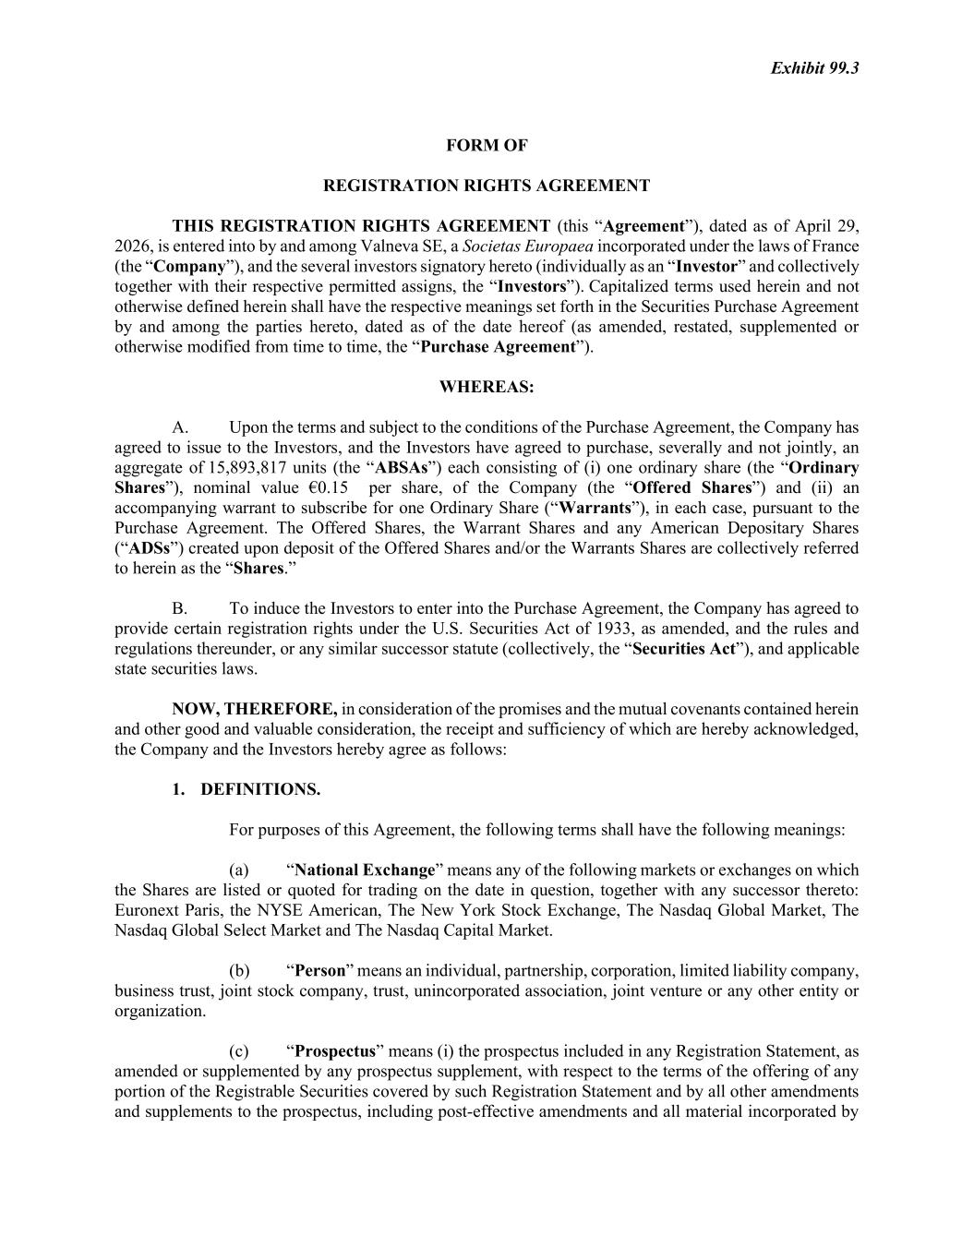

Exhibit 99.3 FORM OF REGISTRATION RIGHTS AGREEMENT THIS REGISTRATION RIGHTS AGREEMENT (this “Agreement”), dated as of April 29, 2026, is entered into by and among Valneva SE, a Societas Europaea incorporated under the laws of France (the “Company”), and the several investors signatory hereto (individually as an “Investor” and collectively together with their respective permitted assigns, the “Investors”). Capitalized terms used herein and not otherwise defined herein shall have the respective meanings set forth in the Securities Purchase Agreement by and among the parties hereto, dated as of the date hereof (as amended, restated, supplemented or otherwise modified from time to time, the “Purchase Agreement”). WHEREAS: A. Upon the terms and subject to the conditions of the Purchase Agreement, the Company has agreed to issue to the Investors, and the Investors have agreed to purchase, severally and not jointly, an aggregate of 15,893,817 units (the “ABSAs”) each consisting of (i) one ordinary share (the “Ordinary Shares”), nominal value €0.15 per share, of the Company (the “Offered Shares”) and (ii) an accompanying warrant to subscribe for one Ordinary Share (“Warrants”), in each case, pursuant to the Purchase Agreement. The Offered Shares, the Warrant Shares and any American Depositary Shares (“ADSs”) created upon deposit of the Offered Shares and/or the Warrants Shares are collectively referred to herein as the “Shares.” B. To induce the Investors to enter into the Purchase Agreement, the Company has agreed to provide certain registration rights under the U.S. Securities Act of 1933, as amended, and the rules and regulations thereunder, or any similar successor statute (collectively, the “Securities Act”), and applicable state securities laws. NOW, THEREFORE, in consideration of the promises and the mutual covenants contained herein and other good and valuable consideration, the receipt and sufficiency of which are hereby acknowledged, the Company and the Investors hereby agree as follows: 1. DEFINITIONS. For purposes of this Agreement, the following terms shall have the following meanings: (a) “National Exchange” means any of the following markets or exchanges on which the Shares are listed or quoted for trading on the date in question, together with any successor thereto: Euronext Paris, the NYSE American, The New York Stock Exchange, The Nasdaq Global Market, The Nasdaq Global Select Market and The Nasdaq Capital Market. (b) “Person” means an individual, partnership, corporation, limited liability company, business trust, joint stock company, trust, unincorporated association, joint venture or any other entity or organization. (c) “Prospectus” means (i) the prospectus included in any Registration Statement, as amended or supplemented by any prospectus supplement, with respect to the terms of the offering of any portion of the Registrable Securities covered by such Registration Statement and by all other amendments and supplements to the prospectus, including post-effective amendments and all material incorporated by

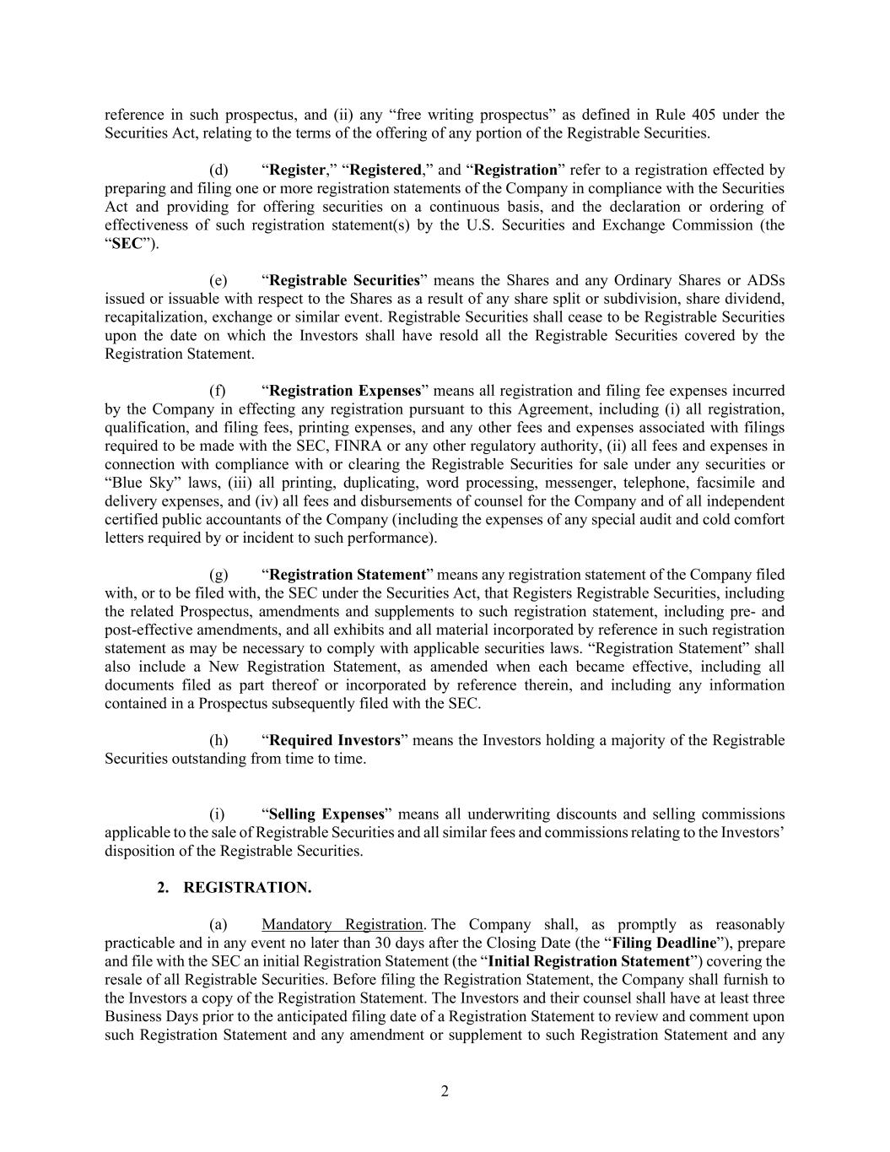
2 reference in such prospectus, and (ii) any “free writing prospectus” as defined in Rule 405 under the Securities Act, relating to the terms of the offering of any portion of the Registrable Securities. (d) “Register,” “Registered,” and “Registration” refer to a registration effected by preparing and filing one or more registration statements of the Company in compliance with the Securities Act and providing for offering securities on a continuous basis, and the declaration or ordering of effectiveness of such registration statement(s) by the U.S. Securities and Exchange Commission (the “SEC”). (e) “Registrable Securities” means the Shares and any Ordinary Shares or ADSs issued or issuable with respect to the Shares as a result of any share split or subdivision, share dividend, recapitalization, exchange or similar event. Registrable Securities shall cease to be Registrable Securities upon the date on which the Investors shall have resold all the Registrable Securities covered by the Registration Statement. (f) “Registration Expenses” means all registration and filing fee expenses incurred by the Company in effecting any registration pursuant to this Agreement, including (i) all registration, qualification, and filing fees, printing expenses, and any other fees and expenses associated with filings required to be made with the SEC, FINRA or any other regulatory authority, (ii) all fees and expenses in connection with compliance with or clearing the Registrable Securities for sale under any securities or “Blue Sky” laws, (iii) all printing, duplicating, word processing, messenger, telephone, facsimile and delivery expenses, and (iv) all fees and disbursements of counsel for the Company and of all independent certified public accountants of the Company (including the expenses of any special audit and cold comfort letters required by or incident to such performance). (g) “Registration Statement” means any registration statement of the Company filed with, or to be filed with, the SEC under the Securities Act, that Registers Registrable Securities, including the related Prospectus, amendments and supplements to such registration statement, including pre- and post-effective amendments, and all exhibits and all material incorporated by reference in such registration statement as may be necessary to comply with applicable securities laws. “Registration Statement” shall also include a New Registration Statement, as amended when each became effective, including all documents filed as part thereof or incorporated by reference therein, and including any information contained in a Prospectus subsequently filed with the SEC. (h) “Required Investors” means the Investors holding a majority of the Registrable Securities outstanding from time to time. (i) “Selling Expenses” means all underwriting discounts and selling commissions applicable to the sale of Registrable Securities and all similar fees and commissions relating to the Investors’ disposition of the Registrable Securities. 2. REGISTRATION. (a) Mandatory Registration. The Company shall, as promptly as reasonably practicable and in any event no later than 30 days after the Closing Date (the “Filing Deadline”), prepare and file with the SEC an initial Registration Statement (the “Initial Registration Statement”) covering the resale of all Registrable Securities. Before filing the Registration Statement, the Company shall furnish to the Investors a copy of the Registration Statement. The Investors and their counsel shall have at least three Business Days prior to the anticipated filing date of a Registration Statement to review and comment upon such Registration Statement and any amendment or supplement to such Registration Statement and any

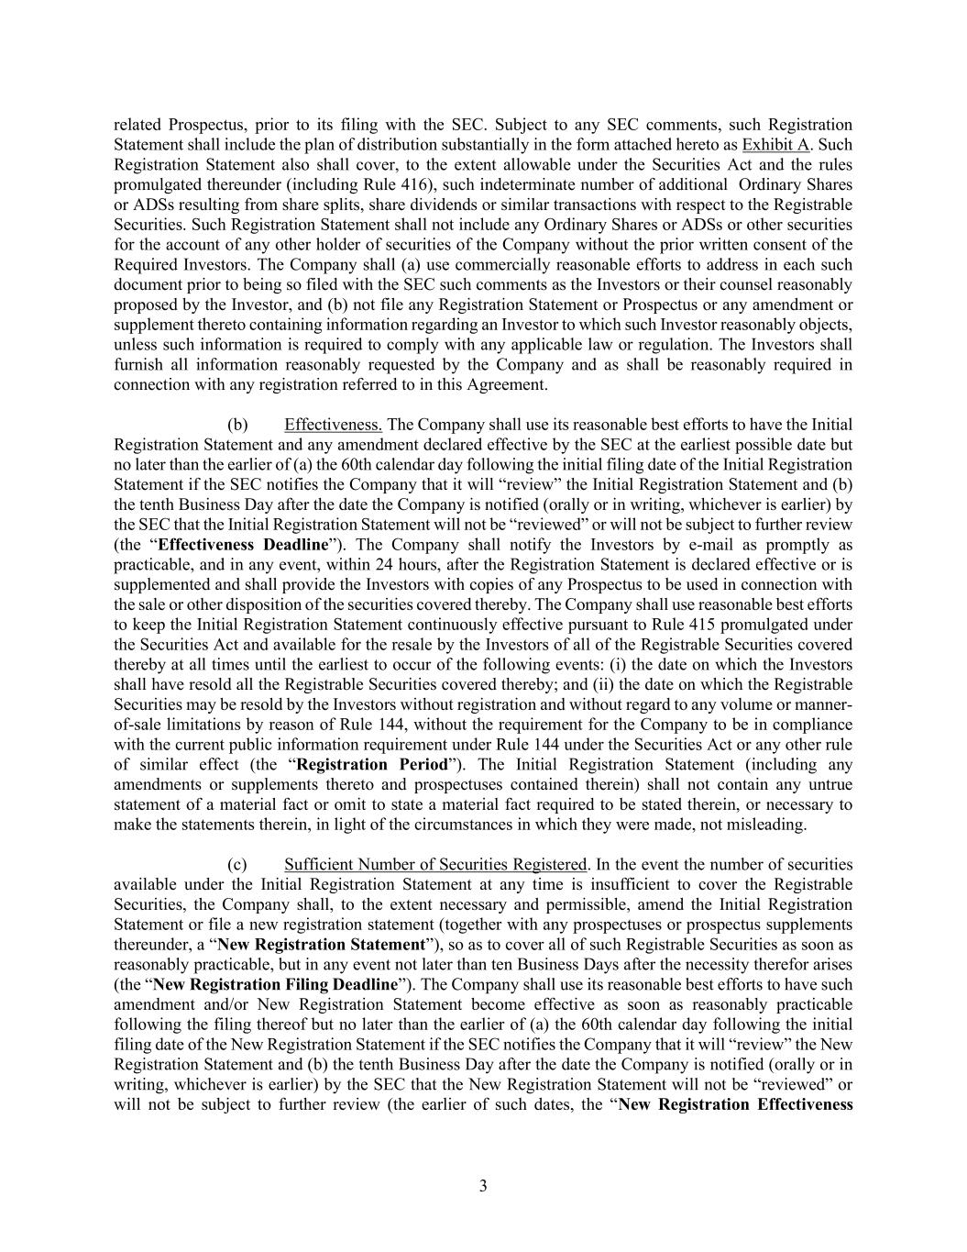
3 related Prospectus, prior to its filing with the SEC. Subject to any SEC comments, such Registration Statement shall include the plan of distribution substantially in the form attached hereto as Exhibit A. Such Registration Statement also shall cover, to the extent allowable under the Securities Act and the rules promulgated thereunder (including Rule 416), such indeterminate number of additional Ordinary Shares or ADSs resulting from share splits, share dividends or similar transactions with respect to the Registrable Securities. Such Registration Statement shall not include any Ordinary Shares or ADSs or other securities for the account of any other holder of securities of the Company without the prior written consent of the Required Investors. The Company shall (a) use commercially reasonable efforts to address in each such document prior to being so filed with the SEC such comments as the Investors or their counsel reasonably proposed by the Investor, and (b) not file any Registration Statement or Prospectus or any amendment or supplement thereto containing information regarding an Investor to which such Investor reasonably objects, unless such information is required to comply with any applicable law or regulation. The Investors shall furnish all information reasonably requested by the Company and as shall be reasonably required in connection with any registration referred to in this Agreement. (b) Effectiveness. The Company shall use its reasonable best efforts to have the Initial Registration Statement and any amendment declared effective by the SEC at the earliest possible date but no later than the earlier of (a) the 60th calendar day following the initial filing date of the Initial Registration Statement if the SEC notifies the Company that it will “review” the Initial Registration Statement and (b) the tenth Business Day after the date the Company is notified (orally or in writing, whichever is earlier) by the SEC that the Initial Registration Statement will not be “reviewed” or will not be subject to further review (the “Effectiveness Deadline”). The Company shall notify the Investors by e-mail as promptly as practicable, and in any event, within 24 hours, after the Registration Statement is declared effective or is supplemented and shall provide the Investors with copies of any Prospectus to be used in connection with the sale or other disposition of the securities covered thereby. The Company shall use reasonable best efforts to keep the Initial Registration Statement continuously effective pursuant to Rule 415 promulgated under the Securities Act and available for the resale by the Investors of all of the Registrable Securities covered thereby at all times until the earliest to occur of the following events: (i) the date on which the Investors shall have resold all the Registrable Securities covered thereby; and (ii) the date on which the Registrable Securities may be resold by the Investors without registration and without regard to any volume or manner- of-sale limitations by reason of Rule 144, without the requirement for the Company to be in compliance with the current public information requirement under Rule 144 under the Securities Act or any other rule of similar effect (the “Registration Period”). The Initial Registration Statement (including any amendments or supplements thereto and prospectuses contained therein) shall not contain any untrue statement of a material fact or omit to state a material fact required to be stated therein, or necessary to make the statements therein, in light of the circumstances in which they were made, not misleading. (c) Sufficient Number of Securities Registered. In the event the number of securities available under the Initial Registration Statement at any time is insufficient to cover the Registrable Securities, the Company shall, to the extent necessary and permissible, amend the Initial Registration Statement or file a new registration statement (together with any prospectuses or prospectus supplements thereunder, a “New Registration Statement”), so as to cover all of such Registrable Securities as soon as reasonably practicable, but in any event not later than ten Business Days after the necessity therefor arises (the “New Registration Filing Deadline”). The Company shall use its reasonable best efforts to have such amendment and/or New Registration Statement become effective as soon as reasonably practicable following the filing thereof but no later than the earlier of (a) the 60th calendar day following the initial filing date of the New Registration Statement if the SEC notifies the Company that it will “review” the New Registration Statement and (b) the tenth Business Day after the date the Company is notified (orally or in writing, whichever is earlier) by the SEC that the New Registration Statement will not be “reviewed” or will not be subject to further review (the earlier of such dates, the “New Registration Effectiveness

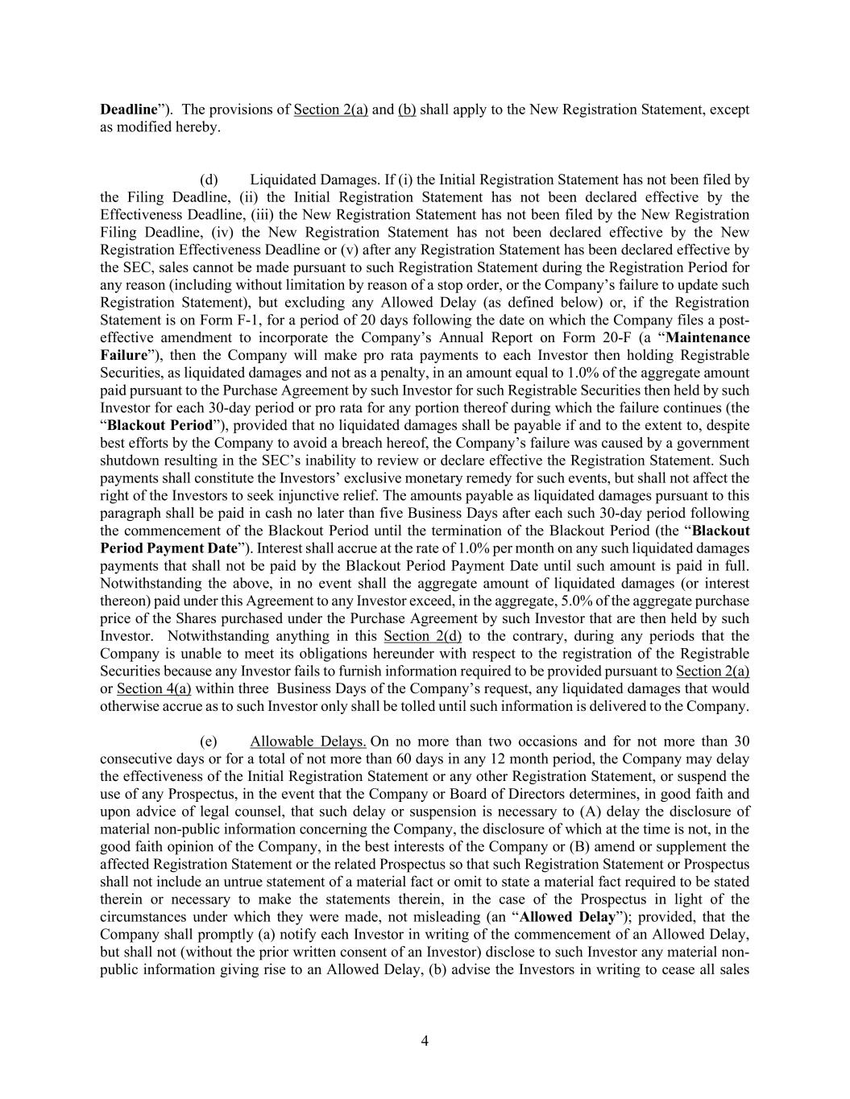
4 Deadline”). The provisions of Section 2(a) and (b) shall apply to the New Registration Statement, except as modified hereby. (d) Liquidated Damages. If (i) the Initial Registration Statement has not been filed by the Filing Deadline, (ii) the Initial Registration Statement has not been declared effective by the Effectiveness Deadline, (iii) the New Registration Statement has not been filed by the New Registration Filing Deadline, (iv) the New Registration Statement has not been declared effective by the New Registration Effectiveness Deadline or (v) after any Registration Statement has been declared effective by the SEC, sales cannot be made pursuant to such Registration Statement during the Registration Period for any reason (including without limitation by reason of a stop order, or the Company’s failure to update such Registration Statement), but excluding any Allowed Delay (as defined below) or, if the Registration Statement is on Form F-1, for a period of 20 days following the date on which the Company files a post- effective amendment to incorporate the Company’s Annual Report on Form 20-F (a “Maintenance Failure”), then the Company will make pro rata payments to each Investor then holding Registrable Securities, as liquidated damages and not as a penalty, in an amount equal to 1.0% of the aggregate amount paid pursuant to the Purchase Agreement by such Investor for such Registrable Securities then held by such Investor for each 30-day period or pro rata for any portion thereof during which the failure continues (the “Blackout Period”), provided that no liquidated damages shall be payable if and to the extent to, despite best efforts by the Company to avoid a breach hereof, the Company’s failure was caused by a government shutdown resulting in the SEC’s inability to review or declare effective the Registration Statement. Such payments shall constitute the Investors’ exclusive monetary remedy for such events, but shall not affect the right of the Investors to seek injunctive relief. The amounts payable as liquidated damages pursuant to this paragraph shall be paid in cash no later than five Business Days after each such 30-day period following the commencement of the Blackout Period until the termination of the Blackout Period (the “Blackout Period Payment Date”). Interest shall accrue at the rate of 1.0% per month on any such liquidated damages payments that shall not be paid by the Blackout Period Payment Date until such amount is paid in full. Notwithstanding the above, in no event shall the aggregate amount of liquidated damages (or interest thereon) paid under this Agreement to any Investor exceed, in the aggregate, 5.0% of the aggregate purchase price of the Shares purchased under the Purchase Agreement by such Investor that are then held by such Investor. Notwithstanding anything in this Section 2(d) to the contrary, during any periods that the Company is unable to meet its obligations hereunder with respect to the registration of the Registrable Securities because any Investor fails to furnish information required to be provided pursuant to Section 2(a) or Section 4(a) within three Business Days of the Company’s request, any liquidated damages that would otherwise accrue as to such Investor only shall be tolled until such information is delivered to the Company. (e) Allowable Delays. On no more than two occasions and for not more than 30 consecutive days or for a total of not more than 60 days in any 12 month period, the Company may delay the effectiveness of the Initial Registration Statement or any other Registration Statement, or suspend the use of any Prospectus, in the event that the Company or Board of Directors determines, in good faith and upon advice of legal counsel, that such delay or suspension is necessary to (A) delay the disclosure of material non-public information concerning the Company, the disclosure of which at the time is not, in the good faith opinion of the Company, in the best interests of the Company or (B) amend or supplement the affected Registration Statement or the related Prospectus so that such Registration Statement or Prospectus shall not include an untrue statement of a material fact or omit to state a material fact required to be stated therein or necessary to make the statements therein, in the case of the Prospectus in light of the circumstances under which they were made, not misleading (an “Allowed Delay”); provided, that the Company shall promptly (a) notify each Investor in writing of the commencement of an Allowed Delay, but shall not (without the prior written consent of an Investor) disclose to such Investor any material non- public information giving rise to an Allowed Delay, (b) advise the Investors in writing to cease all sales

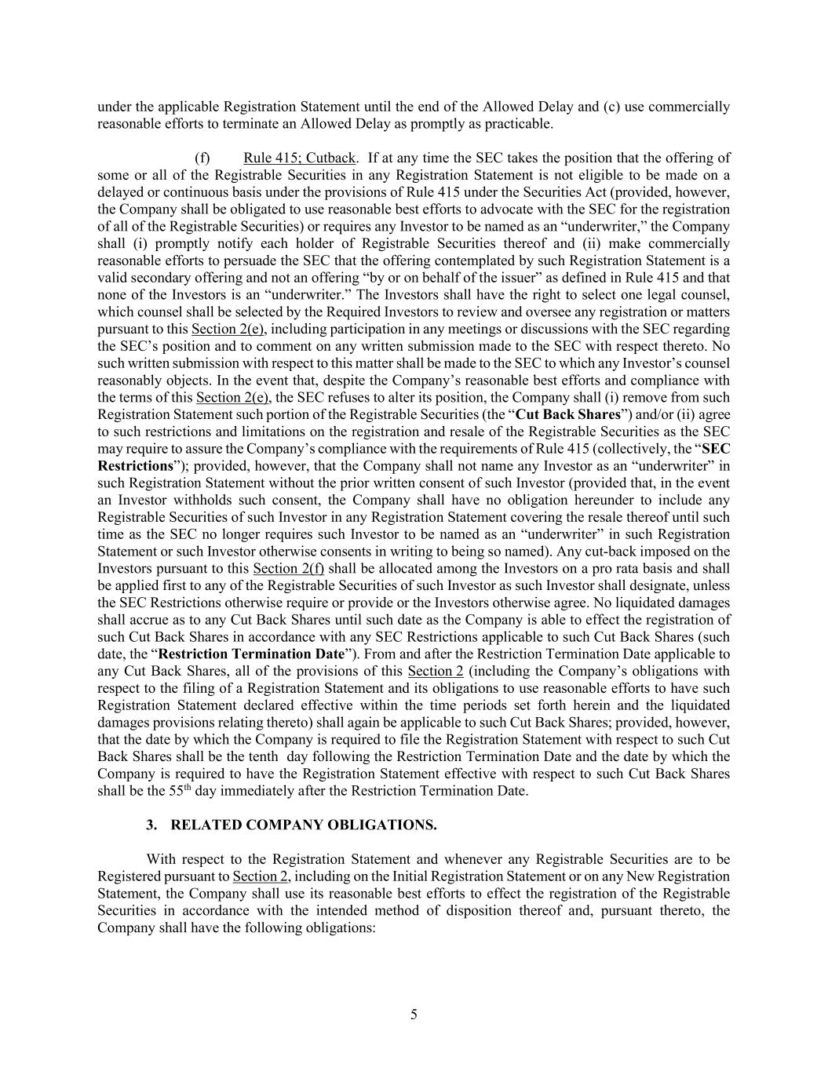
5 under the applicable Registration Statement until the end of the Allowed Delay and (c) use commercially reasonable efforts to terminate an Allowed Delay as promptly as practicable. (f) Rule 415; Cutback. If at any time the SEC takes the position that the offering of some or all of the Registrable Securities in any Registration Statement is not eligible to be made on a delayed or continuous basis under the provisions of Rule 415 under the Securities Act (provided, however, the Company shall be obligated to use reasonable best efforts to advocate with the SEC for the registration of all of the Registrable Securities) or requires any Investor to be named as an “underwriter,” the Company shall (i) promptly notify each holder of Registrable Securities thereof and (ii) make commercially reasonable efforts to persuade the SEC that the offering contemplated by such Registration Statement is a valid secondary offering and not an offering “by or on behalf of the issuer” as defined in Rule 415 and that none of the Investors is an “underwriter.” The Investors shall have the right to select one legal counsel, which counsel shall be selected by the Required Investors to review and oversee any registration or matters pursuant to this Section 2(e), including participation in any meetings or discussions with the SEC regarding the SEC’s position and to comment on any written submission made to the SEC with respect thereto. No such written submission with respect to this matter shall be made to the SEC to which any Investor’s counsel reasonably objects. In the event that, despite the Company’s reasonable best efforts and compliance with the terms of this Section 2(e), the SEC refuses to alter its position, the Company shall (i) remove from such Registration Statement such portion of the Registrable Securities (the “Cut Back Shares”) and/or (ii) agree to such restrictions and limitations on the registration and resale of the Registrable Securities as the SEC may require to assure the Company’s compliance with the requirements of Rule 415 (collectively, the “SEC Restrictions”); provided, however, that the Company shall not name any Investor as an “underwriter” in such Registration Statement without the prior written consent of such Investor (provided that, in the event an Investor withholds such consent, the Company shall have no obligation hereunder to include any Registrable Securities of such Investor in any Registration Statement covering the resale thereof until such time as the SEC no longer requires such Investor to be named as an “underwriter” in such Registration Statement or such Investor otherwise consents in writing to being so named). Any cut-back imposed on the Investors pursuant to this Section 2(f) shall be allocated among the Investors on a pro rata basis and shall be applied first to any of the Registrable Securities of such Investor as such Investor shall designate, unless the SEC Restrictions otherwise require or provide or the Investors otherwise agree. No liquidated damages shall accrue as to any Cut Back Shares until such date as the Company is able to effect the registration of such Cut Back Shares in accordance with any SEC Restrictions applicable to such Cut Back Shares (such date, the “Restriction Termination Date”). From and after the Restriction Termination Date applicable to any Cut Back Shares, all of the provisions of this Section 2 (including the Company’s obligations with respect to the filing of a Registration Statement and its obligations to use reasonable efforts to have such Registration Statement declared effective within the time periods set forth herein and the liquidated damages provisions relating thereto) shall again be applicable to such Cut Back Shares; provided, however, that the date by which the Company is required to file the Registration Statement with respect to such Cut Back Shares shall be the tenth day following the Restriction Termination Date and the date by which the Company is required to have the Registration Statement effective with respect to such Cut Back Shares shall be the 55th day immediately after the Restriction Termination Date. 3. RELATED COMPANY OBLIGATIONS. With respect to the Registration Statement and whenever any Registrable Securities are to be Registered pursuant to Section 2, including on the Initial Registration Statement or on any New Registration Statement, the Company shall use its reasonable best efforts to effect the registration of the Registrable Securities in accordance with the intended method of disposition thereof and, pursuant thereto, the Company shall have the following obligations:

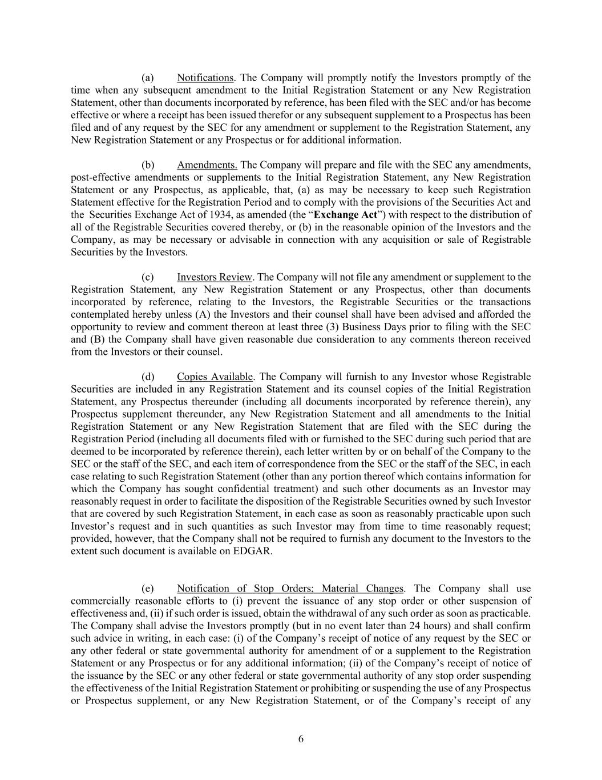
6 (a) Notifications. The Company will promptly notify the Investors promptly of the time when any subsequent amendment to the Initial Registration Statement or any New Registration Statement, other than documents incorporated by reference, has been filed with the SEC and/or has become effective or where a receipt has been issued therefor or any subsequent supplement to a Prospectus has been filed and of any request by the SEC for any amendment or supplement to the Registration Statement, any New Registration Statement or any Prospectus or for additional information. (b) Amendments. The Company will prepare and file with the SEC any amendments, post-effective amendments or supplements to the Initial Registration Statement, any New Registration Statement or any Prospectus, as applicable, that, (a) as may be necessary to keep such Registration Statement effective for the Registration Period and to comply with the provisions of the Securities Act and the Securities Exchange Act of 1934, as amended (the “Exchange Act”) with respect to the distribution of all of the Registrable Securities covered thereby, or (b) in the reasonable opinion of the Investors and the Company, as may be necessary or advisable in connection with any acquisition or sale of Registrable Securities by the Investors. (c) Investors Review. The Company will not file any amendment or supplement to the Registration Statement, any New Registration Statement or any Prospectus, other than documents incorporated by reference, relating to the Investors, the Registrable Securities or the transactions contemplated hereby unless (A) the Investors and their counsel shall have been advised and afforded the opportunity to review and comment thereon at least three (3) Business Days prior to filing with the SEC and (B) the Company shall have given reasonable due consideration to any comments thereon received from the Investors or their counsel. (d) Copies Available. The Company will furnish to any Investor whose Registrable Securities are included in any Registration Statement and its counsel copies of the Initial Registration Statement, any Prospectus thereunder (including all documents incorporated by reference therein), any Prospectus supplement thereunder, any New Registration Statement and all amendments to the Initial Registration Statement or any New Registration Statement that are filed with the SEC during the Registration Period (including all documents filed with or furnished to the SEC during such period that are deemed to be incorporated by reference therein), each letter written by or on behalf of the Company to the SEC or the staff of the SEC, and each item of correspondence from the SEC or the staff of the SEC, in each case relating to such Registration Statement (other than any portion thereof which contains information for which the Company has sought confidential treatment) and such other documents as an Investor may reasonably request in order to facilitate the disposition of the Registrable Securities owned by such Investor that are covered by such Registration Statement, in each case as soon as reasonably practicable upon such Investor’s request and in such quantities as such Investor may from time to time reasonably request; provided, however, that the Company shall not be required to furnish any document to the Investors to the extent such document is available on EDGAR. (e) Notification of Stop Orders; Material Changes. The Company shall use commercially reasonable efforts to (i) prevent the issuance of any stop order or other suspension of effectiveness and, (ii) if such order is issued, obtain the withdrawal of any such order as soon as practicable. The Company shall advise the Investors promptly (but in no event later than 24 hours) and shall confirm such advice in writing, in each case: (i) of the Company’s receipt of notice of any request by the SEC or any other federal or state governmental authority for amendment of or a supplement to the Registration Statement or any Prospectus or for any additional information; (ii) of the Company’s receipt of notice of the issuance by the SEC or any other federal or state governmental authority of any stop order suspending the effectiveness of the Initial Registration Statement or prohibiting or suspending the use of any Prospectus or Prospectus supplement, or any New Registration Statement, or of the Company’s receipt of any

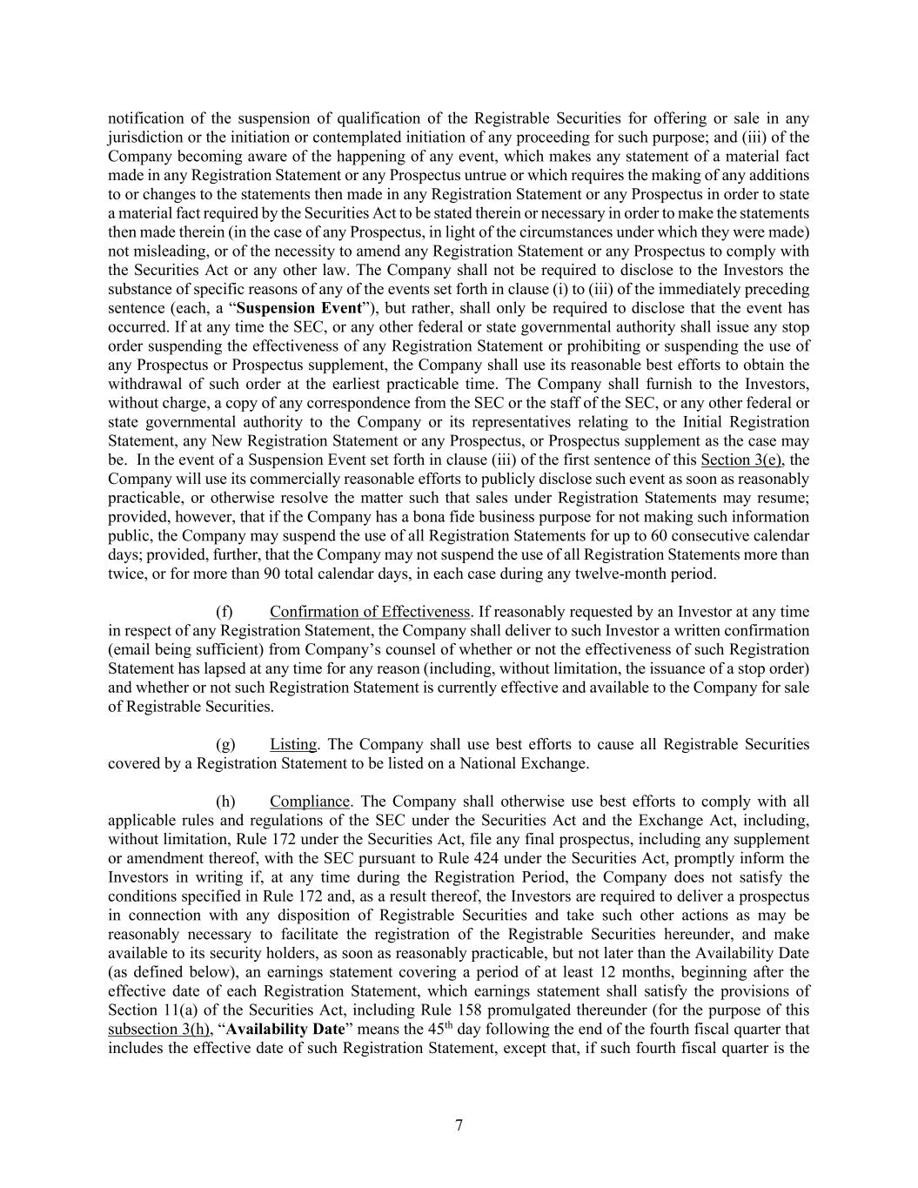
7 notification of the suspension of qualification of the Registrable Securities for offering or sale in any jurisdiction or the initiation or contemplated initiation of any proceeding for such purpose; and (iii) of the Company becoming aware of the happening of any event, which makes any statement of a material fact made in any Registration Statement or any Prospectus untrue or which requires the making of any additions to or changes to the statements then made in any Registration Statement or any Prospectus in order to state a material fact required by the Securities Act to be stated therein or necessary in order to make the statements then made therein (in the case of any Prospectus, in light of the circumstances under which they were made) not misleading, or of the necessity to amend any Registration Statement or any Prospectus to comply with the Securities Act or any other law. The Company shall not be required to disclose to the Investors the substance of specific reasons of any of the events set forth in clause (i) to (iii) of the immediately preceding sentence (each, a “Suspension Event”), but rather, shall only be required to disclose that the event has occurred. If at any time the SEC, or any other federal or state governmental authority shall issue any stop order suspending the effectiveness of any Registration Statement or prohibiting or suspending the use of any Prospectus or Prospectus supplement, the Company shall use its reasonable best efforts to obtain the withdrawal of such order at the earliest practicable time. The Company shall furnish to the Investors, without charge, a copy of any correspondence from the SEC or the staff of the SEC, or any other federal or state governmental authority to the Company or its representatives relating to the Initial Registration Statement, any New Registration Statement or any Prospectus, or Prospectus supplement as the case may be. In the event of a Suspension Event set forth in clause (iii) of the first sentence of this Section 3(e), the Company will use its commercially reasonable efforts to publicly disclose such event as soon as reasonably practicable, or otherwise resolve the matter such that sales under Registration Statements may resume; provided, however, that if the Company has a bona fide business purpose for not making such information public, the Company may suspend the use of all Registration Statements for up to 60 consecutive calendar days; provided, further, that the Company may not suspend the use of all Registration Statements more than twice, or for more than 90 total calendar days, in each case during any twelve-month period. (f) Confirmation of Effectiveness. If reasonably requested by an Investor at any time in respect of any Registration Statement, the Company shall deliver to such Investor a written confirmation (email being sufficient) from Company’s counsel of whether or not the effectiveness of such Registration Statement has lapsed at any time for any reason (including, without limitation, the issuance of a stop order) and whether or not such Registration Statement is currently effective and available to the Company for sale of Registrable Securities. (g) Listing. The Company shall use best efforts to cause all Registrable Securities covered by a Registration Statement to be listed on a National Exchange. (h) Compliance. The Company shall otherwise use best efforts to comply with all applicable rules and regulations of the SEC under the Securities Act and the Exchange Act, including, without limitation, Rule 172 under the Securities Act, file any final prospectus, including any supplement or amendment thereof, with the SEC pursuant to Rule 424 under the Securities Act, promptly inform the Investors in writing if, at any time during the Registration Period, the Company does not satisfy the conditions specified in Rule 172 and, as a result thereof, the Investors are required to deliver a prospectus in connection with any disposition of Registrable Securities and take such other actions as may be reasonably necessary to facilitate the registration of the Registrable Securities hereunder, and make available to its security holders, as soon as reasonably practicable, but not later than the Availability Date (as defined below), an earnings statement covering a period of at least 12 months, beginning after the effective date of each Registration Statement, which earnings statement shall satisfy the provisions of Section 11(a) of the Securities Act, including Rule 158 promulgated thereunder (for the purpose of this subsection 3(h), “Availability Date” means the 45th day following the end of the fourth fiscal quarter that includes the effective date of such Registration Statement, except that, if such fourth fiscal quarter is the

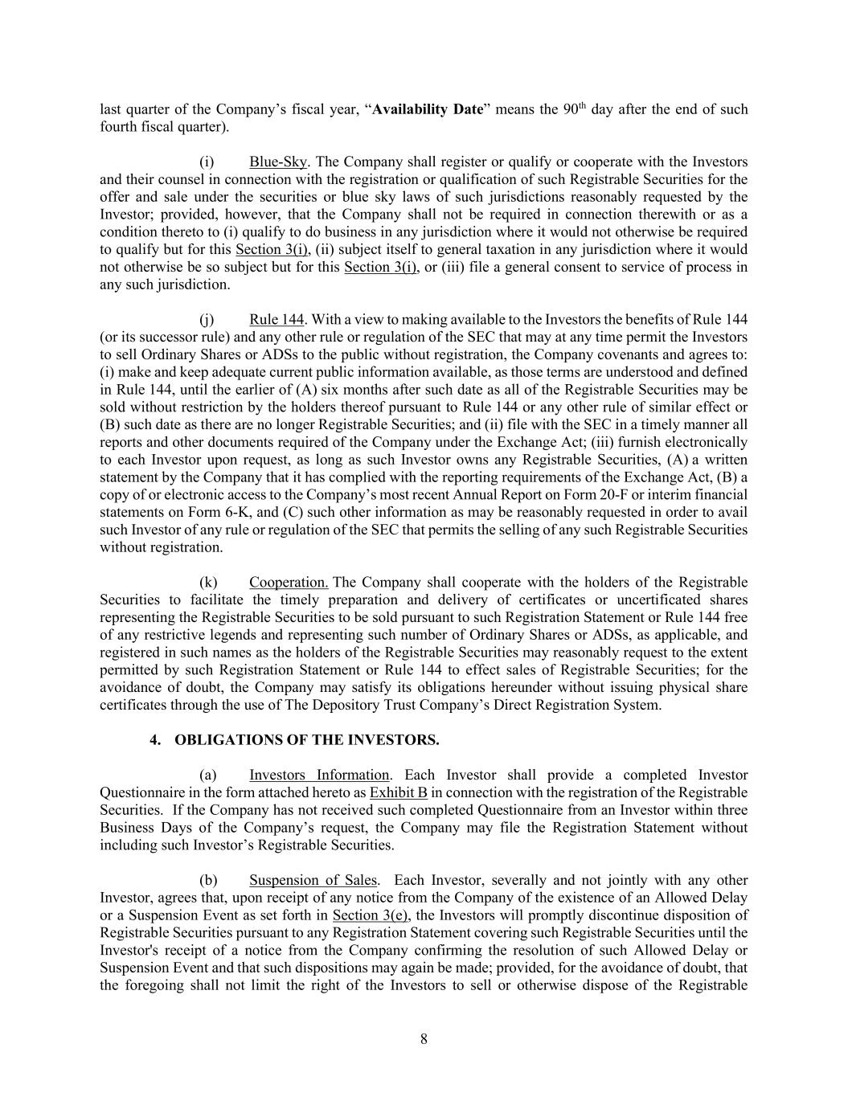
8 last quarter of the Company’s fiscal year, “Availability Date” means the 90th day after the end of such fourth fiscal quarter). (i) Blue-Sky. The Company shall register or qualify or cooperate with the Investors and their counsel in connection with the registration or qualification of such Registrable Securities for the offer and sale under the securities or blue sky laws of such jurisdictions reasonably requested by the Investor; provided, however, that the Company shall not be required in connection therewith or as a condition thereto to (i) qualify to do business in any jurisdiction where it would not otherwise be required to qualify but for this Section 3(i), (ii) subject itself to general taxation in any jurisdiction where it would not otherwise be so subject but for this Section 3(i), or (iii) file a general consent to service of process in any such jurisdiction. (j) Rule 144. With a view to making available to the Investors the benefits of Rule 144 (or its successor rule) and any other rule or regulation of the SEC that may at any time permit the Investors to sell Ordinary Shares or ADSs to the public without registration, the Company covenants and agrees to: (i) make and keep adequate current public information available, as those terms are understood and defined in Rule 144, until the earlier of (A) six months after such date as all of the Registrable Securities may be sold without restriction by the holders thereof pursuant to Rule 144 or any other rule of similar effect or (B) such date as there are no longer Registrable Securities; and (ii) file with the SEC in a timely manner all reports and other documents required of the Company under the Exchange Act; (iii) furnish electronically to each Investor upon request, as long as such Investor owns any Registrable Securities, (A) a written statement by the Company that it has complied with the reporting requirements of the Exchange Act, (B) a copy of or electronic access to the Company’s most recent Annual Report on Form 20-F or interim financial statements on Form 6-K, and (C) such other information as may be reasonably requested in order to avail such Investor of any rule or regulation of the SEC that permits the selling of any such Registrable Securities without registration. (k) Cooperation. The Company shall cooperate with the holders of the Registrable Securities to facilitate the timely preparation and delivery of certificates or uncertificated shares representing the Registrable Securities to be sold pursuant to such Registration Statement or Rule 144 free of any restrictive legends and representing such number of Ordinary Shares or ADSs, as applicable, and registered in such names as the holders of the Registrable Securities may reasonably request to the extent permitted by such Registration Statement or Rule 144 to effect sales of Registrable Securities; for the avoidance of doubt, the Company may satisfy its obligations hereunder without issuing physical share certificates through the use of The Depository Trust Company’s Direct Registration System. 4. OBLIGATIONS OF THE INVESTORS. (a) Investors Information. Each Investor shall provide a completed Investor Questionnaire in the form attached hereto as Exhibit B in connection with the registration of the Registrable Securities. If the Company has not received such completed Questionnaire from an Investor within three Business Days of the Company’s request, the Company may file the Registration Statement without including such Investor’s Registrable Securities. (b) Suspension of Sales. Each Investor, severally and not jointly with any other Investor, agrees that, upon receipt of any notice from the Company of the existence of an Allowed Delay or a Suspension Event as set forth in Section 3(e), the Investors will promptly discontinue disposition of Registrable Securities pursuant to any Registration Statement covering such Registrable Securities until the Investor's receipt of a notice from the Company confirming the resolution of such Allowed Delay or Suspension Event and that such dispositions may again be made; provided, for the avoidance of doubt, that the foregoing shall not limit the right of the Investors to sell or otherwise dispose of the Registrable

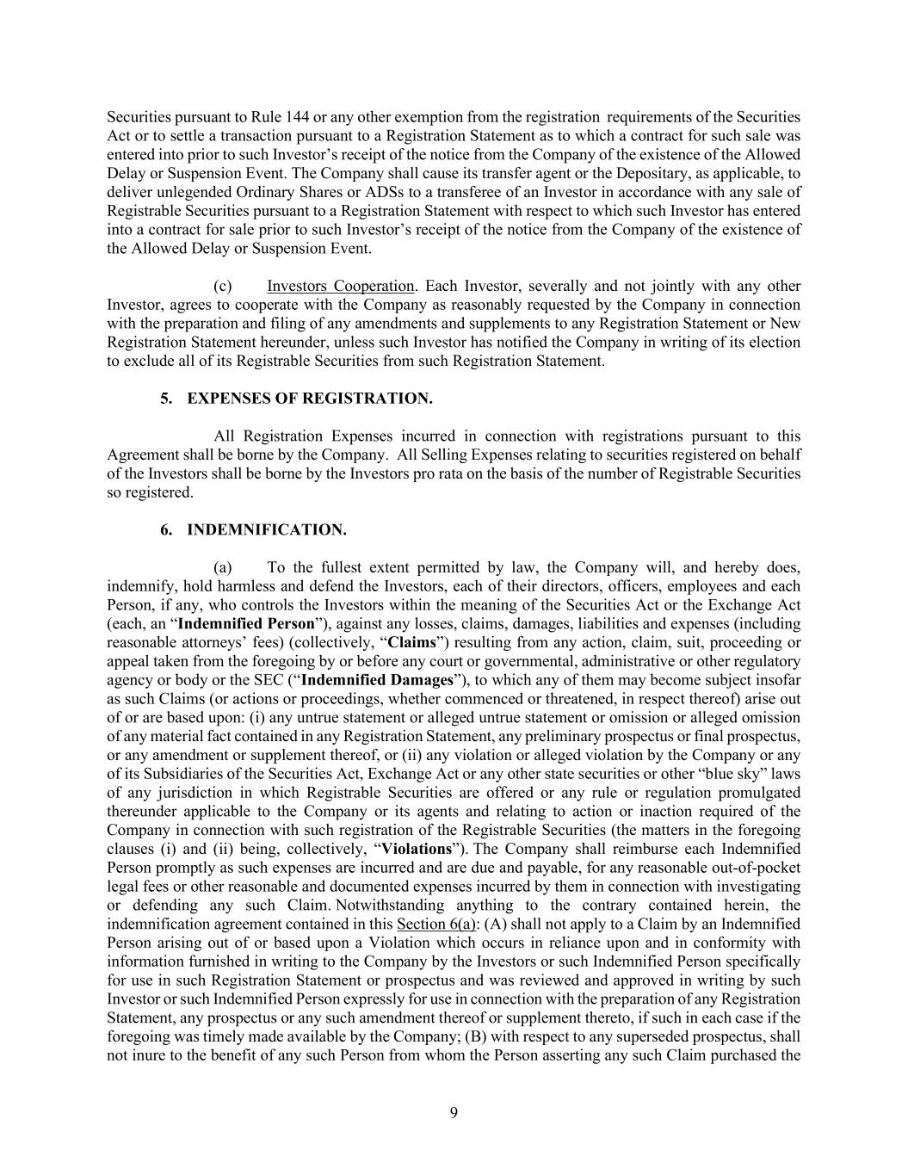
9 Securities pursuant to Rule 144 or any other exemption from the registration requirements of the Securities Act or to settle a transaction pursuant to a Registration Statement as to which a contract for such sale was entered into prior to such Investor’s receipt of the notice from the Company of the existence of the Allowed Delay or Suspension Event. The Company shall cause its transfer agent or the Depositary, as applicable, to deliver unlegended Ordinary Shares or ADSs to a transferee of an Investor in accordance with any sale of Registrable Securities pursuant to a Registration Statement with respect to which such Investor has entered into a contract for sale prior to such Investor’s receipt of the notice from the Company of the existence of the Allowed Delay or Suspension Event. (c) Investors Cooperation. Each Investor, severally and not jointly with any other Investor, agrees to cooperate with the Company as reasonably requested by the Company in connection with the preparation and filing of any amendments and supplements to any Registration Statement or New Registration Statement hereunder, unless such Investor has notified the Company in writing of its election to exclude all of its Registrable Securities from such Registration Statement. 5. EXPENSES OF REGISTRATION. All Registration Expenses incurred in connection with registrations pursuant to this Agreement shall be borne by the Company. All Selling Expenses relating to securities registered on behalf of the Investors shall be borne by the Investors pro rata on the basis of the number of Registrable Securities so registered. 6. INDEMNIFICATION. (a) To the fullest extent permitted by law, the Company will, and hereby does, indemnify, hold harmless and defend the Investors, each of their directors, officers, employees and each Person, if any, who controls the Investors within the meaning of the Securities Act or the Exchange Act (each, an “Indemnified Person”), against any losses, claims, damages, liabilities and expenses (including reasonable attorneys’ fees) (collectively, “Claims”) resulting from any action, claim, suit, proceeding or appeal taken from the foregoing by or before any court or governmental, administrative or other regulatory agency or body or the SEC (“Indemnified Damages”), to which any of them may become subject insofar as such Claims (or actions or proceedings, whether commenced or threatened, in respect thereof) arise out of or are based upon: (i) any untrue statement or alleged untrue statement or omission or alleged omission of any material fact contained in any Registration Statement, any preliminary prospectus or final prospectus, or any amendment or supplement thereof, or (ii) any violation or alleged violation by the Company or any of its Subsidiaries of the Securities Act, Exchange Act or any other state securities or other “blue sky” laws of any jurisdiction in which Registrable Securities are offered or any rule or regulation promulgated thereunder applicable to the Company or its agents and relating to action or inaction required of the Company in connection with such registration of the Registrable Securities (the matters in the foregoing clauses (i) and (ii) being, collectively, “Violations”). The Company shall reimburse each Indemnified Person promptly as such expenses are incurred and are due and payable, for any reasonable out-of-pocket legal fees or other reasonable and documented expenses incurred by them in connection with investigating or defending any such Claim. Notwithstanding anything to the contrary contained herein, the indemnification agreement contained in this Section 6(a): (A) shall not apply to a Claim by an Indemnified Person arising out of or based upon a Violation which occurs in reliance upon and in conformity with information furnished in writing to the Company by the Investors or such Indemnified Person specifically for use in such Registration Statement or prospectus and was reviewed and approved in writing by such Investor or such Indemnified Person expressly for use in connection with the preparation of any Registration Statement, any prospectus or any such amendment thereof or supplement thereto, if such in each case if the foregoing was timely made available by the Company; (B) with respect to any superseded prospectus, shall not inure to the benefit of any such Person from whom the Person asserting any such Claim purchased the

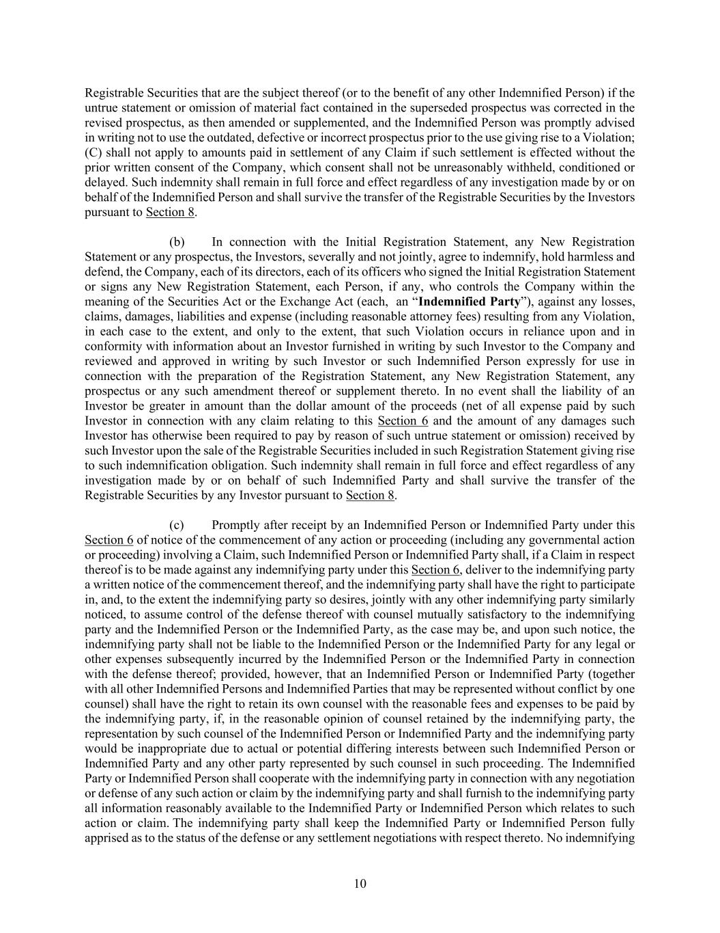
10 Registrable Securities that are the subject thereof (or to the benefit of any other Indemnified Person) if the untrue statement or omission of material fact contained in the superseded prospectus was corrected in the revised prospectus, as then amended or supplemented, and the Indemnified Person was promptly advised in writing not to use the outdated, defective or incorrect prospectus prior to the use giving rise to a Violation; (C) shall not apply to amounts paid in settlement of any Claim if such settlement is effected without the prior written consent of the Company, which consent shall not be unreasonably withheld, conditioned or delayed. Such indemnity shall remain in full force and effect regardless of any investigation made by or on behalf of the Indemnified Person and shall survive the transfer of the Registrable Securities by the Investors pursuant to Section 8. (b) In connection with the Initial Registration Statement, any New Registration Statement or any prospectus, the Investors, severally and not jointly, agree to indemnify, hold harmless and defend, the Company, each of its directors, each of its officers who signed the Initial Registration Statement or signs any New Registration Statement, each Person, if any, who controls the Company within the meaning of the Securities Act or the Exchange Act (each, an “Indemnified Party”), against any losses, claims, damages, liabilities and expense (including reasonable attorney fees) resulting from any Violation, in each case to the extent, and only to the extent, that such Violation occurs in reliance upon and in conformity with information about an Investor furnished in writing by such Investor to the Company and reviewed and approved in writing by such Investor or such Indemnified Person expressly for use in connection with the preparation of the Registration Statement, any New Registration Statement, any prospectus or any such amendment thereof or supplement thereto. In no event shall the liability of an Investor be greater in amount than the dollar amount of the proceeds (net of all expense paid by such Investor in connection with any claim relating to this Section 6 and the amount of any damages such Investor has otherwise been required to pay by reason of such untrue statement or omission) received by such Investor upon the sale of the Registrable Securities included in such Registration Statement giving rise to such indemnification obligation. Such indemnity shall remain in full force and effect regardless of any investigation made by or on behalf of such Indemnified Party and shall survive the transfer of the Registrable Securities by any Investor pursuant to Section 8. (c) Promptly after receipt by an Indemnified Person or Indemnified Party under this Section 6 of notice of the commencement of any action or proceeding (including any governmental action or proceeding) involving a Claim, such Indemnified Person or Indemnified Party shall, if a Claim in respect thereof is to be made against any indemnifying party under this Section 6, deliver to the indemnifying party a written notice of the commencement thereof, and the indemnifying party shall have the right to participate in, and, to the extent the indemnifying party so desires, jointly with any other indemnifying party similarly noticed, to assume control of the defense thereof with counsel mutually satisfactory to the indemnifying party and the Indemnified Person or the Indemnified Party, as the case may be, and upon such notice, the indemnifying party shall not be liable to the Indemnified Person or the Indemnified Party for any legal or other expenses subsequently incurred by the Indemnified Person or the Indemnified Party in connection with the defense thereof; provided, however, that an Indemnified Person or Indemnified Party (together with all other Indemnified Persons and Indemnified Parties that may be represented without conflict by one counsel) shall have the right to retain its own counsel with the reasonable fees and expenses to be paid by the indemnifying party, if, in the reasonable opinion of counsel retained by the indemnifying party, the representation by such counsel of the Indemnified Person or Indemnified Party and the indemnifying party would be inappropriate due to actual or potential differing interests between such Indemnified Person or Indemnified Party and any other party represented by such counsel in such proceeding. The Indemnified Party or Indemnified Person shall cooperate with the indemnifying party in connection with any negotiation or defense of any such action or claim by the indemnifying party and shall furnish to the indemnifying party all information reasonably available to the Indemnified Party or Indemnified Person which relates to such action or claim. The indemnifying party shall keep the Indemnified Party or Indemnified Person fully apprised as to the status of the defense or any settlement negotiations with respect thereto. No indemnifying

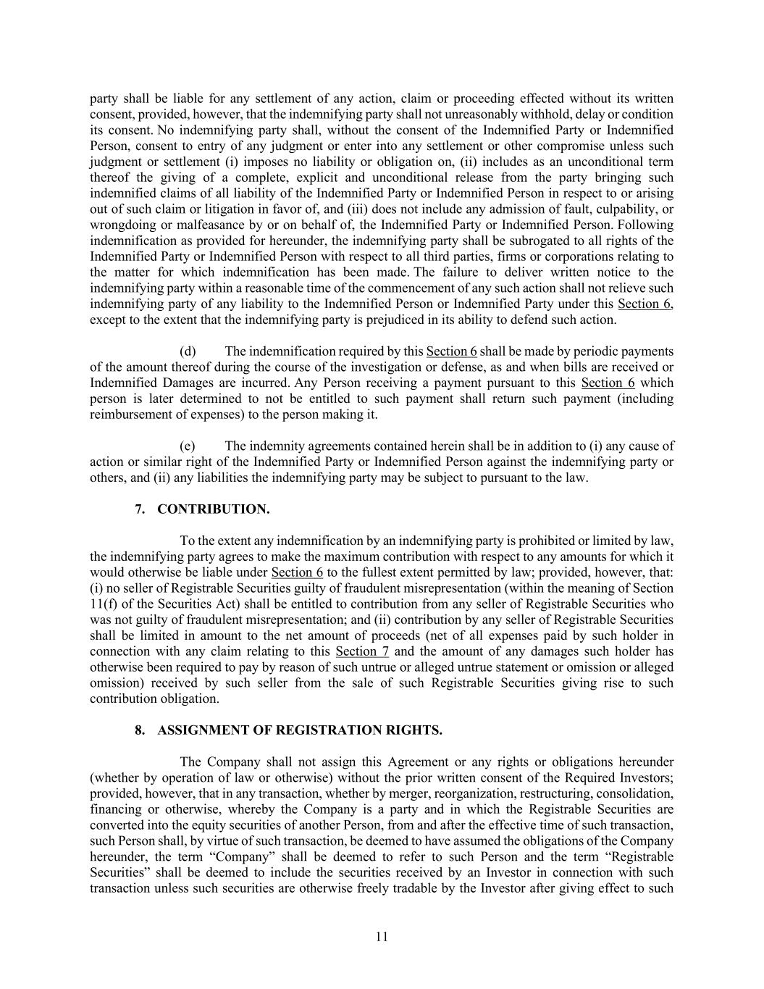
11 party shall be liable for any settlement of any action, claim or proceeding effected without its written consent, provided, however, that the indemnifying party shall not unreasonably withhold, delay or condition its consent. No indemnifying party shall, without the consent of the Indemnified Party or Indemnified Person, consent to entry of any judgment or enter into any settlement or other compromise unless such judgment or settlement (i) imposes no liability or obligation on, (ii) includes as an unconditional term thereof the giving of a complete, explicit and unconditional release from the party bringing such indemnified claims of all liability of the Indemnified Party or Indemnified Person in respect to or arising out of such claim or litigation in favor of, and (iii) does not include any admission of fault, culpability, or wrongdoing or malfeasance by or on behalf of, the Indemnified Party or Indemnified Person. Following indemnification as provided for hereunder, the indemnifying party shall be subrogated to all rights of the Indemnified Party or Indemnified Person with respect to all third parties, firms or corporations relating to the matter for which indemnification has been made. The failure to deliver written notice to the indemnifying party within a reasonable time of the commencement of any such action shall not relieve such indemnifying party of any liability to the Indemnified Person or Indemnified Party under this Section 6, except to the extent that the indemnifying party is prejudiced in its ability to defend such action. (d) The indemnification required by this Section 6 shall be made by periodic payments of the amount thereof during the course of the investigation or defense, as and when bills are received or Indemnified Damages are incurred. Any Person receiving a payment pursuant to this Section 6 which person is later determined to not be entitled to such payment shall return such payment (including reimbursement of expenses) to the person making it. (e) The indemnity agreements contained herein shall be in addition to (i) any cause of action or similar right of the Indemnified Party or Indemnified Person against the indemnifying party or others, and (ii) any liabilities the indemnifying party may be subject to pursuant to the law. 7. CONTRIBUTION. To the extent any indemnification by an indemnifying party is prohibited or limited by law, the indemnifying party agrees to make the maximum contribution with respect to any amounts for which it would otherwise be liable under Section 6 to the fullest extent permitted by law; provided, however, that: (i) no seller of Registrable Securities guilty of fraudulent misrepresentation (within the meaning of Section 11(f) of the Securities Act) shall be entitled to contribution from any seller of Registrable Securities who was not guilty of fraudulent misrepresentation; and (ii) contribution by any seller of Registrable Securities shall be limited in amount to the net amount of proceeds (net of all expenses paid by such holder in connection with any claim relating to this Section 7 and the amount of any damages such holder has otherwise been required to pay by reason of such untrue or alleged untrue statement or omission or alleged omission) received by such seller from the sale of such Registrable Securities giving rise to such contribution obligation. 8. ASSIGNMENT OF REGISTRATION RIGHTS. The Company shall not assign this Agreement or any rights or obligations hereunder (whether by operation of law or otherwise) without the prior written consent of the Required Investors; provided, however, that in any transaction, whether by merger, reorganization, restructuring, consolidation, financing or otherwise, whereby the Company is a party and in which the Registrable Securities are converted into the equity securities of another Person, from and after the effective time of such transaction, such Person shall, by virtue of such transaction, be deemed to have assumed the obligations of the Company hereunder, the term “Company” shall be deemed to refer to such Person and the term “Registrable Securities” shall be deemed to include the securities received by an Investor in connection with such transaction unless such securities are otherwise freely tradable by the Investor after giving effect to such

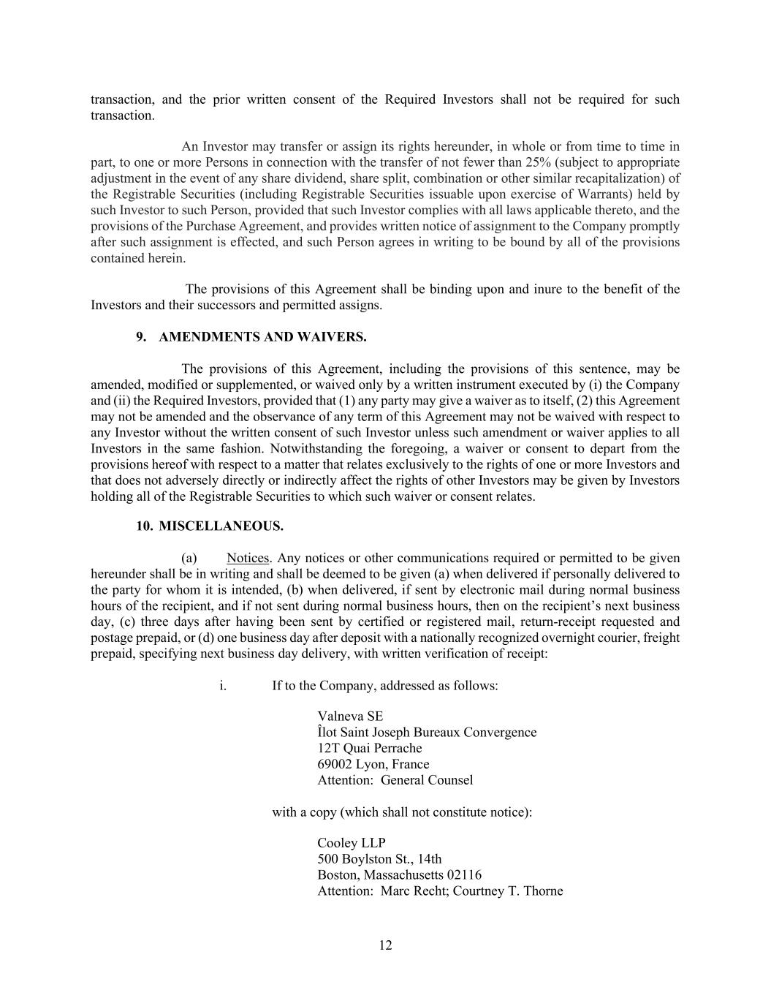
12 transaction, and the prior written consent of the Required Investors shall not be required for such transaction. An Investor may transfer or assign its rights hereunder, in whole or from time to time in part, to one or more Persons in connection with the transfer of not fewer than 25% (subject to appropriate adjustment in the event of any share dividend, share split, combination or other similar recapitalization) of the Registrable Securities (including Registrable Securities issuable upon exercise of Warrants) held by such Investor to such Person, provided that such Investor complies with all laws applicable thereto, and the provisions of the Purchase Agreement, and provides written notice of assignment to the Company promptly after such assignment is effected, and such Person agrees in writing to be bound by all of the provisions contained herein. The provisions of this Agreement shall be binding upon and inure to the benefit of the Investors and their successors and permitted assigns. 9. AMENDMENTS AND WAIVERS. The provisions of this Agreement, including the provisions of this sentence, may be amended, modified or supplemented, or waived only by a written instrument executed by (i) the Company and (ii) the Required Investors, provided that (1) any party may give a waiver as to itself, (2) this Agreement may not be amended and the observance of any term of this Agreement may not be waived with respect to any Investor without the written consent of such Investor unless such amendment or waiver applies to all Investors in the same fashion. Notwithstanding the foregoing, a waiver or consent to depart from the provisions hereof with respect to a matter that relates exclusively to the rights of one or more Investors and that does not adversely directly or indirectly affect the rights of other Investors may be given by Investors holding all of the Registrable Securities to which such waiver or consent relates. 10. MISCELLANEOUS. (a) Notices. Any notices or other communications required or permitted to be given hereunder shall be in writing and shall be deemed to be given (a) when delivered if personally delivered to the party for whom it is intended, (b) when delivered, if sent by electronic mail during normal business hours of the recipient, and if not sent during normal business hours, then on the recipient’s next business day, (c) three days after having been sent by certified or registered mail, return-receipt requested and postage prepaid, or (d) one business day after deposit with a nationally recognized overnight courier, freight prepaid, specifying next business day delivery, with written verification of receipt: i. If to the Company, addressed as follows: Valneva SE Îlot Saint Joseph Bureaux Convergence 12T Quai Perrache 69002 Lyon, France Attention: General Counsel with a copy (which shall not constitute notice): Cooley LLP 500 Boylston St., 14th Boston, Massachusetts 02116 Attention: Marc Recht; Courtney T. Thorne

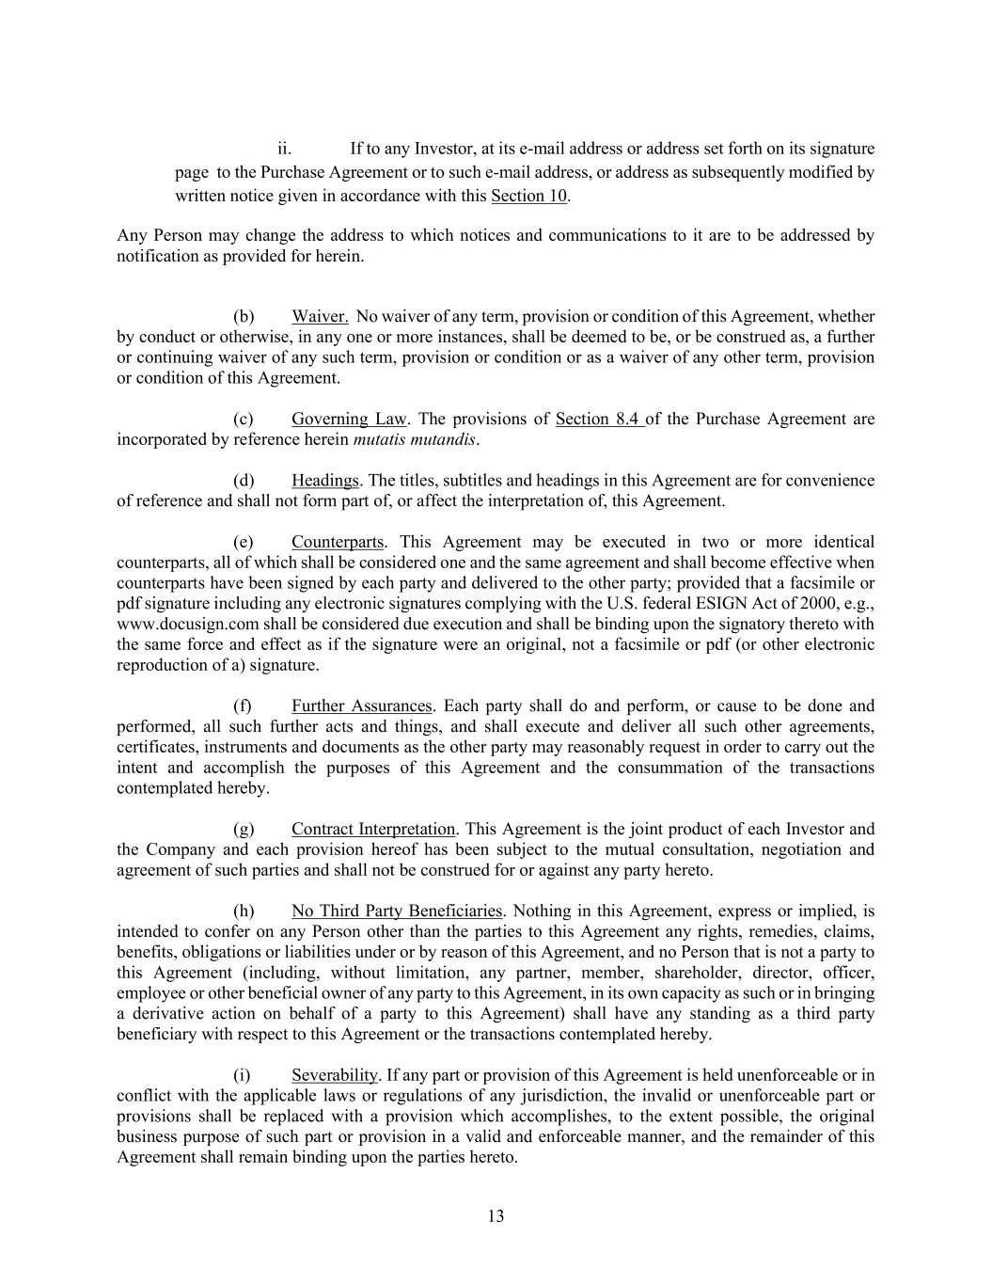
13 ii. If to any Investor, at its e-mail address or address set forth on its signature page to the Purchase Agreement or to such e-mail address, or address as subsequently modified by written notice given in accordance with this Section 10. Any Person may change the address to which notices and communications to it are to be addressed by notification as provided for herein. (b) Waiver. No waiver of any term, provision or condition of this Agreement, whether by conduct or otherwise, in any one or more instances, shall be deemed to be, or be construed as, a further or continuing waiver of any such term, provision or condition or as a waiver of any other term, provision or condition of this Agreement. (c) Governing Law. The provisions of Section 8.4 of the Purchase Agreement are incorporated by reference herein mutatis mutandis. (d) Headings. The titles, subtitles and headings in this Agreement are for convenience of reference and shall not form part of, or affect the interpretation of, this Agreement. (e) Counterparts. This Agreement may be executed in two or more identical counterparts, all of which shall be considered one and the same agreement and shall become effective when counterparts have been signed by each party and delivered to the other party; provided that a facsimile or pdf signature including any electronic signatures complying with the U.S. federal ESIGN Act of 2000, e.g., www.docusign.com shall be considered due execution and shall be binding upon the signatory thereto with the same force and effect as if the signature were an original, not a facsimile or pdf (or other electronic reproduction of a) signature. (f) Further Assurances. Each party shall do and perform, or cause to be done and performed, all such further acts and things, and shall execute and deliver all such other agreements, certificates, instruments and documents as the other party may reasonably request in order to carry out the intent and accomplish the purposes of this Agreement and the consummation of the transactions contemplated hereby. (g) Contract Interpretation. This Agreement is the joint product of each Investor and the Company and each provision hereof has been subject to the mutual consultation, negotiation and agreement of such parties and shall not be construed for or against any party hereto. (h) No Third Party Beneficiaries. Nothing in this Agreement, express or implied, is intended to confer on any Person other than the parties to this Agreement any rights, remedies, claims, benefits, obligations or liabilities under or by reason of this Agreement, and no Person that is not a party to this Agreement (including, without limitation, any partner, member, shareholder, director, officer, employee or other beneficial owner of any party to this Agreement, in its own capacity as such or in bringing a derivative action on behalf of a party to this Agreement) shall have any standing as a third party beneficiary with respect to this Agreement or the transactions contemplated hereby. (i) Severability. If any part or provision of this Agreement is held unenforceable or in conflict with the applicable laws or regulations of any jurisdiction, the invalid or unenforceable part or provisions shall be replaced with a provision which accomplishes, to the extent possible, the original business purpose of such part or provision in a valid and enforceable manner, and the remainder of this Agreement shall remain binding upon the parties hereto.

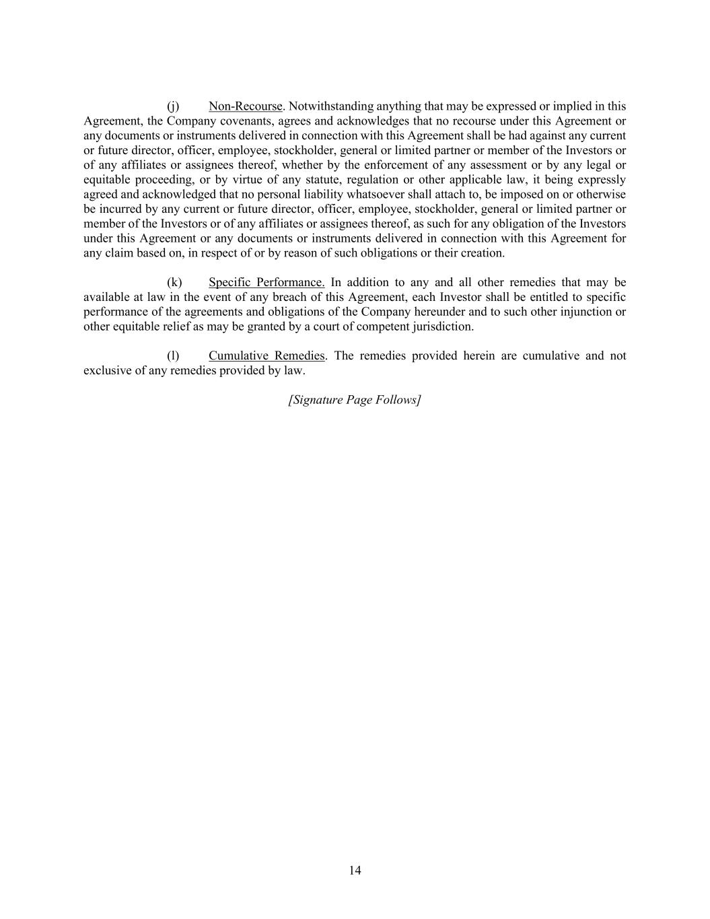
14 (j) Non-Recourse. Notwithstanding anything that may be expressed or implied in this Agreement, the Company covenants, agrees and acknowledges that no recourse under this Agreement or any documents or instruments delivered in connection with this Agreement shall be had against any current or future director, officer, employee, stockholder, general or limited partner or member of the Investors or of any affiliates or assignees thereof, whether by the enforcement of any assessment or by any legal or equitable proceeding, or by virtue of any statute, regulation or other applicable law, it being expressly agreed and acknowledged that no personal liability whatsoever shall attach to, be imposed on or otherwise be incurred by any current or future director, officer, employee, stockholder, general or limited partner or member of the Investors or of any affiliates or assignees thereof, as such for any obligation of the Investors under this Agreement or any documents or instruments delivered in connection with this Agreement for any claim based on, in respect of or by reason of such obligations or their creation. (k) Specific Performance. In addition to any and all other remedies that may be available at law in the event of any breach of this Agreement, each Investor shall be entitled to specific performance of the agreements and obligations of the Company hereunder and to such other injunction or other equitable relief as may be granted by a court of competent jurisdiction. (l) Cumulative Remedies. The remedies provided herein are cumulative and not exclusive of any remedies provided by law. [Signature Page Follows]

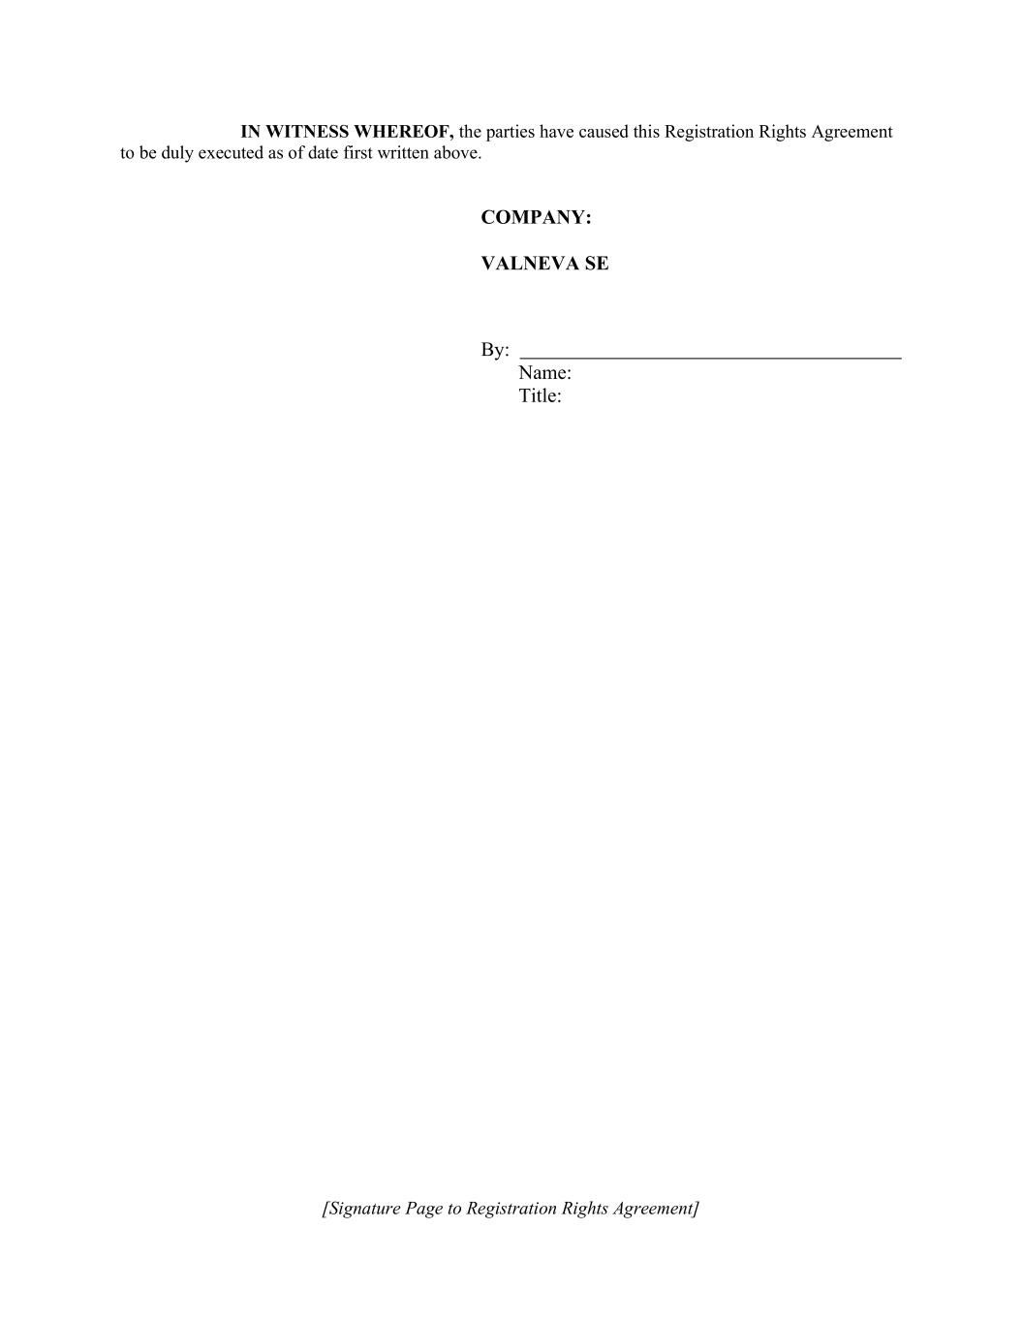
[Signature Page to Registration Rights Agreement] IN WITNESS WHEREOF, the parties have caused this Registration Rights Agreement to be duly executed as of date first written above. COMPANY: VALNEVA SE By: Name: Title:

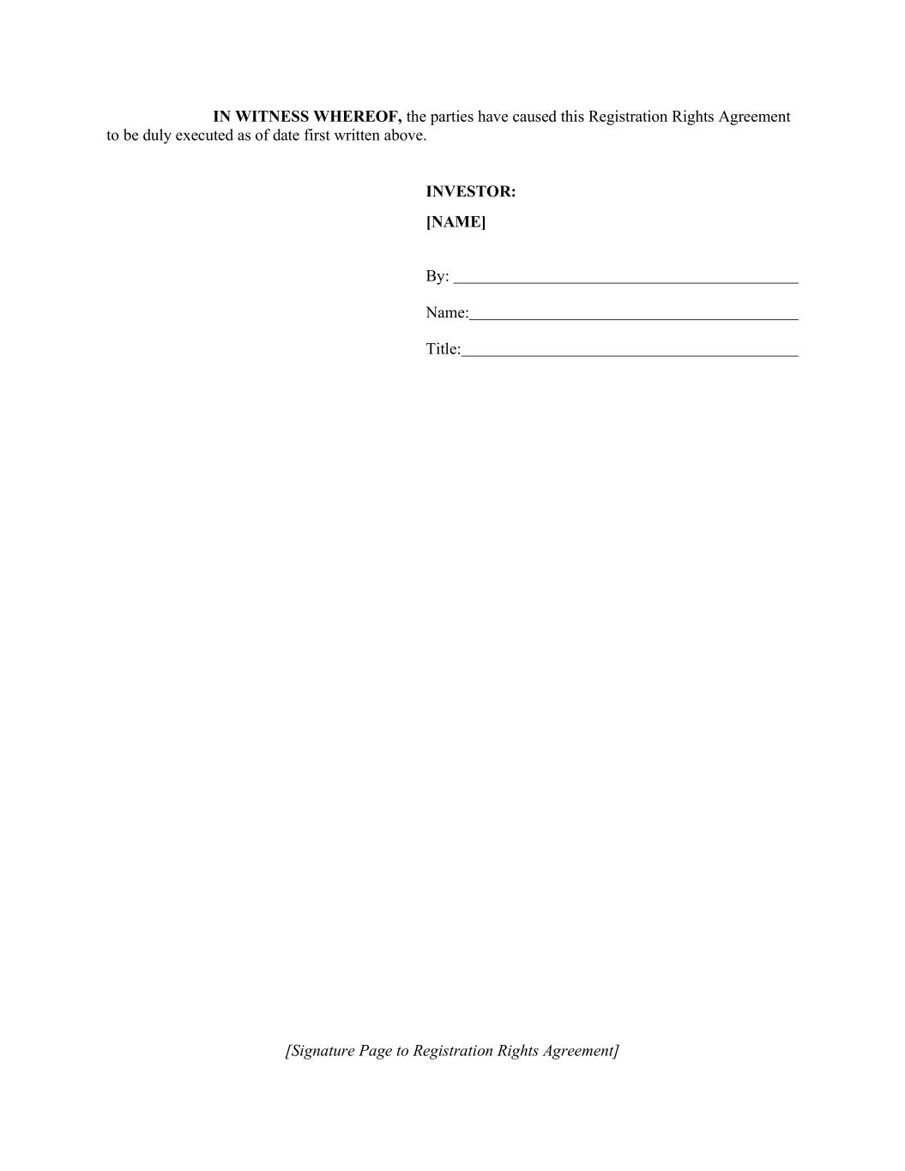
[Signature Page to Registration Rights Agreement] IN WITNESS WHEREOF, the parties have caused this Registration Rights Agreement to be duly executed as of date first written above. INVESTOR: [NAME] By: Name: Title:

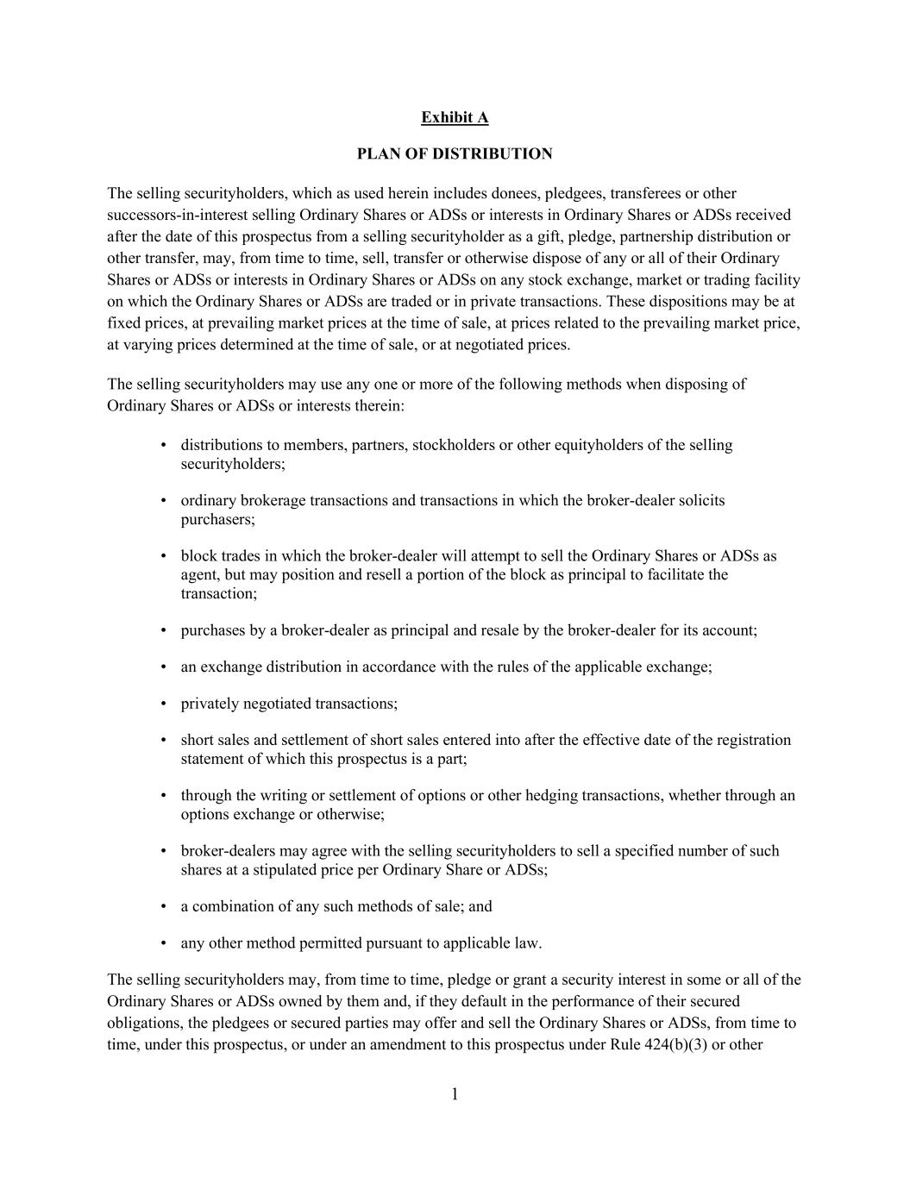
1 Exhibit A PLAN OF DISTRIBUTION The selling securityholders, which as used herein includes donees, pledgees, transferees or other successors-in-interest selling Ordinary Shares or ADSs or interests in Ordinary Shares or ADSs received after the date of this prospectus from a selling securityholder as a gift, pledge, partnership distribution or other transfer, may, from time to time, sell, transfer or otherwise dispose of any or all of their Ordinary Shares or ADSs or interests in Ordinary Shares or ADSs on any stock exchange, market or trading facility on which the Ordinary Shares or ADSs are traded or in private transactions. These dispositions may be at fixed prices, at prevailing market prices at the time of sale, at prices related to the prevailing market price, at varying prices determined at the time of sale, or at negotiated prices. The selling securityholders may use any one or more of the following methods when disposing of Ordinary Shares or ADSs or interests therein: • distributions to members, partners, stockholders or other equityholders of the selling securityholders; • ordinary brokerage transactions and transactions in which the broker-dealer solicits purchasers; • block trades in which the broker-dealer will attempt to sell the Ordinary Shares or ADSs as agent, but may position and resell a portion of the block as principal to facilitate the transaction; • purchases by a broker-dealer as principal and resale by the broker-dealer for its account; • an exchange distribution in accordance with the rules of the applicable exchange; • privately negotiated transactions; • short sales and settlement of short sales entered into after the effective date of the registration statement of which this prospectus is a part; • through the writing or settlement of options or other hedging transactions, whether through an options exchange or otherwise; • broker-dealers may agree with the selling securityholders to sell a specified number of such shares at a stipulated price per Ordinary Share or ADSs; • a combination of any such methods of sale; and • any other method permitted pursuant to applicable law. The selling securityholders may, from time to time, pledge or grant a security interest in some or all of the Ordinary Shares or ADSs owned by them and, if they default in the performance of their secured obligations, the pledgees or secured parties may offer and sell the Ordinary Shares or ADSs, from time to time, under this prospectus, or under an amendment to this prospectus under Rule 424(b)(3) or other

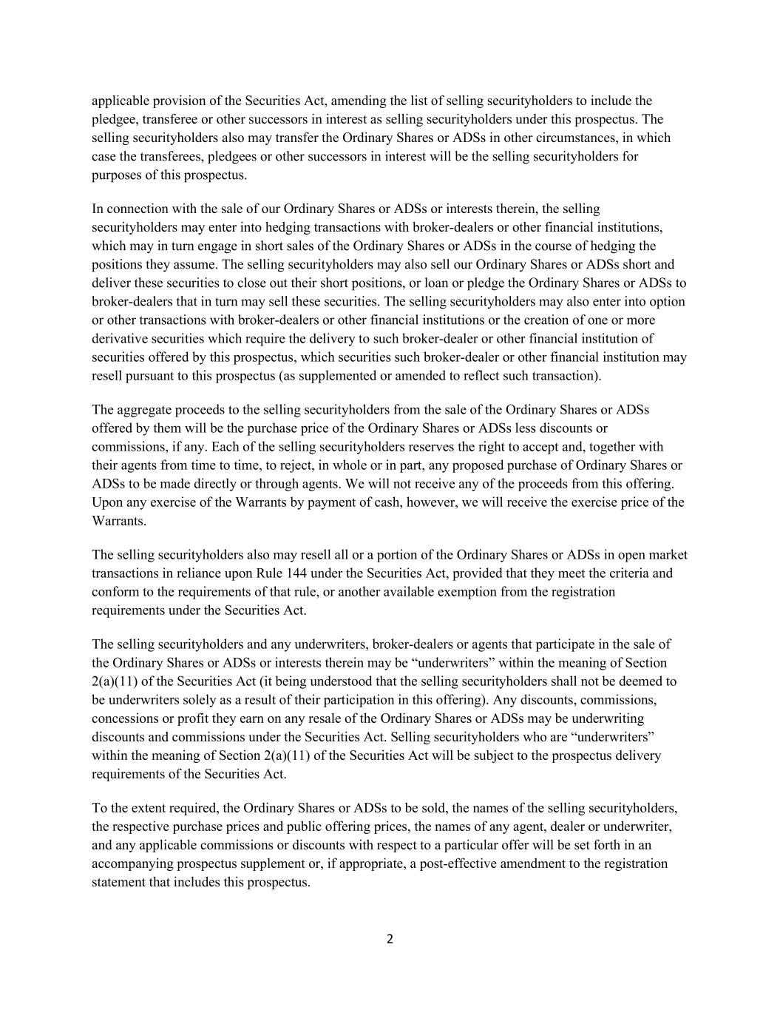
2 applicable provision of the Securities Act, amending the list of selling securityholders to include the pledgee, transferee or other successors in interest as selling securityholders under this prospectus. The selling securityholders also may transfer the Ordinary Shares or ADSs in other circumstances, in which case the transferees, pledgees or other successors in interest will be the selling securityholders for purposes of this prospectus. In connection with the sale of our Ordinary Shares or ADSs or interests therein, the selling securityholders may enter into hedging transactions with broker-dealers or other financial institutions, which may in turn engage in short sales of the Ordinary Shares or ADSs in the course of hedging the positions they assume. The selling securityholders may also sell our Ordinary Shares or ADSs short and deliver these securities to close out their short positions, or loan or pledge the Ordinary Shares or ADSs to broker-dealers that in turn may sell these securities. The selling securityholders may also enter into option or other transactions with broker-dealers or other financial institutions or the creation of one or more derivative securities which require the delivery to such broker-dealer or other financial institution of securities offered by this prospectus, which securities such broker-dealer or other financial institution may resell pursuant to this prospectus (as supplemented or amended to reflect such transaction). The aggregate proceeds to the selling securityholders from the sale of the Ordinary Shares or ADSs offered by them will be the purchase price of the Ordinary Shares or ADSs less discounts or commissions, if any. Each of the selling securityholders reserves the right to accept and, together with their agents from time to time, to reject, in whole or in part, any proposed purchase of Ordinary Shares or ADSs to be made directly or through agents. We will not receive any of the proceeds from this offering. Upon any exercise of the Warrants by payment of cash, however, we will receive the exercise price of the Warrants. The selling securityholders also may resell all or a portion of the Ordinary Shares or ADSs in open market transactions in reliance upon Rule 144 under the Securities Act, provided that they meet the criteria and conform to the requirements of that rule, or another available exemption from the registration requirements under the Securities Act. The selling securityholders and any underwriters, broker-dealers or agents that participate in the sale of the Ordinary Shares or ADSs or interests therein may be “underwriters” within the meaning of Section 2(a)(11) of the Securities Act (it being understood that the selling securityholders shall not be deemed to be underwriters solely as a result of their participation in this offering). Any discounts, commissions, concessions or profit they earn on any resale of the Ordinary Shares or ADSs may be underwriting discounts and commissions under the Securities Act. Selling securityholders who are “underwriters” within the meaning of Section 2(a)(11) of the Securities Act will be subject to the prospectus delivery requirements of the Securities Act. To the extent required, the Ordinary Shares or ADSs to be sold, the names of the selling securityholders, the respective purchase prices and public offering prices, the names of any agent, dealer or underwriter, and any applicable commissions or discounts with respect to a particular offer will be set forth in an accompanying prospectus supplement or, if appropriate, a post-effective amendment to the registration statement that includes this prospectus.

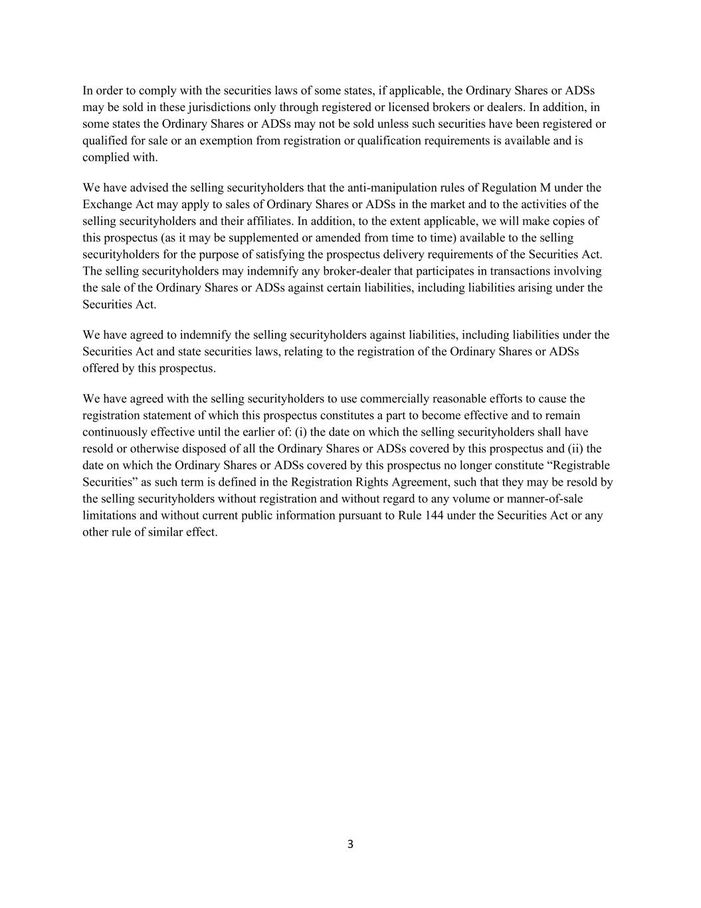
3 In order to comply with the securities laws of some states, if applicable, the Ordinary Shares or ADSs may be sold in these jurisdictions only through registered or licensed brokers or dealers. In addition, in some states the Ordinary Shares or ADSs may not be sold unless such securities have been registered or qualified for sale or an exemption from registration or qualification requirements is available and is complied with. We have advised the selling securityholders that the anti-manipulation rules of Regulation M under the Exchange Act may apply to sales of Ordinary Shares or ADSs in the market and to the activities of the selling securityholders and their affiliates. In addition, to the extent applicable, we will make copies of this prospectus (as it may be supplemented or amended from time to time) available to the selling securityholders for the purpose of satisfying the prospectus delivery requirements of the Securities Act. The selling securityholders may indemnify any broker-dealer that participates in transactions involving the sale of the Ordinary Shares or ADSs against certain liabilities, including liabilities arising under the Securities Act. We have agreed to indemnify the selling securityholders against liabilities, including liabilities under the Securities Act and state securities laws, relating to the registration of the Ordinary Shares or ADSs offered by this prospectus. We have agreed with the selling securityholders to use commercially reasonable efforts to cause the registration statement of which this prospectus constitutes a part to become effective and to remain continuously effective until the earlier of: (i) the date on which the selling securityholders shall have resold or otherwise disposed of all the Ordinary Shares or ADSs covered by this prospectus and (ii) the date on which the Ordinary Shares or ADSs covered by this prospectus no longer constitute “Registrable Securities” as such term is defined in the Registration Rights Agreement, such that they may be resold by the selling securityholders without registration and without regard to any volume or manner-of-sale limitations and without current public information pursuant to Rule 144 under the Securities Act or any other rule of similar effect.

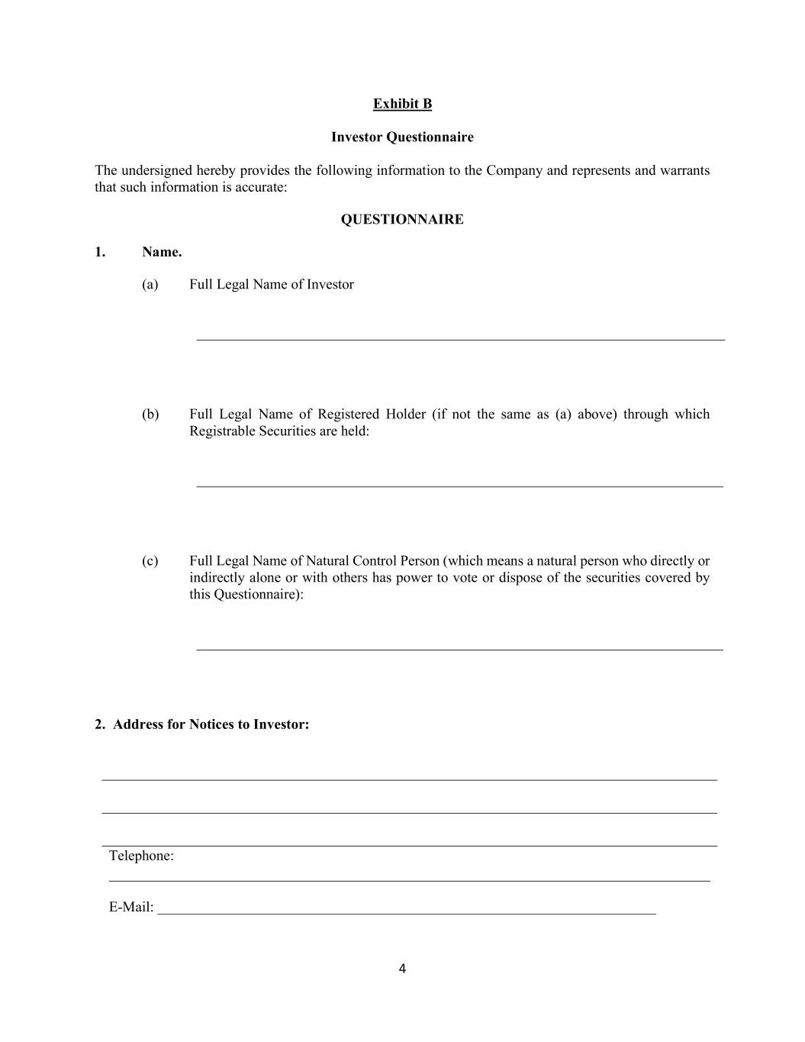
4 Exhibit B Investor Questionnaire The undersigned hereby provides the following information to the Company and represents and warrants that such information is accurate: QUESTIONNAIRE 1. Name. (a) Full Legal Name of Investor (b) Full Legal Name of Registered Holder (if not the same as (a) above) through which Registrable Securities are held: (c) Full Legal Name of Natural Control Person (which means a natural person who directly or indirectly alone or with others has power to vote or dispose of the securities covered by this Questionnaire): 2. Address for Notices to Investor: Telephone: E-Mail: _____________________________________________________________________

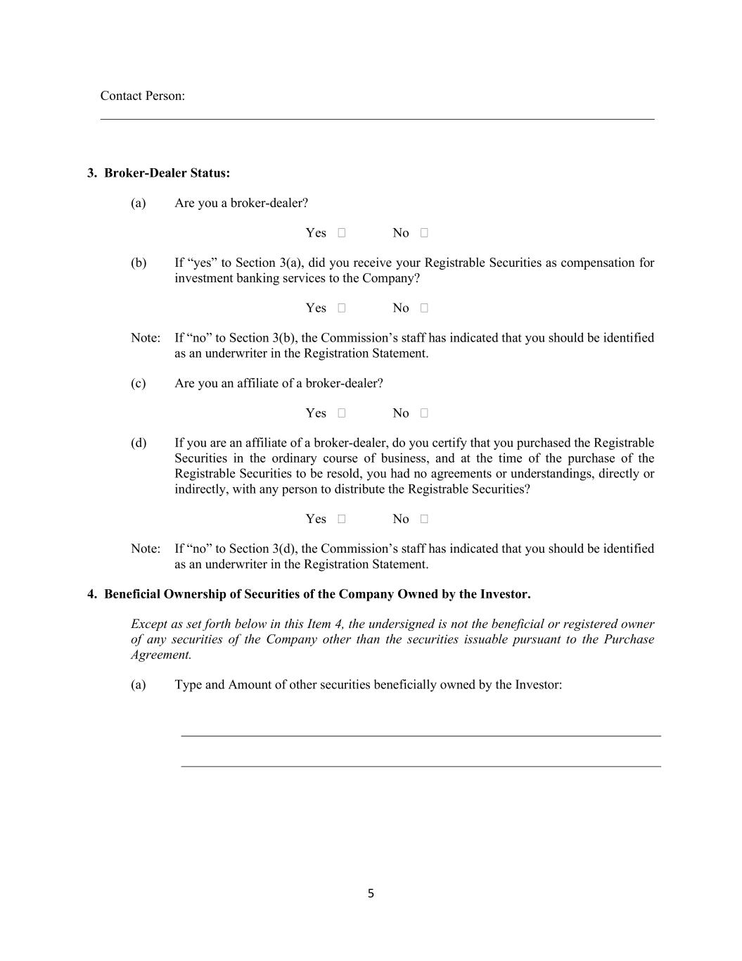
5 Contact Person: 3. Broker-Dealer Status: (a) Are you a broker-dealer? Yes ☐ No ☐ (b) If “yes” to Section 3(a), did you receive your Registrable Securities as compensation for investment banking services to the Company? Yes ☐ No ☐ Note: If “no” to Section 3(b), the Commission’s staff has indicated that you should be identified as an underwriter in the Registration Statement. (c) Are you an affiliate of a broker-dealer? Yes ☐ No ☐ (d) If you are an affiliate of a broker-dealer, do you certify that you purchased the Registrable Securities in the ordinary course of business, and at the time of the purchase of the Registrable Securities to be resold, you had no agreements or understandings, directly or indirectly, with any person to distribute the Registrable Securities? Yes ☐ No ☐ Note: If “no” to Section 3(d), the Commission’s staff has indicated that you should be identified as an underwriter in the Registration Statement. 4. Beneficial Ownership of Securities of the Company Owned by the Investor. Except as set forth below in this Item 4, the undersigned is not the beneficial or registered owner of any securities of the Company other than the securities issuable pursuant to the Purchase Agreement. (a) Type and Amount of other securities beneficially owned by the Investor:

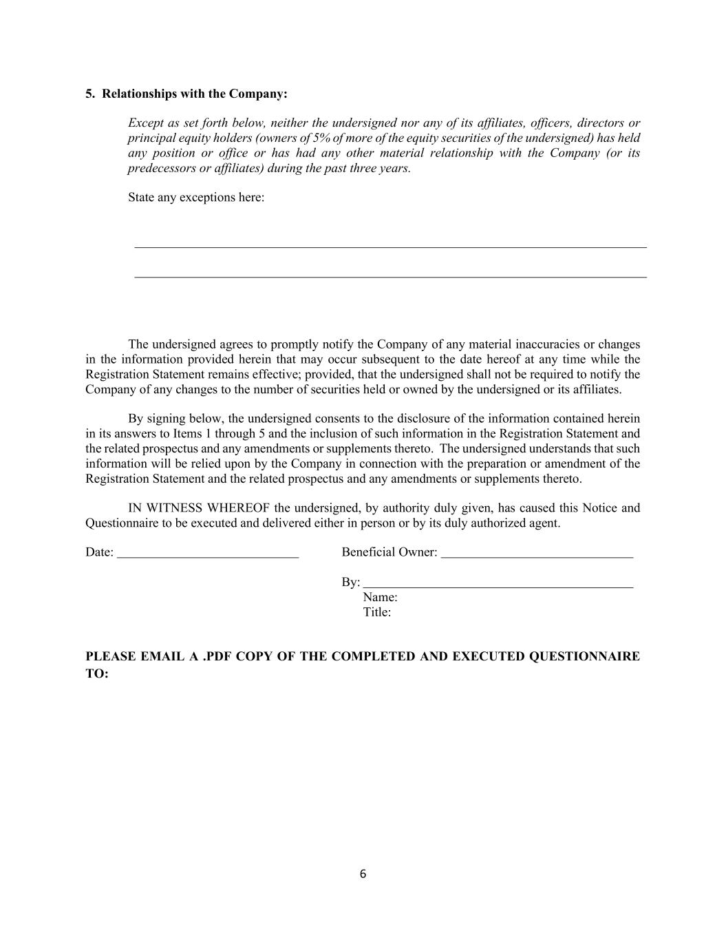
6 5. Relationships with the Company: Except as set forth below, neither the undersigned nor any of its affiliates, officers, directors or principal equity holders (owners of 5% of more of the equity securities of the undersigned) has held any position or office or has had any other material relationship with the Company (or its predecessors or affiliates) during the past three years. State any exceptions here: The undersigned agrees to promptly notify the Company of any material inaccuracies or changes in the information provided herein that may occur subsequent to the date hereof at any time while the Registration Statement remains effective; provided, that the undersigned shall not be required to notify the Company of any changes to the number of securities held or owned by the undersigned or its affiliates. By signing below, the undersigned consents to the disclosure of the information contained herein in its answers to Items 1 through 5 and the inclusion of such information in the Registration Statement and the related prospectus and any amendments or supplements thereto. The undersigned understands that such information will be relied upon by the Company in connection with the preparation or amendment of the Registration Statement and the related prospectus and any amendments or supplements thereto. IN WITNESS WHEREOF the undersigned, by authority duly given, has caused this Notice and Questionnaire to be executed and delivered either in person or by its duly authorized agent. Date: Beneficial Owner: By: Name: Title: PLEASE EMAIL A .PDF COPY OF THE COMPLETED AND EXECUTED QUESTIONNAIRE TO:

VALNEVA SE
Îlot Saint-Joseph, Bureaux Convergence, Bât. A,
12 ter Quai Perrache
69002 Lyon, France

Valneva Announces the Successful Completion of a €84 million Reserved Offering

Lyon (France), April 30, 2026 – Valneva SE (Nasdaq: VALN; Euronext Paris: VLA) (“Valneva” or the “Company”), a specialty vaccine company, announces the successful completion of an €84 million (including share issue premium) reserved offering subscribed by a limited number of investors (the “Reserved Offering”), including €37 million to be received upon closing and an aggregate of up to €47 million if all the warrants are exercised, subject to satisfaction of specific conditions. The closing of the Reserved Offering is expected to occur on May 5, 2026, subject to customary closing conditions.
The Reserved Offering was led by existing investor Frazier Life Sciences, with participation by new investors TCGX, Deep Track Capital, Cormorant Asset Management, Perceptive Advisors, Vivo Capital, and Samsara BioCapital, as well as existing investor Nantahala Capital.
Use of proceeds
The Company intends to use the net proceeds from the Reserved Offering, together with its existing cash, to (i) advance its existing pipeline of differentiated vaccine candidates, maximize growth of its cash-generating commercial business and (ii) for working capital and general corporate purposes. The net proceeds will be allocated equally between these two objectives.

Terms & Conditions of the Reserved Offering
The Reserved Offering was carried out through the issuance of 15,893,817 new ordinary shares of the Company (the “New Shares”), each New Share with one share warrant attached (a “Warrant” and, together with the New Share to which it is attached, an “ABSA”, or Actions à Bons de Souscription d'Actions) at a subscription price of €2.33 per ABSA, as part of a share capital increase for an amount of €37 million. If all the Warrants attached to the New Shares are exercised, up to 15,893,817 additional new ordinary shares (the “Warrant Shares”) will be issued by the Company for an amount of approximately €47 million.
The Reserved Offering has been carried out (i) in the United States, to a limited number of “qualified institutional buyers” as defined by Rule 144A of the U.S. Securities Act of 1933, as amended (the “Securities Act”), pursuant to an exemption from the registration requirements of Section 4(a)(2) of the Securities Act, and (ii) outside the United States, in offshore transactions in accordance with Regulation S of the Securities Act, (A) within the European Union (including France), to “qualified investors” within the meaning of Article 2(e) of Regulation (EU) 2017/1129, as amended (the “Prospectus Regulation”) and (B) outside the European Union (excluding the United States, Canada, Japan and Australia) in accordance with the rules applicable in each of the countries concerned, for the benefit of categories of investors defined in the 28th resolution of the General Meeting.
Jefferies LLC, Jefferies GmbH, TD Cowen, Stifel, Nicolaus & Company, Incorporated, Stifel Europe Securities SAS, acted as Global Coordinators, and Van Lanschot Kempen (USA) Inc. and Van Lanschot Kempen N.V., together with the Global Coordinators, acted as Joint Bookrunners (the “Managers”), have been appointed to assist the Company as placement agents in connection with the Reserved Offering. Jefferies GmbH also acted as settlement agent in connection with the Reserved Offering.

The ABSA are issued through a capital increase without shareholders’ preferential subscription rights for the benefit of categories of investors in accordance with Article L. 225-138 of the French Commercial Code and pursuant to the decisions of the Company’s Chief Executive Officer on April 29, 2026, acting upon sub-delegation of the Company’s Board of Directors on April 28, 2026, in accordance with the delegations granted pursuant to the 28th and 34th resolutions of the Company’s combined shareholders’ meeting held on June 25, 2025 (the “General Meeting”).
Concurrently with the execution of a securities purchase agreement, the Company and the investors entered into a registration rights agreement pursuant to which the Company has agreed to file a registration statement with the Securities and Exchange Commission registering the resale of the New Shares, the Warrant Shares and any American Depositary Shares (“ADSs”) created upon deposit thereof.
Terms & Conditions of the ABSA
The issue price of one ABSA is €2.33 (including €0.15 par value and €2.18 share issue premium), representing a facial discount of 1.6% to the volume-weighted average price of the Valneva shares on the regulated market of Euronext Paris (“Euronext Paris”) over the three trading days preceding the setting of such issue price, i.e. April 27, 28, and 29, 2026 (i.e. €2.37) (the “3-day VWAP”). The theoretical value of a Warrant using the Black-Scholes method is €0.30, which takes into account various parameters, including volatility (37.5%), the issue price of the ABSA, the Exercise Price (as defined below) of the Warrants or the Exercise Period (as defined below).
One Warrant entitles its holder to subscribe to one Warrant Share of the Company (the “Exercise Ratio”), at an exercise price of €2.96 per ordinary share (the “Exercise Price”), representing a premium of 25% to the 3-day VWAP, subject to standard adjustments.
The issue price of an ABSA minus the theoretical value of a Warrant reflects a total discount of 14.4% per Valneva share compared with the 3-day VWAP, consistent with the maximum discount authorized by the General Meeting pursuant to its 28th resolution.
The Warrants may be exercised, in whole or in part, for cash, at any time from the Business Day immediately following their issuance to the earlier of (i) the 30th calendar day following receipt by the Company of the FDA regulatory approval for its investigational 6-valent OspA-based Lyme disease vaccine candidate (LB6V, formerly known as VLA15) and (ii) the third business day (included) prior to March 31, 2028 (the “Exercise Period”), it being specified that, if, as of March 1, 2028, (i) the FDA has determined that the application for the FDA regulatory approval was sufficiently complete to permit a substantive review and (ii) the FDA regulatory approval has not yet been obtained, such
maturity date shall automatically be extended to September 30, 2028 and the Exercise Period shall be correspondingly extended.

In the case of a suspension1, the Exercise Period shall be automatically extended for a period equal to the duration of such suspension; provided, however, that in no event shall such extension result in the Exercise Period exceeding the period ending on the third business day (included) prior to March 31, 2028 (or, if applicable, September 30, 2028).
The Warrants are not listed on a regulated market or multilateral trading facility but are admitted to the operations of Euroclear France SA (ISIN: FR00140188J5). The Warrants were detached from the New Shares upon their issuance.
Holders of Warrants will be automatically grouped in a masse to defend their common interests. The masse will act, in part, through a representative and, in part, through collective decisions of the Warrants holders.
Dilution
The 15,893,817 New Shares issued in the Reserved Offering will represent dilution of approximately 9.1% of the share capital of the Company (on a non-diluted basis). On an illustrative basis, a shareholder holding 1% of Valneva’s share capital before the Reserved Offering would hold a stake of 0.9% after completion of the Reserved Offering.
In addition, assuming the exercise in full of all 15,893,817 Warrants at the Exercise Ratio, a maximum of 15,893,817 new ordinary shares would be issued, representing additional dilution of approximately 8.4% of the share capital of the Company (on a non-diluted basis, after issuance of the New Shares).
Evolution of the shareholding structure in connection with the Reserved Offering
The shareholding structure of the Company prior to the Reserved Offering is set forth below:

Shareholding prior to the Reserved Offering (on a non-diluted basis)
Shareholders |  |  | Number of shares |  |  | % of share capital |  |  | Number of theoretical voting rights |  |  | % of theoretical voting rights
CDC (Bpifrance Participations, and CDC Croissance) |  |  | 11,914,707 |  |  | 6.85% |  |  | 19,073,542 |  |  | 10.12%
Of which Bpifrance Participations SA |  |  | 7,158,835 |  |  | 4.12% |  |  | 14,317,670 |  |  | 7.60%
Pfizer Inc. |  |  | 9,554,395 |  |  | 5.49% |  |  | 9,554,395 |  |  | 5.07%
Groupe Grimaud La Corbière |  |  | 6,252,237 |  |  | 3.60% |  |  | 11,707,068 |  |  | 6.21%
1 The Company may suspend the exercise of the Warrants in the event of a capital increase, an issuance of securities giving access to the share capital, any other financial transaction involving a preferential subscription right or a priority subscription period for shareholders, or a merger or demerger (scission), for a period not exceeding three months (or such other period set by applicable regulations).

Shareholding prior to the Reserved Offering (on a non-diluted basis)
Shareholders |  |  | Number of shares |  |  | % of share capital |  |  | Number of theoretical voting rights |  |  | % of theoretical voting rights
Braidwell LP |  |  | 5,400,000 |  |  | 3.11% |  |  | 5,400,000 |  |  | 2.87%
Candriam |  |  | 3,833,571 |  |  | 2.20% |  |  | 3,833,571 |  |  | 2.03%
Frazier Life Sciences Public Fund, L.P |  |  | 3,623,582 |  |  | 2.08% |  |  | 3,623,582 |  |  | 1.92%
Employees |  |  | 467,345 |  |  | 0.27% |  |  | 561,501 |  |  | 0.30%
Treasury shares |  |  | 124,322 |  |  | 0.07% |  |  | 124,322 |  |  | 0.07%
Free float |  |  | 132,707,261 |  |  | 76.32% |  |  | 134,587,881 |  |  | 71.41%
Total |  |  | 173,877,420 |  |  | 100.00% |  |  | 188,465,862 |  |  | 100.00%

The issuance of the New Shares will have the following impact on the allocation of the share capital and voting rights of the Company:

Shareholding following the issuance of the New Shares (on a non-diluted basis)
Shareholders |  |  | Number of shares |  |  | % of share capital |  |  | Number of theoretical voting rights |  |  | % of theoretical voting rights
CDC (Bpifrance Participations and CDC Croissance) |  |  | 11,914,707 |  |  | 6.28% |  |  | 19,073,542 |  |  | 9.33%
Of which Bpifrance Participations SA |  |  | 7,158,835 |  |  | 3.77% |  |  | 14,317,670 |  |  | 7.01%
Pfizer Inc. |  |  | 9,554,395 |  |  | 5.03% |  |  | 9,554,395 |  |  | 4.68%
Frazier Life Sciences Public Fund, L.P |  |  | 7,291,827 |  |  | 3.84% |  |  | 7,291,827 |  |  | 3.57%
Groupe Grimaud La Corbière |  |  | 6,252,237 |  |  | 3.29% |  |  | 11,707,068 |  |  | 5.73%
Braidwell LP |  |  | 5,400,000 |  |  | 2.85% |  |  | 5,400,000 |  |  | 2.64%
Candriam |  |  | 3,833,571 |  |  | 2.02% |  |  | 3,833,571 |  |  | 1.88%
Employees |  |  | 467,345 |  |  | 0.25% |  |  | 561,501 |  |  | 0.27%
Treasury shares |  |  | 124,322 |  |  | 0.07% |  |  | 124,322 |  |  | 0.06%
Free float |  |  | 144,932,833 |  |  | 76.37% |  |  | 146,813,453 |  |  | 71.84%
Total |  |  | 189,771,237 |  |  | 100.00% |  |  | 204,359,679 |  |  | 100.00%

The issuance of the New Shares and the Warrant Shares (assuming full exercise) will have the following impact on the allocation of the share capital and voting rights of the Company:

Shareholding following the issuance of the New Shares and the Warrant Shares (on a non-diluted basis)
Shareholders |  |  | Number of shares |  |  | % of share capital |  |  | Number of theoretical voting rights |  |  | % of theoretical voting rights
CDC (Bpifrance Participations, CDC Croissance) |  |  | 11,914,707 |  |  | 5.79% |  |  | 19,073,542 |  |  | 8.66%
Of which Bpifrance Participations SA |  |  | 7,158,835 |  |  | 3.48% |  |  | 14,317,670 |  |  | 6.50%
Frazier Life Sciences Public Fund, L.P |  |  | 10,960,072 |  |  | 5.33% |  |  | 10,960,072 |  |  | 4.98%
Pfizer Inc. |  |  | 9,554,395 |  |  | 4.65% |  |  | 9,554,395 |  |  | 4.34%
Groupe Grimaud La Corbière |  |  | 6,252,237 |  |  | 3.04% |  |  | 11,707,068 |  |  | 5.32%
Braidwell LP |  |  | 5,400,000 |  |  | 2.63% |  |  | 5,400,000 |  |  | 2.45%
Candriam |  |  | 3,833,571 |  |  | 1.86% |  |  | 3,833,571 |  |  | 1.74%
Employees |  |  | 467,345 |  |  | 0.23% |  |  | 561,501 |  |  | 0.25%
Treasury shares |  |  | 124,322 |  |  | 0.06% |  |  | 124,322 |  |  | 0.06%
Free float |  |  | 157,158,405 |  |  | 76.41% |  |  | 159,039,025 |  |  | 72.21%
Total |  |  | 205,665,054 |  |  | 100.00% |  |  | 220,253,496 |  |  | 100.00%

Lock-up
In connection with the Reserved Offering, the Company’s board members and executive officers are subject to a contractual lock-up from the date hereof and for a period of 60 days after the settlement and delivery of the New Shares, subject to customary exceptions.
The Company has also agreed to be bound by a contractual lock-up for a period of 60 days following the date of the settlement and delivery of the Reserved Offering, subject to customary exceptions.
The investors in the Reserved Offering have not entered into any lock-up undertakings.
Cash position
As of December 31, 2025, the Company had cash and cash equivalents of €109.7 million. Without the net proceeds of the Reserved Offering, the Company’s current resources are sufficient to cover its operating needs for the next 12 months.
Risk Factors

Potential investors should carefully consider the following risks: (i) shareholders who have not participated in the Reserved Offering may see their participation in the Company’s share capital diluted due to the issuance of the New Shares and the potential exercise of the Warrants, (ii) the volatility and liquidity of the Company’s ordinary shares and ADSs may experience significant fluctuation, and there may be differences on Nasdaq and Euronext, (iii) sales of the Company’s ordinary shares and ADSs, in particular by its significant shareholders, could occur on the market and have an adverse impact on the Company’s trading prices, and (iv) existing and potential investors in the Company’s ordinary shares or ADSs may have to request the prior authorization from the French Ministry of Economy prior to acquiring a significant ownership position in the ordinary shares or ADSs of the Company.
In addition, the Company draws attention to the risk factors related to the Company and its activities presented in section 1.5 of the 2025 universal registration document filed with the AMF under number D.26-0102 on March 17, 2026, which are available free of charge on the Company’s website, as well as on the AMF’s website.
Settlement and Delivery -- Documentation
The Company’s ADSs are listed on the Nasdaq Global Select Market under the ticker symbol “VALN”. The Company’s ordinary shares are listed on Euronext under the symbol “VLA”.
The New Shares are expected to be admitted to trading on Euronext Paris on May 5, 2026. The New Shares will be subject to the provisions of the Company’s bylaws and will be assimilated to existing shares upon final completion of the Reserved Offering. They will be admitted to trading on the same trading line as the Company’s existing shares under the same ISIN code FR0004056851.
The Reserved Offering is not subject to a prospectus requiring an approval of the French Financial Markets Authority (Autorité des marchés financiers – the “AMF”) or to the filing with the AMF of a document containing the information set out in Annex IX of the Prospectus Regulation.
Further reduction of operating expenses
Following the recent consolidation of its operations in France2, Valneva has initiated a further restructuring plan, to include a workforce reduction, which is designed to reduce expenses while continuing to focus its resources on its base business and key strategic projects.
About Valneva SE
We are a specialty vaccine company that develops, manufactures, and commercializes prophylactic vaccines for infectious diseases addressing unmet medical needs. We take a highly specialized and targeted approach, applying our deep expertise across multiple vaccine modalities, focused on providing either first-, best- or only-in-class vaccine solutions.
We have a strong track record, having advanced multiple vaccines from early R&D to approvals, and currently market three proprietary travel vaccines.
2 See Valneva press release dated November 26, 2025.
Revenues from our growing commercial business help fuel the continued advancement of our vaccine pipeline. This includes the only Lyme disease vaccine candidate in advanced clinical development, which is partnered with Pfizer, the world’s most clinically advanced Shigella vaccine candidate, as well as vaccine candidates against other global public health threats. More information is available on the Company’s website.

Media and Investor Relations Contacts

Laetitia Bachelot-Fontaine  VP Global Communications & European Investor Relations  M +33 (0)6 4516 7099  laetitia.bachelot-fontaine@valneva.com |  |  | Joshua Drumm, Ph.D.  VP Global Investor Relations  M +001 917 815 4520  joshua.drumm@valneva.com

Special Note Regarding Forward-Looking Statements
This press release contains “forward-looking” statements within the meaning of the “safe harbor” provisions of the Private Securities Litigation Reform Act of 1995, including, but not limited to, statements regarding the expected closing of the Reserved Offering and the use of proceeds therefrom. Words such as “expects,” “intends,” “can,” “could,” “may,” “might,” “plan,” “potential,” “should,” and “will,” or the negative of these and similar expressions are intended to identify forward-looking statements.
These forward-looking statements, which are based on our management’s current expectations and assumptions and on information currently available to management involve known and unknown risks, uncertainties and other factors that could cause actual results to differ materially from those implied by the forward-looking statements, including such as unfavorable conditions in the industry, geopolitical events, market conditions, including the trading price and volatility of Valneva’s ADSs and ordinary shares, and risks related to Valneva’s business and financial performance.
Further information on the risk factors that may affect the Company’s business and financial performance is included in Valneva’s Annual Report on Form 20-F filed with the SEC on March 17, 2026 under “Item 3.D. Risk Factors” and in Valneva’s 2025 universal registration document filed with the French Financial Markets Authority (Autorité des marchés financiers – the “AMF”) under number D.26-0102 on March 17, 2026, and in any subsequent filings Valneva makes with the SEC from time to time, which are available on the SEC’s website.
The forward-looking statements included in this press release speak only as of the date of this press release, and except as required by law, Valneva assumes no obligation to update these forward-looking statements publicly.
Disclaimers
This press release does not constitute an offer to sell or the solicitation of an offer to buy any securities of the Company in the United States of America, nor shall there be any sale of such securities, in any state or jurisdiction in which such offer, solicitation or sale would be unlawful prior to registration or qualification under the securities laws of any such state or jurisdiction. None of the securities to be issued in connection with the Reserved Offering have been registered under the Securities Act and such securities may not be offered or sold in the United States except pursuant to an effective registration statement or an applicable exemption from the registration requirements.
The distribution of this press release may be subject to legal or regulatory restrictions in certain jurisdictions. Any person who comes into possession of this press release must inform him or herself of and comply with any such restrictions.
This document does not constitute an offer to the public in France. The securities referred to herein have not been and will not be offered or sold to the public in France, and no marketing materials
relating to the securities may be made available or distributed in any way that would constitute, directly or indirectly, an offer to the public in France (except for public offerings defined in Article L. 411-2, 1° of the French Monetary and Financial Code (Code monétaire et financier)).

The securities referred to in this document are reserved to certain categories of beneficiaries as defined in the 28th resolution of the 2025 General Meeting, in accordance with Article L. 225-138 of the French Commercial Code.
This announcement is an advertisement and not a prospectus within the meaning of the Prospectus Regulation nor a document containing the information set out in Annex IX of the Prospectus Regulation.
In relation to each member state of the European Economic Area (each, a “Relevant Member State”), an offer of the securities referred to herein is not being made and will not be made to the public in that Relevant Member State, other than (i) to any legal entity which is a qualified investor as defined in the Prospectus Regulation, (ii) to fewer than 150 natural or legal persons per Relevant Member State (other than a qualified investor as defined in the Prospectus Regulation); or (iii) in any other circumstances falling within Article 1(4) of the Prospectus Regulation; provided that no such offer of the securities referred to herein shall require the Company or any Manager to publish a prospectus pursuant to Article 3 of the Prospectus Regulation or a document containing the information set out in Annex IX of the Prospectus Regulation, and each person who initially acquires any shares or to whom any offer is made will be deemed to have represented, acknowledged and agreed to and with each of the Managers and the Company that it is a qualified investor as defined in the Prospectus Regulation.
For the purposes of the above, the expression an “offer to the public” in any Relevant Member State shall have the meaning ascribed to it in article 2(d) of the Prospectus Regulation.
This communication is being distributed only to, and is directed only at (a) persons outside the United Kingdom, (b) persons who have professional experience in matters relating to investments falling within Article 19(5) of the Financial Services and Markets Act 2000 (Financial Promotion) Order 2005 (the “Order”), and (c) high net worth entities, and other persons to whom it may otherwise lawfully be communicated, falling within Article 49(2) of the Order (all such persons together being referred to as “relevant persons”). Any investment or investment activity to which this communication relates is available only to relevant persons and will be engaged in only with relevant persons. Any person who is not a relevant person should not act or rely on this communication or any of its contents.
Solely for the purposes of each manufacturer’s product approval process, the target market assessment in respect of the New Shares and Warrants offered in the Reserved Offering has led to the conclusion in relation to the type of clients criteria only that: (i) the type of clients to whom the New Shares and Warrants are targeted is eligible counterparties and professional clients only, each as defined in Directive 2014/65/EU, as amended (“MiFID II”); and (ii) all channels for distribution of the New Shares and Warrants offered in the Reserved Offering to eligible counterparties and professional clients are appropriate.
Any person subsequently offering, selling or recommending the New Shares or Warrants (a “distributor”) should take into consideration the manufacturers’ type of clients assessment; however, a distributor subject to MiFID II is responsible for undertaking its own target market assessment in respect of the New Shares and Warrants offered in the Reserved Offering (by either adopting or refining the manufacturers’ type of clients assessment) and determining appropriate distribution channels.
This press release has been prepared in both French and English. In the event of any discrepancies between the two versions of the press release, the French language version shall prevail.

